BIOMASS IN TURKEY

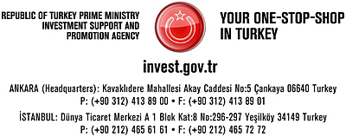

BIOMASS

Turkey’s main biomass sources are agricultural, forestry, animal and organic wastes. Biomass potential is 8,6 million TOE and the amount of 6 million of this potential is being used. With Turkey’s high potential in agriculture and installed capacity in bio-diesel and bio-ethanol Turkey can be the bio-fuel supply center of Europe. The value of the vegetable and animal wasted that may be used in the production of bio-fuel equals to 10,3 million tons of petroleum.

BIODIESEL POTENTIAL OF TURKEY

Biomass Energy Generation Potential | 8.7 million tep/year
Biodiesel Potential | 1.5 million tons/year
Bioethanol | 3.0 million tons/year
Source: TEIAS (www.teias.gov.tr), 2008

There are currently nine biogas/biomass plants operating in Turkey. Three plants belonging to formerly state-owned pulp and paper producer SEKA and one belonging to a private sector paper producer, MOPAK, have been inactive for the past three years. Information related to existing plants is shown in the table below:

PLANT | LOCATION | INSTALLED  CAPACITY  (MW) | ANNUAL GENERATION (MWH)
 |  |  | 2001 | 2002 | 2003 | 2004 | 2005 | 2006/9 Months*
AKSA | BURSA | 1.4 | 1,053 | 750 | 0 | 0 | 178 | 206
BAGFAS | BANDIRMA | 10.0 | 32,999 | 31,461 | 23,625 | 13,708 | 32,233 | 20,514
BANDIRMA ASIT (ETIMADEN) | BANDIRMA | 11.5 | 9,052 | 8,731 | 6,697 | 7,226 | 45,491 | 27,670
BELKA | ANKARA | 3.2 | 22,889 | 22,969 | 24,489 | 24,427 | 23,711 | 14,154
IZAYDAS (IZMIT COP) | IZMIT | 5.2 | 3,822 | 4,121 | 5,845 | 6,898 | 10,402 | 2,309
KEMERBURGAZ | ISTANBUL | 4.0 | 0 | 2,632 | 7,437 | 5,938 | 4,758 | 10,934
ADANA ATIK | ADANA | 0.8 | - | - | - | - | - | -
ITC-KA MAMAK | ANKARA | 4.2 | - | - | - | - | - | -
EKOLOJIK ENERJI (KEMERBURGAZ) | ISTANBUL | 1.0 | - | - | - | - | - | -
TOTAL |  | 41.3 | 69,816 | 70,665 | 68,092 | 58,196 | 116,773 | 75,787
Source: TEIAS. *Latest available data on power plant basis. TEIAS has discontinued the publication of power generation data for
individual plants.

For more detailed information, please find attached file (AGRICULTURAL WASTE – ANALYSIS)!

THE BIOMASS AND EQUIVALENT ENERGY POTENTIAL FROM AGRICULTURAL WASTE IN TURKEY
TOTAL UTILIZABLE WASTE
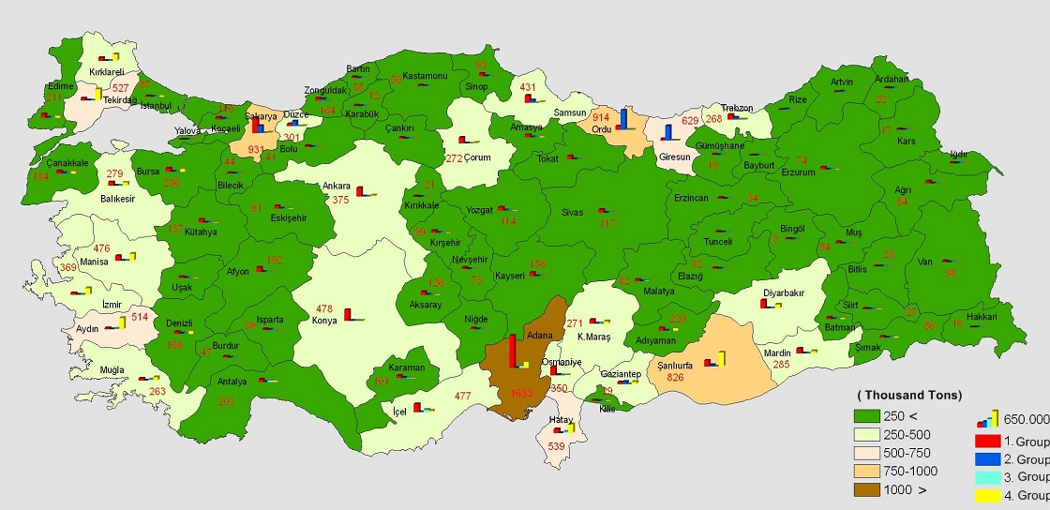

THE BIOMASS AND EQUILAVENT ENERGY POTENTIAL FROM AGRICULTURAL WASTE IN TURKEY
TOTAL OIL EQUIVALENT (TON)
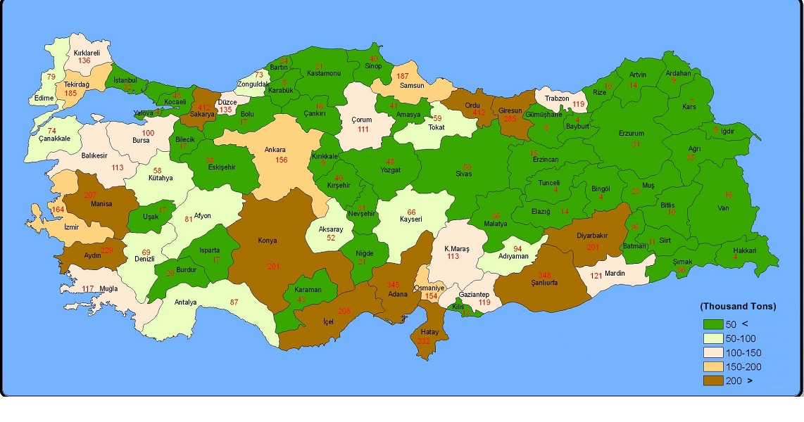
THE BIOGAS AND EQUIVALENT ENERGY POTENTIAL FROM ANIMAL WASTE IN TURKEY
TOTAL UTILIZABLE WASTE
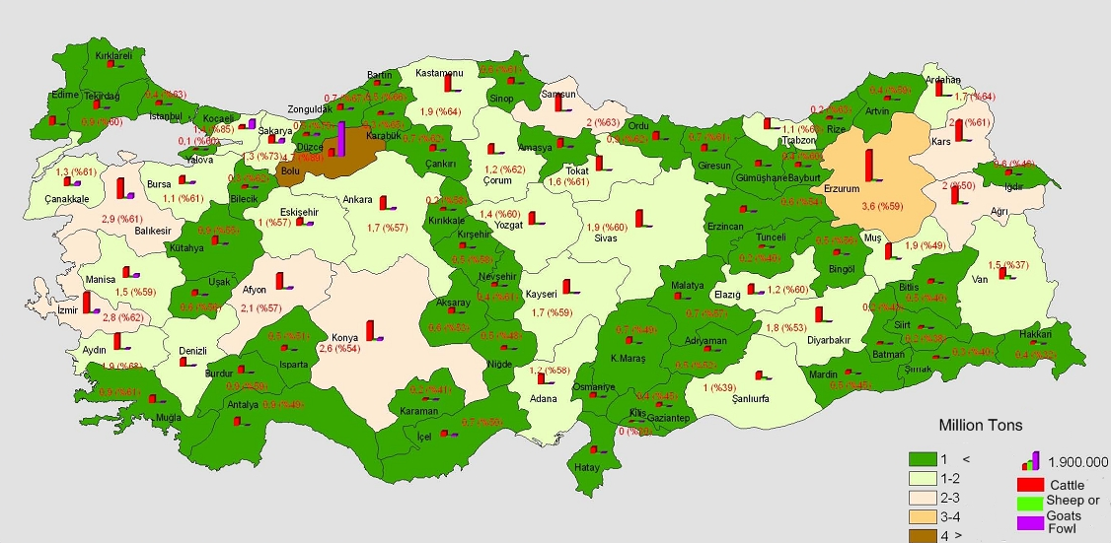

THE BIOGAS AND EQUIVALENT ENERGY POTENTIAL FROM ANIMAL WASTE IN TURKEY
TOTAL OIL EQUIVALENT (TON)
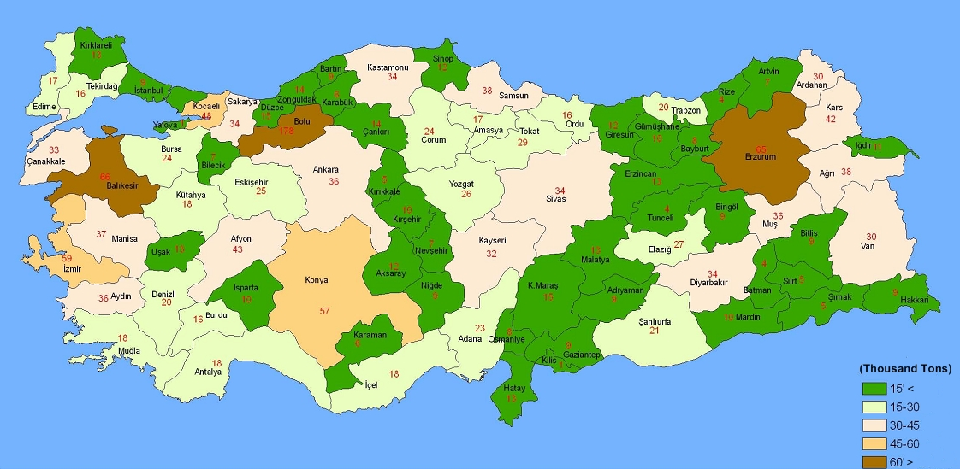
THE TOTAL BIOMASS AND EQUIVALENT ENERGY POTENTIAL FROM AGRICULTURAL AND ANIMAL WASTE IN TURKEY
UTILIZABLE WASTE
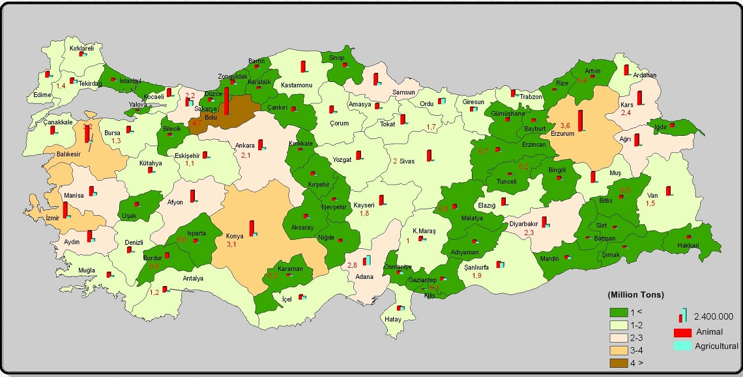THE TOTAL BIOMASS AND EQUIVALENT ENERGY POTENTIAL FROM AGRICULTURAL AND ANIMAL WASTE IN TURKEY
OIL EQUIVALENT (TON)
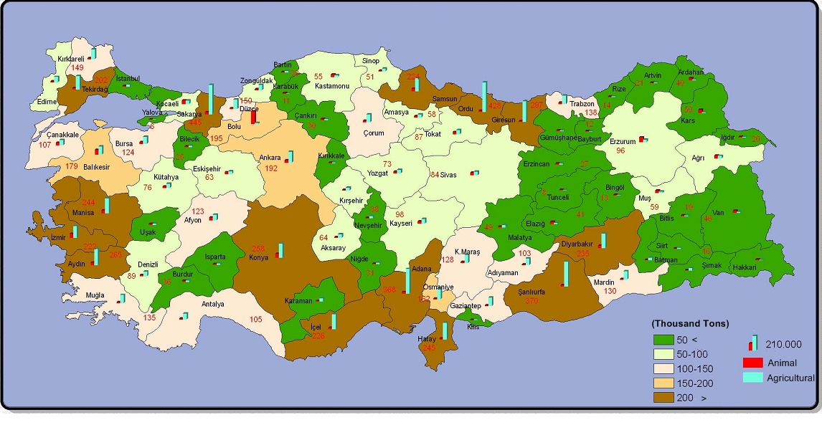
CEREALS

Turkey has a great agricultural production potential arising out of her ecological and climatologically conditions, land property and rich crop pattern. Due to these factors, Turkey is one of the most favored countries in terms of agricultural production.

In Turkey, traditionally cereals lead the list in total agricultural production. Wheat, barley, maize, oats, rye, rice, millet, spelt, canary grass and mixed grain are the main species of cereals grown in Turkey. Especially cool season cereals are grown vastly in comparison with warm season cereals. In particular wheat and barley are the most important crops among cereals.

Although in Turkey, the production of cereals has shown some fluctuations year by year depending especially on climatologically conditions, the total production is more than 30 million tons. While total production of cereals was 34,6 million tons in 2006, this figure was realized as 29,3 million tons in 2007 due to dry weather conditions. Out of the total production in 2008, the share of 60,7% by 17,8 million tons is taken by wheat and the share of 20,2% by 5,9 million tons belongs to barley. The share of other cereals in the total production is 19,1% and a big portion of which is comprised by maize.

Wheat has been grown in Anatolia for thousands of years and is a part of life in rural areas. Likewise, it has significant impact in Turkish people’s diet, with an annual consumption of about 250 kg/per head.

All kind of wheat varieties are grown in Turkey. The major wheat growing regions are Central Anatolia, Thrace and South-Eastern Anatolia. The majority of varieties grown are winter varieties which are planted in fall; September and October. Harvest begins in May through the end of August, differing according to regions.

Production of Cereals n Turkey (1000 Tons)

YEARS | WHEAT | BARLEY | RYE | OATS | MAIZE | RICE
1995 | 18 000 000 | 7 500 000 | 240 000 | 250 000 | 1 900 000 | 120 000
2000 | 21 000 000 | 8 000 000 | 260 000 | 314 000 | 2 300 000 | 210 000
2001 | 19 000 000 | 7 500 000 | 220 000 | 265 000 | 2 200 000 | 230 000
2002 | 19 500 000 | 8 300 000 | 255 000 | 290 000 | 2 100 000 | 252 000
2003 | 19 000 000 | 8 100 000 | 240 000 | 270 000 | 2 800 000 | 260 000
2004 | 21 000 000 | 9 000 000 | 270 000 | 275 000 | 3 000 000 | 294 000
2005 | 21 500 000 | 9 500 000 | 270 000 | 270 000 | 4 200 000 | 360 000
2006 | 20 010 000 | 9 551 000 | 271 000 | 209 000 | 3 811 000 | 418 000
2007 | 17 200 000 | 7 300 000 | 241 000 | 189 000 | 3 535 000 | 389 000
2008 | 17 800 000 | 5 900 000 | 255 000 | 207 000 | 4 280 000 | 457 000
Source: State Institute of Statistics

Turkey has a significant place among the world’s biggest cereal producing countries. While Turkey ranks the ninth in the production of total wheat, ranks fourth in the production of durum wheat. Due to high quality and quantity production, pastry and milling industry products account for more than 30% of agro industrial output in terms of value.

Following wheat, barley is the second most important item among cereals. It is grown to be used mainly as animal feed and in the beer industry. The bulk of barley produced in Turkey has a good reputation in export markets both for its quality and malt characteristics. Similar to wheat, it is grown in all the agricultural regions including double-row and multi-row varieties. Harvesting of barley begins about two weeks before wheat.

Although Turkey is one of the world’s leading producer countries of cereals, domestic consumption is also very high. Despite high domestic consumption, Turkey exports some quantities of cereals every year and the export generally reaches to maximum levels in the years when the climatic conditions are adequate for growing of cereals. Although rice also exported from Turkey, in general is production is insufficient and needs to be supplemented by imports. Turkey exports cereals to various countries all over the world but, most of the exports are oriented to Middle East and European countries.

 | 2005 |  | 2006 |  | 2007 |  | 2008
 | Q | V | Q | V | Q | V | Q | V
WHEAT | 327931 | 52155 | 685673 | 100853 | 18281 | 9132 | 8005 | 5569
BARLEY | 289394 | 39054 | 410498 | 61818 | 215780 | 43399 | 300 | 300
MAIZE | 132578 | 22325 | 180665 | 35950 | 8320 | 12478 | 15056 | 24948
RICE | 813 | 1025 | 5739 | 2322 | 1180 | 1538 | 8034 | 7762
OTHERS | 117 | 51 | 47 | 15 | 109 | 56 | 105 | 167
TOTAL | 750833 | 114610 | 1282622 | 200958 | 243670 | 66603 | 31290 | 38412
Source: Under secretariat for Foreign Trade

COTTON
As an important world cotton grower Turkey ranked seventh in the world production of cotton with about 1 321 thousand tons in 2008. As one of the results of the Southeastern Anatolia Project (GAP), which is the largest project ever attempted in Turkey, cotton production in Turkey has begun to increase.

THE PRODUCTION AND LAND AREA FOR COTTON PRODUCTION
YEAR | PRODUCTION | AREA SAWN
2007/'08 | 1 320 831 | 530 253
2006/'07 | 1 476 556 | 590 700
2005/'06 | 1 291 180 | 546 880
2004/'05 | 1 371 351 | 636 832
2003/'04 | 1 337 065 | 637 329
2002/'03 | 1 457 122 | 721 077
2001/'02 | 1 353 888 | 684 665
2000/'01 | 1 295 066 | 654 177
Source: State Institute of Statistics

PRIVATE COTTON PRODUCER
ASGEN | www.asgen.com.tr | FANTOM PRIM
BAYER TÜRK | www.bayercropscience.com.tr | CARMEN, FLORA, CELIA, CANDIA, JULIA
BİRLİK TOHUMCULUK |  | N-342, N-663, ASSOS
GOLDEN WEST |  | PRIME, PRIMERA, ANAIS, FAMOSA, PLATINA
MAYÇUKONAR | www.may.com.tr | ALPINA, FOTINI, IDEAL, ATLAS, ST 373, ST 453, ST 457, ST 468, ST 474, ST 488
ÖZBUĞDAY | www.ozbugday.com.tr/ | ŞAHİN 2000, BALY 308, TEKS, BA-151, BA GOLD, BA-320, BA-525, AXEL (1029), FLASH (1043)
PUBLIC COTTON PRODUCER
K.MARAŞ T.A |  | SAYAR-314 (Orjinal), MARAŞ-92 (Orjinal), ERŞAN-92 (Orjinal), ERŞAN-92 (Anaç)
N.P.A.E.M. |  | N.84-S, N 663, N.M-503, N DT 15, N 143, N 954, N 342, EKSİ 911, GÜRELBEY, ŞAHİN 2000, AYDIN 110
TARİŞ | www.taris.com.tr | N 84 S, M 503, CARMEN, N 84 S (Anaç), FLORA, CELİA,
TİGEM | www.tigem.gov.tr | MARAŞ-92, SARAY-314
Source: Ministry of Agriculture and Rural Affair, TUGEM (www.tugem.gov.tr), 2008
For more detailed information, please find attached file (CROP PRODUCTS BALANCE SHEETS - CERALS AND OTHER CROP PRODUCTS)!

SEED
In early 1980s, Turkey made major structural reforms and adopted a free market economic policy. These reforms affected the agricultural sector in general and the seed sector in particular. Until the mid 1980s the national seed industry was dominated by the public sector and seed trade was heavily regulated. Government deregulation has dramatically changed both the composition and structure of the seed industry. The private sector is encouraged to participate and invest in plant breeding, infrastructure development and technology transfer.

Seed Production
Seed production is carried out both by public and private sectors. The public sector pruduces seed of wheat, barley, rice and cotton whereas the private sector produces almost seed of all hybrids (maize, sunflower, vegetable and some forage crops. The public sector will gradually withdraw from competition for those crops where the private sector can produces and market seed efficiently. At present formal sector production is sufficient to satisfy the demand for hybrids, cotton, soybean and vegetable crops. Meanwhile, seed production and supply seems inadequate praticularly for cereals and industrial crops.

PUBLIC SEED PRODUCERS
NR |  | NAME | CITY |  |  | PHONE NUMBER |  |  | CONTACT
1 |  | ANADOLU TARIMSAL ARAŞTIRMA ENSTİTÜSÜ MÜDÜRLÜĞÜ | ESKISEHIR |  |  | 0222-3240443 |  |  | www.ataem.gov.tr
2 |  | ANTBİRLİK-ANTALYA PAMUK TARIM SATIŞ KOOPERATİFLERİ BİRLİĞİ | ANTALYA |  |  | 0242-2412974 |  |  | www.antbirlik.com.tr
3 |  | ATATÜRK BAHÇE KÜLTÜRLERİ MERKEZ ARAŞTIRMA ENSTİTÜSÜ MÜDÜRLÜĞÜ | YALOVA |  |  | 0226-8142620 |  |  | www.arastirma-yalova.gov.tr
4 |  | BAHRİ DAĞDAŞ ULUSLAR ARASI TARIMSAL ARAŞTIRMA ENSTİTÜSÜ MÜDÜRLÜĞÜ | KONYA |  |  | 0-332-334050 |  |  | www.bahridagdas.gov.tr
5 |  | BATI AKDENİZ TARIMSAL ARAŞTIRMA ENSTİTÜSÜ MÜDÜRLÜĞÜ | ANTALYA |  |  | 0242-3216797 |  |  | www.batem.gov.tr
6 |  | ÇUKOBİRLİK-ÇUKUROVA PAMUK YERFISTIĞI VE YAĞLI TOHUMLAR TARIM SATIŞ KOOPERATİFLERİ BİRLİĞİ | ADANA |  |  | 0322-4410146 |  |  | www.cukobirlik.com.tr
7 |  | ÇUKUROVA TARIMSAL ARAŞTIRMA ENSTİTÜSÜ MÜDÜRLÜĞÜ | ADANA |  |  | 0322-3340030 |  |  | www.cukurovataem.gov.tr
8 |  | DOĞU ANADOLU TARIMSAL ARAŞTIRMA ENSTİTÜSÜ MÜDÜRLÜĞÜ | ERZURUM |  |  | 0442-3271276 |  |  | www.datae.gov.tr
9 |  | EGE TARIMSAL ARAŞTIRMA ENSTİTÜSÜ MÜDÜRLÜĞÜ | IZMIR |  |  | 0232-8461331 |  |  | www.aari.gov.tr
10 |  | GÜNEYDOĞU ANADOLU PROJESİ EĞİTİM,YAYIM VE ARAŞTIRMA MERKEZİ MÜDÜRLÜĞÜ (HARRAN T. A.E.) | S.URFA |  |  | 0414-4112092 |  |  | www.gapeyam.gov.tr
11 |  | GÜNEYDOĞU ANADOLU TARIMSAL ARAŞTIRMA ENSTİTÜSÜ MÜDÜRLÜĞÜ | DIYARBAKIR |  |  | 0412-2611198 |  |  | www.tagem.gov.tr
12 |  | KAHRAMANMARAŞ TARIMSAL ARAŞTIRMA ENSTİTÜSÜ MD. | K.MARAS |  |  | 0344-2376071 |  |  | www.kahramanmarastaem.gov.tr
13 |  | KARADENİZ TARIMSAL ARAŞTIRMA ENSİTÜSÜ | SAMSUN |  |  | 0362-2560924 |  |  | www.ktae.gov.tr
14 |  | KARADENİZBİRLİK-KARADENİZ YAĞLI TOHUMLAR TARIM SATIŞ KOOPERATİFLERİ BİRLİĞİ | SAMSUN |  |  | 0362-4328380 |  |  | www.karadenizbirlik.com.tr
15 |  | NAZİLLİ PAMUK ARAŞTIRMA ENSTİTÜSÜ MÜDÜRLÜĞÜ |  |  |  | 0256-3131750 |  |  | www.nazillipamuk.gov.tr
16 |  | NİĞDE PATATES ARAŞTIRMA ENSTİTÜSÜ MÜDÜRLÜĞÜ | NIGDE |  |  | 0388-2323354 |  |  | www.patates.gov.tr
17 |  | PANKOBİRLİK (31 Pancar Kooperatifi) | ANKARA |  |  | 0312-4355620 |  |  | www.pankobirlik.com.tr
18 |  | SAKARYA TARIMSAL ARAŞTIRMA ENSTİTÜSÜ MÜDÜRLÜĞÜ | SAKARYA |  |  | 0264-2752591 |  |  | www.staem.gov.tr
19 |  | T.TARIM KREDİ KOOPERATİFLERİ KONYA BÖLGE BİRLİĞİ MD. | KONYA |  |  | 0-322-2456920
20 |  | T.TARIM KREDİ KOOPERATİFLERİ MERKEZ BİRLİĞİ GN. MD. | ANKARA |  |  | 0312-2231364 |  |  | www.tarimkredi.org.tr
21 |  | TARİŞ-İZMİR PAMUK TARIM SATIŞ KOOPERATİFLERİ BİRLİĞİ | IZMIR |  |  | 0232-4224200 |  |  | www.taris.com.tr
22 |  | TARLA BİTKİLERİ MERKEZ ARAŞTIRMA ENSTİTÜSÜ MÜDÜRLÜĞÜ | ANKARA |  |  | 0312-2873334 |  |  | www.tarlabitkileri.gov.tr
23 |  | TİGEM-TARIM İŞLETMELERİ GENEL MÜDÜRLÜĞÜ | ANKARA |  |  | 0312-4178470 |  |  | www.tigem.gov.tr
24 |  | TMO-TOPRAK MAHSULLERİ OFİSİ GENEL MÜDÜRLÜĞÜ | ANKARA |  |  | 0312-4174400 |  |  | www.tmo.gov.tr
25 |  | TRAKYA TARIMSAL ARAŞTIRMA ENSTİTÜSÜ MÜDÜRLÜĞÜ | EDIRNE |  |  | 0284-2358180 |  |  | www.ttae.gov.tr
26 |  | TRAKYABİRLİK-TRAKYA YAĞLI TOHUMLAR TARIM SATIŞ KOOPERATİFLERİ BİRLİĞİ | EDIRNE |  |  | 0284-2255098 |  |  | www.trakyabirlik.com.tr
27 |  | TÜRKİYE ŞEKER FABRİKALARI A.Ş. GENEL MÜDÜRLÜĞÜ | ANKARA |  |  | 0312-4359815 |  |  | www.turkseker.gov.tr
PRIVATE SEED PRODUCERS

NO |  | COMPANY NAME |  |  | CITY |  |  | CONTACT |  |  | FIELD
1 |  | ACAR ÇİM TOHUMU VE ÇEVRE DÜZENLEME TİC.LTD.ŞTİ. (B) |  |  | ISTANBUL |  |  | acar@kablonet.com.tr |  |  | Grass, Clover, Maize, Vegetable
2 |  | ACUN TOHUMCULUK TAR.ÜR.SAN VE TİC.LTD.ŞTİ. |  |  | ISTANBUL |  |  | acunseed@mynet.com |  |  | Vegetable, Paddy
3 |  | ADVANTA TOHUM ISLAH VE ÜRETİM SAN. VE TİC.A.Ş. (AB) |  |  | ISTANBUL |  |  | www.advantatohum.com.tr |  |  | Sunflower, Maizer, Clover, Fodder
4 |  | AGROMAR MARMARA TARIM ÜRÜNLERİ SAN.VE TİC.A.Ş. (AB) |  |  | BURSA |  |  | www.agromar.com |  |  | Vegetable, Maize, Sunflower
5 |  | AGROTAN TOHUMCULUK VE TAR. ÜRÜN. TİC. LTD. ŞTİ.(A) |  |  | BALIKESIR |  |  |  |  |  | Vegetable, Clover
6 |  | AGROTEK TOHUMCULUK TARIM SAN. VE TİC. LTD. ŞTİ. (A) |  |  | ANTALYA |  |  |  |  |  | Vegetable
7 |  | AGROVA TARIMSAL ÜRT.PAZ VE SAN.LTD.ŞTİ (B) |  |  | ADANA |  |  | www.agrovatohum.com |  |  | Peanut, soybean
8 |  | AKDENİZ TOHUM SANAYİ VE TİCARET LTD.ŞTİ |  |  | ISTANBUL |  |  | www.akdeniztohum.com |  |  | Maize
9 |  | ALANYA TOHUMCULUK LTD.ŞTİ (A) |  |  | ANTALYA |  |  | alanyatohumculuk@hotmail.com |  |  | Vegetable
10 |  | Ali ÖNER |  |  | EDIRNE |  |  |  |  |  | Clover
11 |  | ALP TARIM İLAÇLARI PAZ.SAN.TİC.LTD.ŞTİ |  |  | KONYA |  |  | alptarim@e-kolay.net |  |  | Wheat, Barley, Maize, Fodder
12 |  | ALTIN TOHUMCULUK TİC. SAN. A.Ş. (AB) |  |  | IZMIR |  |  | altintohumculuk@superonline.com |  |  | Vegetable
13 |  | ALTINBAŞAK TARIM TİCARET |  |  | EDIRNE |  |  |  |  |  | Wheat, Clover
14 |  | AMC-TR TARIM SAN VE TİC.A.Ş. |  |  | ANTALYA |  |  | amc-tr@superonline.com |  |  | Vegetable
15 |  | ANADOLU EFES BİRACILIK VE MALT SAN. A.Ş. (AB) |  |  | KONYA |  |  | www.efespilsen.com.tr |  |  | Barley
16 |  | ANADOLU TOHUM ÜRETİM PAZARLAMA A.Ş. (AB) |  |  | ISTANBUL |  |  | www.anatoh.com |  |  | Clover, Maize
17 |  | ANKA TOHUMCULUK TAR.SAN.VE TİC.LTD.ŞTİ. (B) |  |  | NEVSEHIR |  |  | ankatohumculuk@superonline.com |  |  | Potato
18 |  | ANT TOHUM TARIMSAL ÜRT.PAZ.A.Ş. (A) |  |  | BURSA |  |  |  |  |  | Vegetable
19 |  | AR TARIM TOHUMCULUK SANAYİ VE TİCARET A.Ş. (AB) |  |  | IZMIR |  |  | www.artarim.com |  |  | Potato
20 |  | ASD PLASTİK AMBALAJ VE TOHUM SAN.TİC.LDT.ŞTİ (AB) |  |  | KONYA |  |  | asd-imp@hotmail.com |  |  | Maize, Barley
21 |  | ASGEN TARIM TİCARET A.Ş. (AB) |  |  | ISTANBUL |  |  | www.asgen.com.tr |  |  | Potato, Maize, Vegetable
22 |  | ATA TOHUMCULUK İŞLETMELERİ SAN. VE TİC.A.Ş. (B) |  |  | ANKARA |  |  | atatohum@ttnet.net.tr |  |  | Barley, Wheat
23 |  | ATAKOL TAR. TOH. VE HAY. SAN.TİC.LTD.ŞTİ. |  |  | ANKARA |  |  | www.atakol-tohum.com |  |  | Wheat, Fodder Beet, Maize, Clover
24 |  | ATELSAN TARIM ÜRÜNLERİ VE TOHUMCULUK A.Ş. |  |  | KONYA |  |  |  |  |  | Wheat, Oat
25 |  | AYER TARIM SAN.VE TİC.A.Ş. (AB) |  |  | ANTALYA |  |  | www.ayer.com.tr |  |  | Vegetable
26 |  | BAHAR TOHUMCULUK ZİR.TİC.SAN.LTD.ŞTİ. |  |  | BURSA |  |  |  |  |  | Vegetable
27 |  | BALIKESİR TOHUM A.Ş. |  |  | BALIKESIR |  |  |  |  |  | Vegetable
28 |  | BAŞARI TOHUM ISLAH ÜRETİM SAN.ve TİC.LTD.ŞTİ |  |  | ISTANBUL |  |  |  |  |  | Vegetable
29 |  | BATI ASYA TOH ve TAR. ÜR. SAN TİC. A.Ş. |  |  | ANKARA |  |  |  |  |  | Vegetable
30 |  | BAYER TÜRK KİMYA SAN. LTD. ŞTİ.(AB) |  |  | ISTANBUL |  |  | www.bayercrops.com |  |  | Cotton
31 |  | BERK TOHUMCULUK TARIM ÜRÜNLERİ İNŞ.TR.YAT.SAN.VE LTD ŞTİ |  |  | IZMIR |  |  |  |  |  | Vegetable
32 |  | BETA ZİRAAT VE TİC. A.Ş. (AB) |  |  | ANKARA |  |  | www.betaziraat.com |  |  | Vegetable, Sugar Beat, Maize,Clover
33 |  | BEZRA TARIM ÜRÜN. BESİCİLİK VE GIDA SAN. TİC. LTD. ŞTİ. |  |  | KONYA |  |  |  |  |  | Clover
34 |  | BİAR TOHUMCULUK BİTKİSEL ARŞ. ÜRT. LTD. ŞTİ. (A) |  |  | ISTANBUL |  |  |  |  |  | Vegetable
35 |  | BİOTEK TOH. TAR. ÜR.SAN.TİC.LTD.ŞTİ. (A) |  |  | KONYA |  |  | www.biotek.com.tr |  |  | Vegetable, Fodder, Sunflower, Maize
36 |  | BOLPAT BOLU PATATES SAN VE TİC A.Ş(B) |  |  | BOLU |  |  | www.bolpat.com.tr |  |  | Potato
37 |  | BURSA TOHUMCULUK ZİR.VE TİC.A.Ş. (AB) |  |  | BURSA |  |  | www.bursaseed.com |  |  | Vegetable
38 |  | C.P STANDART GIDA SAN. VE TİC. A.Ş.(A) |  |  | ISTANBUL |  |  | bayrambolat49@hotmail.com |  |  | Maize
39 |  | CANSA PEYZAJ İNŞ.TAAH.TİC.VE SAN.LTD.ŞTİ. |  |  | ANKARA |  |  | umutdogan@yahoo.com |  |  | Vegetable, Clover
40 |  | CİN TARIM TİCARET LTD. ŞTİ. |  |  | İCEL |  |  |  |  |  | Vegetable
41 |  | COŞKUN TARIM ZİR.ÜR.İTH.İHR. |  |  | ANTALYA |  |  | www.coskuntarim.com |  |  | Wheat
42 |  | ÇAĞDAŞ TOHUM. TARIM SAN.VE TİC. LTD.ŞTİ. (AB) |  |  | ADANA |  |  | cagdastohum@superonline.com |  |  | Vagetable
43 |  | ÇAYIRCI TOHUMCULUK VE BAHARATÇILIK SAN.TİC.LTD.ŞTİ. |  |  | ADANA |  |  |  |  |  | Vagetable
44 |  | ÇİM TEKNİK TOH.ZİR. SANAYİ VE TİC.LTD.ŞTİ.(AB) |  |  | ANKARA |  |  | ulusoya@superonline.com |  |  | Clover
45 |  | ÇİM TOHUMCULUK ZİRAAT SAN. VE TİC.LDT.ŞTİ. |  |  | IZMIR |  |  | cimto@mynet.com |  |  | Vegetable, Fodder
46 |  | ÇİM-ART TOHUMCULUK TAR. İNŞ.PEY. SAN. VE TİC. LTD. ŞTİ. |  |  | ANKARA |  |  | www.cim.art.com |  |  | Clover
47 |  | ÇİMSAN TARIMSAL ÜRÜNLER TİC.LTD.ŞTİ.(AB) |  |  | ISTANBUL |  |  | www.cimsan.com.tr |  |  | Grass, Canola
48 |  | ÇUKUROVA TOHUMCULUK SAN. VE TİC.LTD.ŞTİ. |  |  | ADANA |  |  |  |  |  | Vegetable
49 |  | DAKO TOHUMCULUK TİC. VE SAN. A.Ş. (AB) |  |  | ADANA |  |  | damar@superonline.com |  |  | Maize
50 |  | DAĞDEVİREN. TOHC. TAR. MAK. VE OTO SAN. TİC. LTD. ŞTİ. |  |  | KONYA |  |  |  |  |  | Clover
51 |  | DOĞA TOHUMCULUK PAZARLAMA İTH.İHR. SAN.VE TİC.LTD.ŞTİ. (A) |  |  | NEVSEHIR |  |  |  |  |  | Potato
52 |  | DOĞA ZİRAAT VE ÇEVRE TASARIM TİC. VE SAN.LTD.ŞTİ. |  |  | ANKARA |  |  |  |  |  | Vegetable
53 |  | E.K.O TARIM GIDA PAZARLAMA ve TİC.AŞ. (B) |  |  | ISTANBUL |  |  | www.ekomisir.com |  |  | Maize
54 |  | EKSUN GIDA TARIM SAN. Ve TİC.A.Ş. |  |  | TEKIRDAG |  |  | www.eksun.com.tr |  |  | Wheat
55 |  | ELÇİ TOHUMCULUK |  |  | ANKARA |  |  |  |  |  | Fodder
56 |  | ELİTRA TOH.ZİR. VE KİM.ÜRN.SAN.TİC.LTD.ŞTİ.(B) |  |  | IZMIR |  |  | www.elitraseed.com |  |  | Vegetable
57 |  | FİTO TOHUMCULUK TİC.LTD.ŞTİ.(A) |  |  | ANTALYA |  |  | fitotohum@superonline.com |  |  | Vegetable, Fodder, Maize, Grass
58 |  | FRİTO LAYS GIDA SAN. TİC. A.Ş. |  |  | KOCAELI |  |  | www.intl.fritolay.com |  |  | Potato
59 |  | GENAGRI SEED (A) |  |  | ANTALYA |  |  | www.genagri.com |  |  | Vegetable
60 |  | GENÇ TOHUMCULUK ÜR.AR.TUR.SAN ve TİC.LTD.ŞTİ. |  |  | TEKIRDAG |  |  |  |  |  | Barley, Sunfloer, Maize
61 |  | GENTA GENELTARIM ÜRÜNLERİ PAZARLAMA A.Ş. |  |  | ISTANBUL |  |  | www.anatoh.com |  |  | Vegetable
62 |  | GENTAR TOH.SAN.ve TİC.LTD.ŞTİ. (A) |  |  | ADANA |  |  | gentartohum@tt.net.tr |  |  | Vegetable
63 |  | GÖMEÇ TARIMSAL ÜR.PAZ.SAN. VE TİC.A.Ş. |  |  | NEVSEHIR |  |  |  |  |  | Potato
64 |  | GÖMEÇ TOHUM.TARIM SAN.VE TİC.A.Ş. (AB) |  |  | NEVSEHIR |  |  | www.gomectohumculuk.com.tr |  |  | Potato
65 |  | GÜLİSTAN-GÜLTAŞ A.Ş. (AB) |  |  | ADANA |  |  | gultas@superonline.com |  |  | Vegetable
66 |  | GÜN-TAR ZİRAİ TOHUMLUK, İLAÇ VE HAYVANCILIKLTD.ŞTİ. |  |  | TEKIRDAG |  |  | guntar59@guntar59.com |  |  | Wheat, Barley, Fodder, Paddy
67 |  | HARMAN TARIM TOHUMCULUK VE GIDA PAZ. TİC.LTD.ŞTİ. |  |  | EDIRNE |  |  | huseyinucar@hotmail.com |  |  | Paddy, Wheat
68 |  | HASEL TARIM ÜRÜNLERİ SAN.TİC. LTD.ŞTİ.(B) |  |  | ANTALYA |  |  | www.haseltarim.com |  |  | Vegetable
69 |  | HAZERA TOHUMCULUK VE TİC. A.Ş.(A) |  |  | ANTALYA |  |  |  |  |  | Vegetable
70 |  | İbrahim AKGÜN |  |  | EDIRNE |  |  |  |  |  | Paddy, Wheat
71 |  | İLCİ İNŞAAT SAN. VE TİC. A.Ş. |  |  | ANKARA |  |  | www.ilci.com.tr |  |  | Wheat, Barley, Fodder
72 |  | İSTANBUL TARIM SAN. VE TİC. A.Ş.(AB) |  |  | ANTALYA |  |  | www.istanbultarim.com.tr |  |  | Vegetable, Grass
73 |  | İSTANBUL TOHUMCULUK TARIM SAN.VE TİC. LTD.ŞTİ.(AB) |  |  | ISTANBUL |  |  | www.istanbultohumculuk.com.tr |  |  | Vegetable, Grass
74 |  | İSTEFAN KOVAÇİ VARİSİ ELENAUYGAN VE ORTAĞI |  |  | ISTANBUL |  |  |  |  |  | Vegetable, Grass
75 |  | İTAŞ-İHRACATÇI BİRLİKLERİ TOH.VE ARŞT. SAN. VE TİC. A.Ş.(AB) |  |  | ANKARA |  |  | www.itas.com.tr |  |  | Chickpea, Beans
76 |  | KAFKAS TOHUMCULUK LTD.ŞTİ. |  |  | BURSA |  |  | kafkastohum@mynet.com |  |  | Vegetable, Fodder
77 |  | KARTAŞ TAR. ÜRÜN. TİC. LTD. ŞTİ. |  |  | TEKIRDAG |  |  | www.kartastarim.com |  |  | Wheat
78 |  | KAYA TOHUMCULUK SAMİ KAYA |  |  | ISTANBUL |  |  | kayao@ultratv.net |  |  | Vegetable, Grass
79 |  | KAZAK TARIM İNŞ. TAAH. SAN. VE TİC.LTD.ŞTİ. |  |  | ANKARA |  |  | www.kazaktarim.com.tr |  |  | Grass, Fodder
80 |  | KRAFT GIDA SAN.VE TİC.A.Ş. |  |  | ISTANBUL |  |  | www.krafteurope.com |  |  | Potato
81 |  | KÜÇÜK ÇİFTLİK TOHUMCULUK VE TARIM ÜRETİM PAZ. VE SAN. LTD.ŞTİ. |  |  | BALIKESIR |  |  |  |  |  | Vegetable
82 |  | KWS TÜRK TAR. TİC. LTD. ŞTİ. |  |  | ESKISEHIR |  |  | www.kwsturk.com.tr |  |  | Maize, Fodder
83 |  | LOTUS TARIM TOH. ve GÜB. SAN. AŞ. |  |  | ANTALYA |  |  | www.lotustarim.com |  |  | Vegetable
84 |  | MANİER TAR.KİM MEDK.İNŞ.TUR.SAN.TİC.LDT.ŞTİ (A) |  |  | HATAY |  |  | www.manier.com.tr |  |  | Vegetable
85 |  | MARO TARIM İNŞAAT TİC. VE SAN.A.Ş.(B) |  |  | ANKARA |  |  | www.maro.com.tr |  |  | Vegetable
86 |  | MARTAR TOHUMCULUK MARMARA TAR. SAN. VE TİC. A.Ş. |  |  | BALIKESIR |  |  |  |  |  | Wheat
87 |  | MAY TOHUMCULUK ZİR. VE TİC. LTD.ŞTİ. (AB) |  |  | BURSA |  |  | www.may.com.tr |  |  | Vegetable
88 |  | MAY–AGRO AŞ. (AB) |  |  | BURSA |  |  | www.may.com.tr |  |  | Soybean, Sunflower, Maize, Fodder
89 |  | MAY-ÇUKONAR (AB) |  |  | ADANA |  |  | www.may.com.tr |  |  | Cotton
90 |  | MEN-PA TAR. ÜR.SAN. ÜR.PAZ.İTH.İHR.TİC.LTD.ŞTİ |  |  | ADANA |  |  |  |  |  | Potato
91 |  | METGEN TOH.SAN.TİC.LTD.ŞTİ. |  |  | ISTANBUL |  |  | yildiray.gencer@superonline.com |  |  | Vegetable
92 |  | MONSANTO TARIM SANAYİ VE TİCARET LTD.ŞTİ.(AB) |  |  | ISTANBUL |  |  | www.monsanto.com |  |  | Maize, Sunflower
93 |  | MULTİ TARIM LTD.ŞTİ. (A) |  |  | ANTALYA |  |  | multi@superonline.com |  |  | Vegetable
94 |  | NEOBİ TOHUMCULUK A.Ş.(A) |  |  | IZMIR |  |  | www.neobi.com.tr |  |  | Vegetable, Fodder
95 |  | NUMHEMS TOHUMCULUK LTD.ŞTİ.(AB) |  |  | ANTALYA |  |  | skenar@superonline.com |  |  | Vegetable
96 |  | OSM ŞAHİN TOHUMCULUK SAN.TİC.LTD.ŞTİ |  |  | KONYA |  |  |  |  |  | Barley, Fodder
97 |  | OTLULAR TARIMSAL ÜR. DANIŞMANLIK TİC.Ltd.Şti |  |  | ANTALYA |  |  | otlular@tnn.net |  |  | Vegetable
98 |  | ÖNDER TOHUMCULUK SANAYİ VE TİC. A.Ş. |  |  | TEKİRDAG |  |  | ondertohum@mynet.com |  |  | Wheat, Barley
99 |  | ÖZBUĞDAY TARIM İŞL.VE TOH.A.Ş. (AB) |  |  | HATAY |  |  | www.ozbugday.com.tr |  |  | Cotton, Maize, Wheat
100 |  | ÖZTAR TOHUMCULUKVE TARIM ÜR.ÜRETİM VE TİC. A.Ş. (A) |  |  | IZMIR |  |  |  |  |  | Potato
101 |  | PAMUKKALE TOHUMCULUK GÜBRE ZIRAİ İLAÇLAR VE TARIM ÜRÜN. SAN. TİC. LTD. ŞTİ. |  |  | DENIZLI |  |  |  |  |  | Wheat, Barley
102 |  | PAN TOHUM ISLAH VE ÜRETME A.Ş. (AB) |  |  | ANKARA |  |  | pantohum@superonline.com.tr |  |  | Maize
103 |  | PAŞA TOHUMCULUK TOHUM, ZİRAİ İLAÇ, TARIM ÜRÜNLERİ PAZ.TİC |  |  | BALIKESIR |  |  | pasatohumculuk@hotmail.com |  |  | Vegetable
104 |  | PİONEER TOHUMCULUK A.Ş. (AB) |  |  | ISTANBUL |  |  | www.pioneer.com |  |  | Sunflower, Maize
105 |  | POLEN TOHUMCULUK VE TARIM ÜRÜNLERİ SAN. VETİC.LTD.ŞTİ. (AB) |  |  | MANISA |  |  | www.polenseed.com |  |  | Maize, Clover
106 |  | POLTAR TARIM ÜRÜNLERİ SAN.VE TİC.LTD.ŞTİ. (AB) |  |  | IZMIR |  |  | www.poltar.com.tr |  |  | Maize, Vegetable
107 |  | PROSEED TOH.ZİRAİ İLAÇ İNŞ.VE MALZ.TAR.GIDA VE SAN.TİC.LTD.ŞTİ |  |  | MERSIN |  |  | www.proseed.com.tr |  |  | Vegetable
108 |  | RİTO TOHUMCULUK A.Ş. (AB) |  |  | ANTALYA |  |  | ritonazmi@superonline.com |  |  | Vegetable
109 |  | SAFA TARIM A.Ş. (A.B) |  |  | KONYA |  |  | www.safatarim.com |  |  | Vegetable
110 |  | SAFİR TARIM ÜRÜN. SAN. VE TİC. LTD.ŞTİ. |  |  | BURSA |  |  | www.safirtarim.com |  |  | Clover
111 |  | SANPA GIDA SAN. VE TİC. A.Ş |  |  | AFYON |  |  |  |  |  | Potato
112 |  | SANTO TOHUM SAN.İTH.İHR.PAZ.VE TİC.LTD.ŞTİ. |  |  | ANTALYA |  |  |  |  |  | Vegetable
113 |  | SANTRAL İNŞAAT TAAH. SAN. TİC. LTD. ŞTİ. |  |  | ISTANBUL |  |  | www.santralinsaat.com |  |  | Fodder, Clover
114 |  | SEMİNİS TOHUMCULUK A.Ş. (AB) |  |  | ANTALYA |  |  | www.seminis.com |  |  | Vegetable
115 |  | SEMİTO TOHUM TAR. SAN.VE TİC.LTD.ŞTİ. (A) |  |  | IZMIR |  |  |  |  |  | Vegetable
116 |  | SERA TARIM TİCARETA.Ş (AB) |  |  | ISTANBUL |  |  | www.seratarim.com.tr |  |  | Vegetable
117 |  | SERTA ZİR.ÜR.İTH.İHR.TİC.LTD.ŞTİ |  |  | ANKARA |  |  |  |  |  | Maize
118 |  | SETO SEBZE TOHUMLARI ÜRETİM TİC. A.Ş. (AB) |  |  | ANTALYA |  |  | www.seto.com.tr |  |  | Vegetable
119 |  | SF EKİN TOHUMCULUK LTD.ŞTİ. |  |  | ANKARA |  |  | bsdogan@yahoo.com |  |  | Vegetable, Grass
120 |  | SİMGE TARIM SAN. İÇ VE DIŞ TİC.LTD.ŞTİ. |  |  | IZMIR |  |  | www.paykoc.com |  |  | Maize
121 |  | SU TARIM LTD.ŞTİ. (AB) |  |  | ANTALYA |  |  | www.sutarim.com.tr |  |  | Vegetable
122 |  | SÜRDE TARIM GIDA LTD.ŞTİ. |  |  | ANTALYA |  |  |  |  |  | Potato
123 |  | SYNGENTA TARIM SAN VE TİC.A.Ş. (AB) |  |  | ISTANBUL |  |  | www.syngenta.com |  |  | Hybrid Maize, Hybrid Sunflower, Vegetable
124 |  | TAREKS TARIM ÜRÜNLERİ ARAÇ GEREÇ İTH.İHR.VE TİC. A.Ş. (AB) |  |  | ANKARA |  |  | tareksas@e-kolay.net |  |  | Potato, Wheat, Paddy, Maize
125 |  | TARMAKS TARIMSAL MAK. SAN. ÜRET. VE TİC.LTD. ŞTİ. |  |  | ANTALYA |  |  | tarmaks@superonline.com |  |  | Vegetable
126 |  | TARIM MARKET TAR. KİM. GIDA. VE İNŞ. SAN. TİC. VE PAZ. LTD. ŞTİ. |  |  | YOZGAT |  |  |  |  |  | Wheat, Barley
127 |  | TASACO TARIM SAN.VE TİC.A.Ş. (AB) |  |  | ANTALYA |  |  | www.tasaco.com |  |  | Fodder, Wheat, Barley, Paddy, Vegetable
128 |  | TAT TOHUMCULUK A.Ş.(AB) |  |  | ISTANBUL |  |  | www.tat.com.tr |  |  | Vegetable
129 |  | TEPEOĞLU TOHUMCULUK |  |  | ESKISEHIR |  |  |  |  |  | Vegetable, Fodder
130 |  | TEZEL TARIM ÜRÜNLERİ TİC.VE SAN. LTD.ŞTİ. |  |  | NEVSEHIR |  |  |  |  |  | Potato
131 |  | TİVAK TARIM ÜRÜNLERİ SAN.VE TİC.A.Ş. (B) |  |  | ANKARA |  |  | tivakas@ttnet.net |  |  | Fodder, Wheat, Maize
132 |  | TOPRAK TARIM LTD.ŞTİ. |  |  | ADANA |  |  | toprakseeds@hotmail.com |  |  | Vegetable
133 |  | TOROS TARIMSAL ÜRT. PAZ.A.Ş. (AB) |  |  | ISTANBUL |  |  | www.toros.com.tr |  |  | Vegetable, Wheat
134 |  | TORUN ZİRAAT TOH. SAN VE TİC. LTD. ŞTİ. |  |  | ISTANBUL |  |  | www.toruntohum.com |  |  | Vegetable
135 |  | TRAKYA TARIM VE VET. TİC.LTD.ŞTİ. (AB) |  |  | TEKIRDAG |  |  | www.trakyatarim.com |  |  | Peddy, Wheat, Barley
136 |  | TÜRK DELTAPİNE INC. (AB) |  |  | IZMIR |  |  | www.deltapine.com.tr |  |  | Cotton
137 |  | ULUSOY TOHUMCULUK ZİR.SAN.VE TİC.LTD.ŞTİ. (AB) |  |  | ANKARA |  |  | www.ulusoyseed.com.tr |  |  | Grass, Fodder
138 |  | ÜNAL TOHUMCULUK LTD.ŞTİ. |  |  | ISTANBUL |  |  | www.unalpeyzaj.com |  |  | Grass
139 |  | YAPRAK TARIM SAN. VE TİC.A.Ş. |  |  | ISTANBUL |  |  |  |  |  | Vegetable
140 |  | YAVAŞOĞLU TİCARET |  |  | EDIRNE |  |  |  |  |  | Paddy
141 |  | YİĞİT TOH.TİC ve SAN.Ltd.Şti |  |  | ESKISEHIR |  |  | yucelali@mynet.com |  |  | Grass, Vegetable, Maize
142 |  | YONCA TARIM ÜR.TOHUM MÜH.SAN.TİC.LTD.ŞTİ |  |  | KONYA |  |  | www.yoncatarim.com |  |  | Fodder
143 |  | YÜKSEL TOHUM TAR.SAN.TİC.LTD.ŞTİ.(AB) |  |  | ANTALYA |  |  | www.yukseltohum.com |  |  | Vegetable
144 |  | ZİMAD ZİRAİ İHT.MAD. İNŞ.TURİZM NAK.SAN ve TİC.LTD.ŞTİ |  |  | ANKARA |  |  | zimad2000@ttnet.net.tr |  |  | Wheat, vetch
145 |  | (TÜRK-TED) TÜRKİYE TOHUMCULUK ENDÜSTRİSİ BİRLİĞİ DERNEĞİ |  |  | ANKARA |  |  | www.turkted.org.tr
A Certified R&D
B Member of (TÜRK-TED)
AB R&D Entities and Member of (TÜRK-TED)
Source: Ministry of Agriculture and Rural Affair, TUGEM (www.tugem.gov.tr), 2008

TIMBER AND TIMBER PRODUCTS
Forestry in Turkey has a well-established past. Since the concept of sustainable management of forests has changed considerable, forestry in Turkey is changing fast to adapt itself to the new concept.
The total area of Turkey is 77,6 million hectares and 27,2% of this area, which is an area of 21,2 million hectares, is forests. A total of 54,4% of the forests in Turkey is of needed (coniferous) trees and 45,6% is of broad-leaved trees. At present the forests were classified as state forest, public forest, private forest and foundation forest. The forests have been divided into three categories in terms of quality and character; protected forests, national parks and productive forests.
In Turkey, about half of the forests are productive forests and in that area, in the past three years, an annual average of 11 million m³ of industrial wood and 12 million m³ of firewood have been produced. Industrial wood production is mainly directed to the manufacturing of logs, wood-based panels (plywood, blackboard, particle board, MDF, HDF and OSB), pulpwood and other wood industries.
For more detailed information, please find attached file (FORESTRY STATISTICS - REPORT 2007)!

