

**Oil Industry in Turkey**

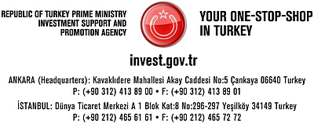

|  |  |
| --- | --- |
| **Content** |  |
| Introduction to Oil Industry in Turkey | 2 |
| Players in the Sector | 2 |
| Exploration Activities | 3 |
| Pipelines | 4 |
| Downstream | 6 |
| Guideline for Investment in the Petroleum Market | 7 |
| Guideline for Investment in the Liquefied Petroleum Gases Market | 11 |
| Useful Links | 14 |

**OIL INDUSTRY in TURKEY**

**Introduction**

Turkey is not a rich country in terms of oil reserves, while the country’s robust economy and growing industry require a huge demand for energy in general, oil in particular. Hence, to meet such an inelastic and growing promises profitable investment opportunities for investors. According to the General Directorate of Petroleum Affairs*,* Turkey has around 265 million barrels of remaining recoverable oil reserves by the end of 2007, while having 6,7 billion barrels of proven and probable-possible oil reserves in total. In 2007, Turkey produced 41,000 barrels per day (bbl/d) of crude oil. Turkey’s total oil production has declined by half since 1991, when production peaked at 85,741 bbl/d. Turkey’s total consumption of oil was 595,970 bbl/d in 2007, up about 3,5 percent from 2006 figures.

Turkey imported 451,571 bbl/d of crude oil in 2007, around 40 % of which was imported from Russia while 38 % from Iran, and Saudi Arabia came third 14 %. The import of crude oil cost Turkey USD 12 billion in 2007.

**Players in the Sector**

Turkey’s oil sector is mixed, comprised of various state-owned, private, and foreign companies. Oil exploration and production activities are dominated by the Turkish Petroleum Corporation (TPAO), which accounts for roughly 70 percent of Turkey’s domestic oil output. The principal government body charged with monitoring the oil sector is the Ministry of Energy and Natural Resources (MENR), which is the key decision-making body that approves new projects along with the State Planning Organization (DPT).

The downstream oil refining and storage sector is dominated by former state-owned enterprise Turkish Petroleum Refineries Co. (TUPRAS), which controls Turkey’s entire refining activities. In September 2005, the Koc-Shell Joint Venture Group purchased a 51 percent stake in Tupras for $4.14 billion. After purchasing the shares, the Koc-Shell consortium formed Enerji Yatirimlan SA to take delivery of the transferred shares. In the oil transport sector, Petroleum Pipelines Co. (BOTAS) owns and operates virtually the entire pipeline network in Turkey. In December 2003, a petroleum market reform bill was passed by Turkey's parliament. The Petroleum Market Law aims to remove state controls on the hydrocarbon sector, liberalize pricing of oil and oil products, end restrictions on vertical integration, and integrate pipeline, refining, and distribution functions. Also, as a result of this law, price ceilings and import quotas on petroleum products were lifted in early 2005.

**Exploration Activities**

Exploration licenses are granted by the General Directorate of Petroleum Affairs, while other licenses are granted by the Energy Market Regulation Authority. The majority of Turkey’s oil reserves are located in southeastern part of the country and in the Thrace region in the northwest. International oil majors, Royal Dutch Shell and ExxonMobil are the largest foreign oil producers in Turkey. The leading exploration and production companies are TPAO, Perenco, Toredor, Aladdin Middle East Joint Venture, Thrace Basin, Amity Oil, Pinacle, Petroleum & Dorchester, Stratic.

**Exploration Fields in Turkey**

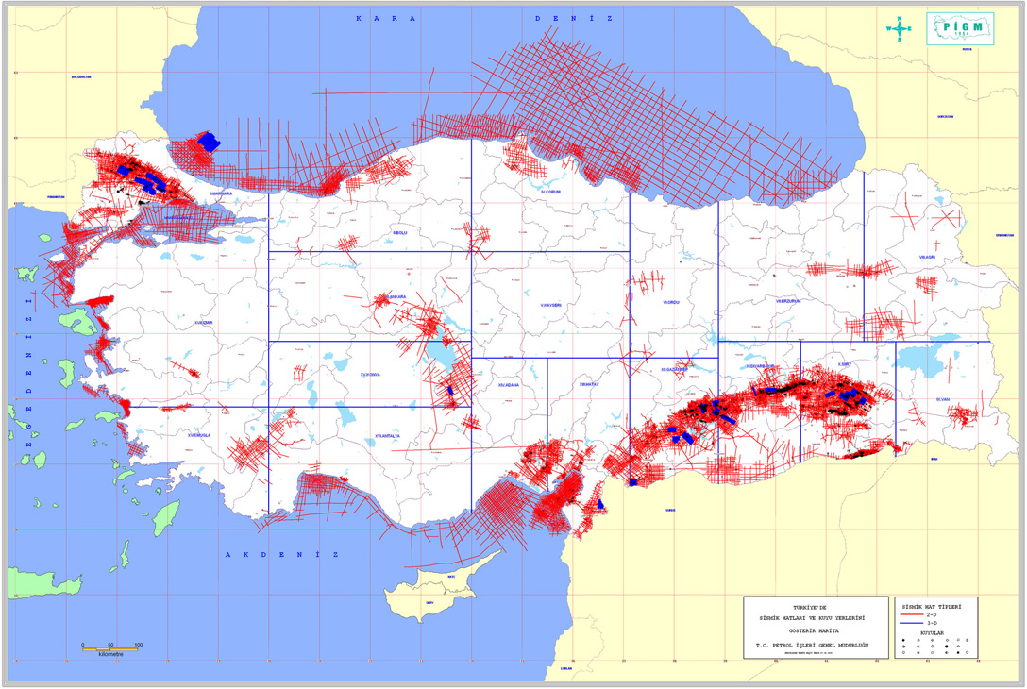

Recent oil exploration activities have focused on Turkey’s offshore regions, where the country holds oil prospects in the Black, Mediterranean, and Aegean Seas. Some reports suggest the Aegean Sea could hold sizeable oil reserves. 20% of the onshore and 1% of the offhore have been explored yet. In 2005, TPAO and its international partners drilled the country’s first exploration wells in the Black Sea. The TPAO-Torreador-Stratic joint venture oversees the Western Black Sea Exploration and Development Project, while the TPAO-BP-Chevron joint venture runs the Eastern Black Sea Offshore Project. Similarly a joint operating agreement was signed by PetroBras and TPAO on August 17, 2006 for exploration in Black Sea.

45 companies, (25 of them foreign and 20 local), carried out exploration activities in Turkey in 2007. During the same year, 62 exploration licenses covering 5.920.460 hectares were granted to 16 companies of 45 companies, conducting exploration activities. As of the end of 2007, 37 companies had 391 exploration licenses covering 36.578.078 hectares. Compared to the previous year it has been observed that number of exploration licenses increased by 4,5 %. TPAO owns 152 exploration licenses (39 %), covering 25.763.266 hectares equivalent to 70% of total acreage. 116 wells, 100 new and 16 from the previous year, were drilled in 200, amounting 149.887 meters drilling. TPAO drilled 68.829 meters in 36 wells which make up of 36 % of the total number of wells and 46 % of the total footage. Batı Gökçe crude oil field in Gaziantep was discovered by TPAO in 2007. 105 oil fields by the end of 2007.

|  |  |  |  |  |
| --- | --- | --- | --- | --- |
| Companies | Exploration , extension and geological test wells | | | |
| **Drilled in 2007** | | **Total by the end of 2007** | |
| **Number** | **Footage (m.)** | **Number** | **Footage (m.)** |
| T.P.A.O. | 36 | 68 828.50 | 1 149 | 2 651 489.98 |
| General Directorate of Mineral Research and Exploration |  |  | 89 | 111 305.00 |
| Other local companies | 5 | 5 573.00 | 36 | 26 623.66 |
| Foreign companies | 48 | 46 231.00 | 563 | 963 957.17 |
| Local+Foreign co.s joint ventures | 11 | 29 254.50 | 167 | 371 934.90 |
| Total | **100** | **149 887.00** | **2 004** | **4 125 310.71** |

***Source:*** General Directorate of Petroleum Affairs

**Pipelines**

Turkey, which lies between the energy-rich countries of the Caspian Sea and Persian Gulf regions and net energy importing countries in continental Europe, is increasingly important for oil transit. Turkey has established or considered a number of pipeline projects that would transport oil into Turkey without relying on the crowded Bosporus Straits.

|  |  |  |  |  |  |  |  |
| --- | --- | --- | --- | --- | --- | --- | --- |
| **Int’l Oil Pipelines** | **Route** | **Length** | **Diameter** (inch) | **Capacity** | **Cost ($)** | **Source** | **Status** |
| **BTC** | Baku -Tbilisi- Ceyhan | 1769 km | 46"/42"/34" | 1 ml bbl/d | 4,80 bl | Azerbaijan Kazakhstan | In operation |
| **Iraq -Turkey** | Kirkuk - Yumurtalik | 1876 km | 46"/40" | 1,37 ml bbl/d | - | Iraq | In operation |
| **Samsun - Ceyhan** | Samsun - Sivas - Ceyhan | 551 km | 48"/42" | 1,35 ml bbl/d | 2 bl | Caspian Region, Russia | Under Construction |

***Source:*** MENR

**Crude Oil Transportation (Thousand Barrels / Year)**

|  |  |  |  |  |  |
| --- | --- | --- | --- | --- | --- |
|  | **IRAK-TURKEY** | **CEYHAN-KIRIKKALE** | **BATMAN-DÖRTYOL** | **ŞELMO-BATMAN** | **BTC (BIL)** |
| **2006** | 12.930 | 27.381 | 10.822 | 535 | 57 |
| **2007** | 39.833 | 23.003 | 10.147 | 507 | 210.352 |
| **2008\*** | 79.095 | 12.874 | 6.065 | - | 162.712 |

*As of July 2008; ***Source:*** BOTAS

**Baku-Tbilisi-Ceyhan Pipeline**

At the forefront of the effort to ease oil traffic through Bosporus is the Baku-Tbilisi-Ceyhan (BTC) Pipeline, the first direct pipeline to deliver crude oil from the Caspian Sea to the Mediterranean without crossing Russian soil or passing through the Bosporus or Turkish Straits. The 1,100-mile pipeline cost nearly $4 billion to build, and is operated by a BP-led consortium of 11 national and international oil companies.

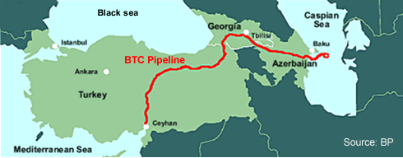

In May 2005, Azerbaijan began test filling the Azeri section of the pipeline, and on July 13, 2006, the first tanker at the Turkish port of Ceyhan was filled with oil from BTC. The line is estimated to have a peak capacity of more than one million bbl/d, and Turkey is earning between $140 and $200 million per year in transit and operating fees from the project. The pipeline has a projected lifespan of 40 years, and when working at normal capacity, transport 1 million barrels (160 000 m³) of oil per day. Work is being carried out to increase the capacity to 1,2 and 1,6 m bbl/d. It has a capacity of 10 million barrels (1,600,000 m3) of oil, which will flow through the pipeline at 2 meters (6.6 ft) per second. There are 8 pump stations through the pipeline route (2 in Azerbaijan, 2 in Georgia, 4 in Turkey). The project includes also the Ceyhan Marine Terminal, two intermediate pigging stations, one pressure reduction station, and 101 small block valves. The pipeline is 1,070 mm (42 inches) diameter for most of its length, narrowing to 865 mm (34 inches) diameter as it nears Ceyhan. The construction of the BTC Pipeline was carried out by an integrated project team that simultaneously led the construction of the Southern Caucasus Pipeline (SPC), which transports natural gas parallel to the BTC for most of its route before connecting to the Turkish gas pipeline network near the town of Horasan. The BTC Pipeline passes a considerable distance through rugged terrain, reaching an elevation of more than 9,000 feet when traversing the Caucasus Mountains.

**Kirkuk-Ceyhan Pipeline**

Turkey’s port of Ceyhan is also the destination for oil exports from northern Iraq in the Kirkuk-Ceyhan oil pipeline, thus making Ceyhan a global energy base from which oil is being swiftly delivered to world markets. The 600-mile dual pipeline from Iraq to Turkey consists of two parallel lines that have a maximum throughput of around 1.6 mbbl/d.

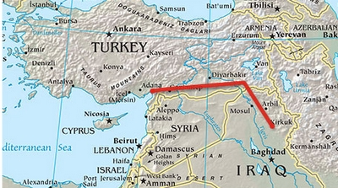

**Bosporus Bypass Options**

The 17-mile long Bosporus Straits, only a half mile wide at its narrowest point, is one of the world’s busiest shipping lanes. The straits are also increasingly an important oil transit point, with oil tankers bringing shipments from the Black Sea to the Mediterranean for export. The Turkish government has raised concerns that increased oil tanker traffic through the narrow and twisting Bosporus heightens the risk of an oil spill. Exports through the Bosporus have grown substantially since the breakup of the former Soviet Union. To ease increasing oil traffic through the Bosporus Straits, a number of Bosporus bypass options are under consideration in southeastern Europe and Turkey itself. The BTC Pipeline is the first of several bypass projects under consideration over the last decade to have materialized.

**Samsun-Ceyhan Pipeline**

Another project currently under construction is the Samsun-Ceyhan bypass, which would transport oil from Turkey’s Black Sea port of Samsun to Ceyhan on the Mediterranean coast. The project is being developed by a 50-50 joint venture between Italy’s Eni and Turkey’s Calik Energy, called the Trans-Anadolu Pipeline Company (TAPPCO), which as of September 2006 holds the only Turkish government license to develop a Bosporus bypass project. Eni holds an 18.5 percent interest in the Kashagan oil field in the Kazakh section of the Caspian Sea, which would likely be a primary source for the Samsun-Ceyhan pipeline.

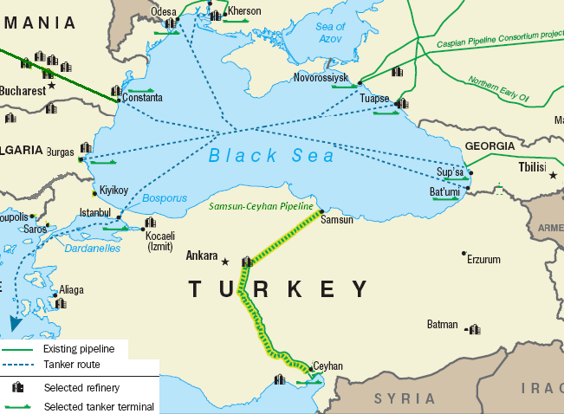

***Source:*** EIA

The Samsun-Ceyhan oil transportation system consists of the following main components:

* New unloading terminal and tank farm close to Samsun;
* Pipeline from the area east of Samsun to Ceyhan (partly following the BTC corridor) and relevant pump/reducing stations;
* Connection with existing Ceyhan loading terminal and additional storage capacity.

The pipeline system transportation capacity is envisaged to be not less than 1,000,000 bbl/d. The design capacity is 1,500,000 bbl/d.

Compared to other by-pass alternatives, the Project offers the following advantages:

* It will benefit from synergies with existing Turkish facilities; from Sariz to Ceyhan the pipeline will follow BTC’s right of way; Crude oil will be delivered to the existing Ceyhan Loading Terminal, which could be exploited at full capacity.
* The route runs only across Turkey, and no intergovernmental agreement should be put in place. Both unloading (Samsun) and loading (Ceyhan) terminals will allow use of VLCC tankers.
* The selected route represents the shortest transshipment distance in the Black Sea, with consequent time and cost savings.
* The environmental conditions along the route, as well as appropriate mitigation actions, are well known. Furthermore the pipeline runs in a scarcely populated area, and partly along the BTC corridor, and this will facilitate/expedite the land acquisition as well as the construction activities.

**Downstream**

TUPRAS is the leading refiner in Turkey, with an 542 thousands bbl/d (28,1 million ton/year) of crude oil refinery capacity. It operates three large refining complexes at Aliaga near Izmir (212,863 bbl/d capacity), Izmit (212,863 bbl/d), and Kirikkale (96,301 bbl/d) as well as a smaller facility at Batman (21,186 bbl/d). A joint venture of Calik Energy and Indian Oil Company (IOC) has been granted refinery license in December 2007; the joint venture is called “Dogu Akdeniz Petrokimya ve Rafineri Sanayi ve Ticaret Anonim Sirketi” which proposed the construction of a 300,000-bbl/d refining and petrochemical complex at Ceyhan, at a reported cost of $4.5 billion.

Several companies are considering new refinery projects in Turkey, reflecting the country’s emerging status as a regional energy hub. Petrol Ofisi AS (POAS) has proposed the building of a $2 billion, 200,000-bbl/d facility in Ceyhan. Russia’s Lukoil is currently drafting a feasibility study for a possible plant along Turkey’s Black Sea coast. Although the plans are tentative, media reports suggest that the site would be either Samsun or Zonguldak, and have a capacity between 160,000 and 200,000 bbl/d.

There are 47 companies which are granted distribution licenses in Turkey, among them the once state-owned POAS is the leading player in the distribution, marketing, and storage of refined petroleum products in Turkey. In July 2000, the company was privatized, with an initial 51 percent of the shares purchased by Doğan Holding (today Doğan holds a 52.7 percent interest). In March 2006, Austria-based OMV purchased a 34 percent stake in POAS. Although POAS is the leading petroleum products distributor and retailer in Turkey, several other companies also have a sizeable market share, including BP, ExxonMobil, Shell, Total, and Turkish company Opet.

**Guideline for Investment in the Petroleum Market**

The petroleum market in Turkey is being restructured as a consequence of the enactment of the Petroleum Market Law (PML) No: 5015 on 20.12.2003. PML regulates the market activities regarding petroleum starting from the crude oil supplied from foreign resources or produced domestically and supplied to the consumers as products. (Downstream activities) PML entrusted in Energy Market Regulatory Authority (EMRA) the duty, authority and responsibility for guidance, regulation, surveillance and supervision of the petroleum market.

**Licenses**

The petroleum market in Turkey has been legally unbundled as 9 activities (refining, distribution, transmission, storage, processing, lube oil, bunker delivery, transportation and vendor activity) and 1 usage (eligible consumer). A license should be obtained for the performance of the legally unbundled activities or uses.

The qualifications of the persons to be granted licenses should comply with the general and the special conditions determined for related license type.

As general qualifications, the persons to be granted licenses should be legal or real persons;

- residing in Turkey,

- having commercial or industrial registry,

- income or corporate tax payer,

Within this scope, the legal persons engaging in market activities in Turkey and qualified as capital stock company as per the legislation of foreign countries are deemed to be the residents of Turkey regarding their activities in Turkey as per the legislation on protecting the value of Turkish currency.

The legal person applying for the licenses of refining, transmission, storage, processing, distribution and bunker delivery should be founded as joint stock or limited liability company as per the provisions of the Turkish Commercial Code No: 6762.

1) The special qualifications related persons should have according to the license types:

1.1) The minimum capital should be:

|  |  |
| --- | --- |
| **Minimum Capital For:** | **TRY** |
| Refining license | 50.000.000 |
| Transmission license | 500.000 |
| Storage license | 1.000.000 |
| Processing license | 500.000 |
| Distribution license | 5.000.000 |
| Bunker delivery license | 2.000.000 |

1.2) The minimum capacity should be (the annual marketing projection as of the date of application or capacity for use):

-60.000 tones of annual sale for distribution license

-5.000 tones of annual use for eligible consumer license (only for diesel oil and fuel oil types).

1.3) For transportation license:

* Should have the possession of at least one road transportation vehicle or have one through financial leasing,
* Should have the possession of at least one sea transportation vehicle or have one through financial leasing or have a lease-service agreement with the related persons,
* Regarding the railway vehicle, should have a lease-service agreement with the related persons.

For the licenses subject to Board’s decision, given the applications are duly filed, the licensing process is completed within maximum 90 days, whereas license applications for vendor activity, eligible consumer and transportation via motorways licenses are concluded within a few working days upon the examination by the related expert.

1.4) Other conditions:

For bunker delivery licenses, permission should be taken from the authorities and/or organizations related with the facilities.

The persons who apply to the Authority for vendor activity licenses of newly established liquid fuel stations should submit together with all the documents stated in the legislation, a document showing that they meet the minimum distance condition.

Vendor activity license holders (operating stations) willing to do sale for agricultural purposes should take the necessary measures and should submit and include in their licenses the documents of their tankers and village pump/s.

In cases which require a facility to perform the market activity, it is obligatory to submit the facility’s Certificate for Starting and Managing a Business Establishment prepared as per the related legislation.

2) Conditions for staying in the market

There is no special condition to continue performing the activities of refining, processing, lube oil, storage, transmission, bunker delivery and transportation. However, to continue performing the distribution activities, there is the condition that the annual total sale to the vendors and users should not be below 60.000 tones.

To continue performing vendor activities, a contract should be made with the new distributor within 3 months as of the termination of the contract with the distributor.

To continue being an eligible consumer, the consumed fuel should not be changed or the annual consumption amount should not be below 5.000 tones.

3) Conditions for exit from the market

The licenses of processing, lube oil, bunker delivery, transportation, vendor activity and eligible consumer license holders are terminated directly upon the application of the related persons. The licenses are also terminated ex-officio in cases of bankruptcy, termination of the license period and administrative sanctions. The distributors have the liability of selling minimum 60.000 tones of white products (petrol, diesel oil) and in case this amount cannot be met, their licenses can be terminated upon Board’s decision. The demands for license termination of the refining undertakings are decided by the Board following the hand-over of the facility pertaining to the national petroleum stock and the stock inventory and after the completion of the income accounting process and provided that the liabilities regarding the commitments entered into with third parties in the market are met and related documents are submitted to the Authority.

**License Fees**

License, license modification, time extension (visa), license copy, tariff approval and liquid fuel trade permission fees to be applied in 2007 in the petroleum market as follows;

|  |  |
| --- | --- |
| **License Fees For:** | **TRY** |
| Refining license | 112.500 |
| Distribution license | 75.000 |
| Storage license | 7.500 |
| Transmission license | 7.500 |
| Bunker delivery license | 3.000 |
| Processing license | 1.500 |
| Lube oil license | 1.500 |
| Eligible consumer license | 1.500 |
| Transportation license |  |
| Per vehicle for motorways | - |
| Per carriage for railways | 75 |
| Per ship for seaways | 1.500 |
| Vendor activity license | 1.000 |
| License copy | 150 |

|  |  |
| --- | --- |
| **License modification:** |  |
| Refining license | 2 % of the license fee |
| Distribution license | 2 % of the license fee |
| Storage license | 1.000.- TRY |
| Transmission license | 1.000.- TRY |
| Processing license | 1.000.- TRY |
| Lube oil license | 1.000.- TRY |
| Eligible consumer license | 1.000.- TRY |
| Bunker delivery license | 1.000.- TRY |
| Transportation license | 1.000.- TRY |
| Vendor activity license | 1.000.- TRY |
| Time extension (visa**)** | 50% of the license fee |
| Trade of liquid fuel permit among distribution licensees | 0.- TRY |
| Tariff approval | 0.- TRY |

**Participation Fee**

The **participation fee** for 2007, the legal persons holding refining, processing, distribution, transmission, bunker delivery and storage licenses are liable to pay has been determined as 0.1% of the net sales related to the market activities performed within the scope of the license shown in the annual income sheets. The participation fee for 2007, the real and legal persons holding transportation, vendor activity and lube oil licenses are liable to pay has been determined as 0 (zero) including the subtitles.

**Permissions**

Permission should be taken from EMRA for liquid fuel trade among the distributors in the petroleum market and for the import of petroleum deemed as product other than liquid fuel.

**1) Permission for trade among distributors:**

The distributors are obliged to get permission form EMRA to do liquid fuel trade among each other. The permission is granted for three-month periods stating the type and amount of the liquid fuel and the place and term of the trade. The issue has been regulated by Board’s Decision.

**2) Import of products other than liquid fuel:**

The materials taken under the scope of the “Communiqué Regarding the Import of Solvent and Some Petroleum Products” determined by EMRA and issued annually by the Undersecretariat for Foreign Trade, are evaluated by EMRA according to a formula and taking as a base the capacity and expertise reports and are given certificate of compliance.

**Operations Subject to Approval**

The service tariffs of transmission facilities and the connected storage facilities (providing service to the third parties) should be approved by EMRA in order to be implemented. The approval period is a calendar year and in case the tariff proposals are not accepted, the proposal is rejected and the implementation of the current tariff is carried on.

**Pricing**

Except for the tariffs subject to approval, price of the goods and services in the market are constituted in the free market conditions on the basis of “tariff”. For the processing and the licensed storage activities not connected to transmission lines “fixed” tariffs are applied; for refining undertaking and distributor licensees’ “price cap” tariffs are applied. The vendors with stations cannot do sale over the price shown on their boards. The price disputes on domestic crude oil among the refining undertakings and producers of crude oil are settled in a binding way under the arbitration of the Authority within maximum thirty days.

**Implementation of National Marker**

Within the scope of the Article 18 of the Petroleum Market Law No: 5015 national marker having the conditions and quality determined by the Authority shall be added to the liquid fuel by the refining undertakings, distributors and processing (bio-diesel) licensees at the refinery exit, customs entry or at other facilities which are the domestic market entry points of the liquid fuel. The aim of this implementation is to determine whether the liquid fuel circulating in the market has entered the market in legal ways or not and preventing the sale of illicit and out of standard products. The adding process is done by the dose-controlled injection equipment installed in the facilities. Such equipment shall have the technical qualifications enabling accurate and traceable measurement results.

The liquid fuel types taken under the scope of this implementation cannot be submitted in the domestic market without adding the national marker having the conditions and quality determined by the Authority. Whether the liquid fuel marketed to the country contains national marker with appropriate conditions and qualifications shall be tested by the “National Marker field Control Equipment” produced for our Authority by The Scientific and Technological Research Council of Turkey and according to the test results the process foreseen in the Law No: 5015. The implementation began as of 01/01/2007 for benzene, gas oil and bio-diesel types.

**Guideline for Investment in the Liquefied Petroleum Gases Market**

In Turkey the liquefied petroleum gas has being used for approximately 45 years since 1960. LPG activities are carried on in three different segments as tubed LPG activity, bulk LPG activity and auto gas activity.

The size of the Turkish LPG market is approximately 5 billion Euros and a tax revenue of 2,2 billion Euros is obtained from the market. In 2006, about 3.520.000 tones of LPG were consumed in Turkey. This amount indicates that Turkey is one of the most important LPG markets in the world. Approximately 42% of this amount was realized as tubed LPG, 44% as auto gas LPG and 14% as bulk LPG. In our country LPG is used in approximately fourteen million homes, there are about eleven thousand four hundred tubed LPG stations and approximately six thousand auto gas stations. LPG is used in 1,5 million vehicles and about 450 thousand people earn their livings in this sector. In terms of market size Turkey comes second after England in Europe and is in the first ten all over the world. Due to increase in use of natural gas as a consequence of our country’s current energy and tax policies, it is projected that the the narrowing in the consumption of tubed and bulk LPG will continue. LPG is preferred for its low cost in our country whereas in the world it is preferred for environmental motives and the sector is enjoying some advantages. Within this scope, taking into account the probability of implementation of such exemptions and advantages in our country will increase some automotive companies’ production of LPG using vehicles. When the increase of 2,1 million tones in the auto gas consumption as a result of the tax advantage obtained in 1999-2000 with the high liquid fuel prices is taken into account, it is expected that the increase in auto gas LPG consumption will continue. TÜPRAŞ is the sole producer in Turkey, about 800 thousand tones of LPG is produced annually in four refineries and sold in the domestic market.

**Market Activities**

With the enactment of the Liquefied Petroleum Gases Market Law No: 5307 and the Law Amending the Electricity Market Law on 13.03.2005 it is aimed to do regulation, guidance, monitoring and supervision activities necessary to perform the market activities of submission to use of the liquefied petroleum gases supplied from domestic or foreign resources in a reliable and economically competitive environment in a transparent, egalitarian and stable manner. With this law, the import, export, storage, transportation, distribution and vendor activity are accepted as market activities. Following the enactment of the Law, the secondary legislation was prepared and issued with an aim to regulate the market activities.

As per the Law, the real and legal persons are obliged to get license from EMRA to engage in market activities. The types of these licenses are; distribution license, storage license, transportation license, production of LPG tube license, control, repair and maintenance of LPG tube license and auto gas vendor activity license. Currently there are 56 distribution license holders, 80 storage license holders, 34 transportation license holders, 6253 auto gas vendor activity license holders, 14 production of LPG tube license holders and 119 control, repair and maintenance of LPG tube license holders in Turkey.

The Law foresees the monitoring and supervision of the market at all stages from supply to the end user. For that reason, the persons who will supply LPG from foreign countries should be distributor license holder or should be granted refining undertaking license by the Authority as per the Petroleum Market Law. The distributors supply LPG from the refineries or import from other countries or supply from other distributers through whole purchase. The import of LPG is done from the five specialty customs after the compliance with technical regulations set forth by the Authority is determined in the laboratories of these five specialty customs. .

The authority to engage in distribution activity within the country is vested only in the distribution license holders. The distribution license holders can perform the activities of distribution of auto gas LPG to the vendor stations under their possession or formed by contracts, supply and sale of bulk LPG to the users, distribution and marketing of tubed LPG, import and export of LPG. In addition, provided that it is inserted in their licenses, they can engage in activities of transportation, filling and storage. The Law stipulates the principle of having storage, filling facility and LPG tubes which are fully in compliance with the technical regulations as a condition for being a distributor. Besides, to commence auto gas activities, the distributors should meet the criteria set forth by the Law and commence the activities of tubed LPG and should take into operation at least one filling facility. In case the distributor has one LPG filling and storage facility, he can only distribute auto gas in the city where the facility is located or in the neighboring cities. To distribute auto gas all over the country there is the obligation of having filling and storage facilities in at least two cities. In addition, the distributors are obliged to store at least twenty times of the daily average LPG amount they supply. Unlike in the petroleum market, the distribution license holders are obliged to do the LPG supply to the auto gas stations with vehicles carrying their trademark, title and emblem and complying with the technical regulations.

**Exit from the Market**

The licenses are automatically terminated in cases of bankruptcy of the license holder, termination of the period of license, upon the demand of the license holder except for LPG distribution and LPG storage licenses, not entering into agreement with any distributor and auto gas vendor within three months upon the termination of the agreement between the LPG auto gas vendor activity license holders and LPG distribution license holders, losing any of the conditions for being granted license. Except from theses cases, the termination of the licenses is realized by Board’s decision. LPG distribution license holders are liable to notify their vendors and the Authority at least three months in advance of stopping the activities. The demand for license termination of the LPG distribution license holders and LPG storage license holders are evaluated provided that the liabilities regarding the commitments entered into with third parties in the market are met and related documents are submitted to the Authority and their licenses are terminated upon Board’s decision.

**Information on Investment Costs**

The investment costs for market activities vary depending on the type of the activity, the capacity, the region of investment and other factors. Following are the minimum approximate costs according to the activity type excluding the land, building, construction and other services;

|  |  |
| --- | --- |
| **Distributor** | 450.000 USD (One filling and storage facility and one vehicle) |
| **Transportation** | 130.000 USD (One vehicle) |
| **Auto gas vendor license** | 170.000 USD (Only management equipment, tank, dispenser etc. excluding the land and construction services) |
| **Tube control, repair and maintenance** | 40.000 USD |
| **Tube production** | 200.000 USD |
| **Storage** | 70.000 USD (cost of one tank of 225 m³, excluding the construction cost of the facility) |

**Licensing process**

The real or legal persons;

* Residing in Turkey,
* Having commercial or industrial registry,
* Income or corporate tax payer,

may apply for licenses.

From the market activities only for distribution activity there is the condition of being a capital stock company. Therefore, the companies willing to engage in LPG distribution activity are obliged to be joint stock company, limited liability company or joint stock commandite company. Other market activities can be performed by real persons, unlimited companies or capital stock companies.

The legal person applying for LPG distribution license should gather the certificate, permission and documents for the establishment and management of the facility showing that there is no drawback in terms of development, society and environment, vocational health, security, technical regulations etc. which are demanded by related organizations and authorities for the establishment and management of LPG facilities. Besides, the applicants of distribution license are obliged to have storage, filling facility and LPG tubes which comply with the technical regulations. The applications are filed together with the documents and forms stated in the web page of the Authority.

EMRA concludes the duly filed applications within at least sixty working days and communicate to the related person.

As per the legislation, the processing period for all applications in the LPG market is 60 days. However, the applications for auto gas vendor activity, tube control, repair and maintenance license and transportation license which are not subject to Board Decision are concluded within approximately five working days if the applications are duly filed. Distribution, storage and tube production license applications which are subject to Board decision are concluded within 60 days if they are duly filed. Tubed LPG vendors are not subject to licenses.

**License Fees**

The fees for license, license modification, time extension (visa) and license copy shall be applied as follows in 2007;

|  |  |  |  |
| --- | --- | --- | --- |
| **License fee for** | **TRY** | **License fee for** | **TRY** |
| LPG Distribution license | 75.000 | LPG Transmission license |  |
| LPG Storage license | 7.500 | - Per vehicle for the motorways | 0 |
| LPG Tube production license | 5.000 | - Transmission via pipeline | 0 |
| LPG Auto gas vendor license | 1000 | - Per carriage for railways | 75 |
| LPG Tube control, repair and maintenance license | 100 | - Per ship via seaways | 1500 |
| **For all types of licenses** | **TRY** | **For all types of licenses** | **TRY** |
| License copy | 150 | License modification | 1000 |
| Time extension | 50% of the license fee |  |  |

**Portion of Income**

Distribution license holders pay 3 YTL portion of income per ton for LPG and this is reflected to the consumers.

**Participation Fee**

The participation fee for 2007, the real or legal persons holding refining undertaking and LPG distribution licenses are liable to pay has been determined as 0.1%. The participation fee, the real or legal persons holding LPG auto gas vendor activity license are liable to pay has been determined as 0 (zero).

**Price Formation**

The prices for sale and purchase of LPG are formed according to the attainable world fee market conditions.

Refining undertakings and distributors notify the Authority of the prices regarding their market activities as ceiling prices, taking into account the price formation in the attainable world free markets.

However, the Authority is entitled to take the necessary measures and determine base and/or ceiling price to be applied on regional or national level at each stage of the activities and not exceeding two months at each time in case agreements or actions which have deteriorating effects on the market and which aim to hinder, deteriorate or restrict the competition or activities in the LPG market are determined. The principles and procedures and the amount of support to be provided to the users for some specific regions or specific purposes without interfering with the prices are determined upon the proposal of the ministry by the Decree of Council of Ministers.

**Useful Links:**

Investment Support and Promotion Agency of Turkey: <http://www.invest.gov.tr/>

General Directorate of Petroleum Affairs: <http://www.pigm.gov.tr/>

Turkish Petroleum Refineries Co.: <http://www.tupras.com.tr/>

Turkish Petroleum Co.: <http://www.tpao.gov.tr/>

Petroleum Pipeline Corporation: <http://www.botas.gov.tr/>

Ministry of Energy and Natural Resources: <http://www.enerji.gov.tr/>

Energy Market Regulation Authority: <http://www.epdk.gov.tr/>

Petroleum Platform Association: <http://www.petform.org.tr/>

Turkish Association of Petroleum Geologists: <http://www.tpjd.org.tr/>