

HYROELECTRIC POWER PLANTS IN TURKEY

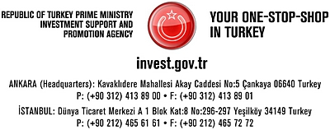

DAMS AND HYDROELECTRIC POWER PLANTS IN TURKEY (HEPPSs)

Main activities in dam construction accelerated after 1954 with the establishment of the DSI (General Directorate of State Hydraulic Works), subsequent legislation and establishment of regional administrations continued to spur dam development in the second half of the 20th Century. The environmental concerns are the one of the reasons for slowing the progress in dam construction activities in the country.

The first dam built during the republic era is the Cubuk-I Dam the main purpose of which is to meet the domestic water requirement of the city of Ankara. No serious activities in dam construction were observed until the end of Second World War except for a few small dams built for irrigation purposes. The largest multi-purposes dam constructed in Turkey is Atatürk Dam. Comparing with the reservoir capacity, Atatürk Dam is 8600 fold larger than Çubuk-I Dam.

According to the standards of ICOLD (International Committee on Large Dams), the dam is classified as a "large dam", if its height from foundation is more than 15 m, or its reservoir volume is equal or more than 3 hm³". The number of constructed large dams in Turkey is 673. The total reservoir capacity of 260 large dams is about 140 km³
DEVELOPMENT OF DAMS AS OF 2008
DAM TYPE | IN OPERATION | UNDER CONSTRUCTION OR IN PROGRAM
DAM TYPE | TOTAL | TOTAL
DAM | 673 | 146
(LARGE-SCALE WATER PROJECTS) | 260 | 63
(SMALL-SCALE WATER PROJECTS) | 413 | 83
SMALL DAMS | 657 | 44

Dams in Turkey can be classified as follows according to crest types:
- Rock or earth-filled types: 650 dams
- Concrete gravity types: 8 dams
- Arch types: 6 dams
- Composite (Concrete Faced Rock – Fill Dam – CFRD or RCC) types: 9 dams

Owing to considerable variation observed in the run-off in terms of seasons, years and regions, it is absolutely necessary to have water storage on the rivers in Turkey. This ensures access to water when it is necessary. Construction of the dams in Turkey is not only for irrigation and hydropower production, but also for the long term domestic water supply. Consequently, Turkey has prioritized the construction of water storage facilities.
RESETTLEMENT POLICY AND PRACTICES
The resettlement of families that are adversely affected by infrastructure projects is regulated by the Resettlement Law in Turkey, which provides for state-assisted resettlement in both rural and urban areas. Resettlement action plans are prepared according to international standards, with the goal of minimizing the negative effects of resettlement and ensuring the maintenance of the current living standard and rehabilitating the income of the people living in the project area.While expropriation compensation payments are granted to all individuals properties, government assistance in resettlement is given to households rather than individuals. Families engaged in agriculture are resettled in rural areas, while families not engaged in agriculture are resettled in towns and cities.
ATATÜRK DAM
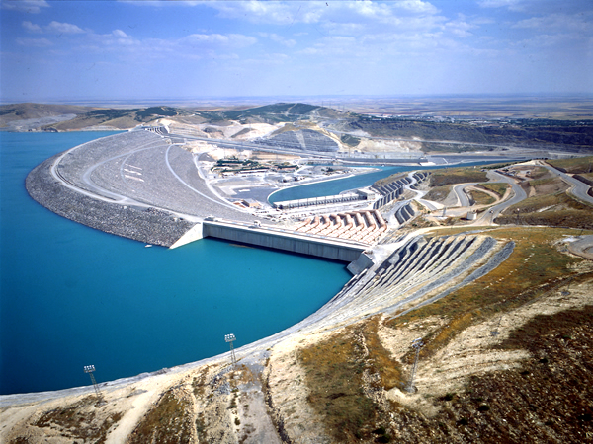

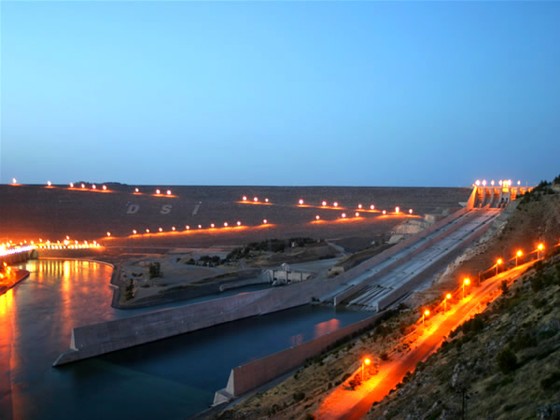
HYDROELECTRIC POTENTIAL

Currently, Turkey has 172 hydroelectric power plants in operation with total installed capacity of 13.700 MW generating an average of 48.000 GWh/year, which is 35% of the economically viable hydroelectric potential. 148 hydroelectric power plants are under construction 8.600 MW of installed capacity to generate average annual 20.000 GWh representing 14% of the economically viable potential. In the future, 1.418 more hydroelectric power plants will be constructed in order to make use of additional 22.700 MW installed capacity. As a result of these works, a total of 1.738 hydroelectric power plants with 45.000 MW will tame rivers to harness the economically viable hydropower of Turkey.

Annual energy consumption per capita in Turkey has reached 2.900 kWh which is above world average of 2.500 kWh. The average energy consumption for the developed countries is 8.900 kWh, but it varies from 12.322 kWh in the USA to 827 kWh in China. Annual increase in energy consumption is 8-10% in Turkey except for the recession years.

Total energy generation in Turkey in the 1950s was 800 GWh, this figure has increased by about 256 times, reaching 191.555 GWh/year today. As of 2008, the current installed capacity is 42.359 MW, which could generate an average of 246.974 GWh/year. Capacity utilization has been 87% in thermal plants and 70% in hydroelectric power plants. 19% of energy generation depends on hydroelectric power and the remaining 81% on thermal power. A special emphasis has recently been placed on alternative energy sources such as wind and geothermal power. The share of geothermal and wind power in total energy generation has reached 2%. There have been some steps taken towards introducing the use of nuclear power as well.

Turkey's theoretical hydroelectric potential is 1% of that of the World and 16% of Europe. The gross theoretical viable hydroelectric potential in Turkey is 433 billion kWh and the technically viable potential is 216 billion kWh. The economically viable potential, however, is 140 billion kWh

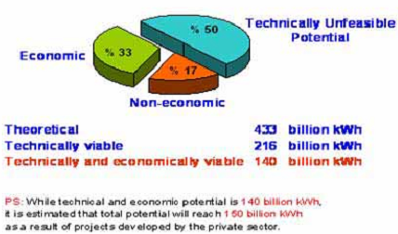

Status of economically viable potential of HEPPs
STATUS OF  ECONOMICALLY VIABLE POTENTIAL | NUMBER OF HYDRO-ELECTRIC POWER PLANTS | TOTAL INSTALLED CAPACITY (MW) | AVERAGE ANNUAL GENERATION (GWH/YEAR) | RATIO (%)
In Operation | 172 | 13,700 | 48,000 | 35
Under Construction | 148 | 8,600 | 20,000 | 14
In Program | 1,418 | 22,700 | 72,000 | 51
Total Potential | 1,738 | 45,000 | 140,000 | 100

DAMS AND HYDROPOWER STATIONS IN OPERATION IN TURKEY (CAPACITIES LARGER THAN 100 MW)
No | Dam & Generating Facility | Construction |  | Location |  | Embank-ment Volume (1,000 m 3) | Crest Level (m) | Height |  |  | Normal Reservoir Volume (hm 3) | Lake Area (km 2) | Energy Benefit
No | Dam & Generating Facility | Starting Year | Completion Year | River | Province | Embank-ment Volume (1,000 m 3) | Crest Level (m) | From Foundation (m) | From River Bed (m) | Normal Water Level (m) | Normal Reservoir Volume (hm 3) | Lake Area (km 2)
 |  |  |  |  |  |  |  |  |  |  |  |  | Capacity (MW) | Annual Generation (GWh)
1 | ATATÜRK | 1983 | 1992 | Fırat | Şanlıurfa | 84,500 | 549.00 | 169.00 | 166.00 | 542.00 | 48,700 | 817.00 | 2,400 | 8,900
2 | KARAKAYA | 1976 | 1987 | Fırat | Diyarbakır | 2,000 | 698.00 | 173.00 | 158.00 | 693.00 | 9,580 | 268.00 | 1,800 | 7,354
3 | KEBAN | 1965 | 1975 | Fırat | Elazığ | 15,585 | 848.00 | 207.00 | 163.00 | 845.00 | 31,000 | 675.00 | 1,330 | 6,000
4 | ALTINKAYA | 1980 | 1988 | Kızılırmak | Samsun | 16,000 | 195.00 | 195.00 | 140.00 | 190.00 | 5,763 | 118.31 | 700 | 1,632
5 | BİRECİK (2) | 1993 | 2000 | Fırat | Ş.Urfa | 9,209 | 389.00 | 63.50 | 53.50 | 385.00 | 1,220 | 56.25 | 672 | 2,518
6 | OYMAPINAR | 1977 | 1984 | Manavgat | Antalya | 676 | 185.00 | 185.00 | 157.00 | 184.00 | 300 | 4.70 | 540 | 1,620
7 | BERKE (2) | 1991 | 2001 | Ceyhan | K.Maraş | 735 | 346.00 | 201.00 | 186.00 | 345.00 | 427 | 7.80 | 510 | 1,672
8 | HASAN UĞURLU | 1971 | 1981 | Yeşilırmak | Samsun | 9,223 | 195.00 | 175.00 | 135.00 | 190.00 | 1,074 | 22.66 | 500 | 1,217
9 | SIR (2) | 1987 | 1991 | Ceyhan | K.Maraş | 494 | 443.00 | 116.00 | 106.00 | 440.00 | 1,120 | 47.50 | 284 | 725
10 | GÖKÇEKAYA | 1967 | 1972 | Sakarya | Eskişehir | 650 | 392.00 | 158.00 | 115.00 | 388.00 | 910 | 20.00 | 278 | 562
11 | BATMAN | 1986 | 1998 | Batman | Batman | 5,400 | 668.50 | 85.50 | 71.50 | 665.00 | 1,175 | 49.25 | 198 | 483
12 | KARKAMIŞ | 1996 | 1999 | Fırat | Maraş | 1,537 | 346.00 | 40.00 | 22.50 | 340.00 | 157 | 28 | 180 | 652
13 | ÖZLÜCE | 1985 | 1998 | Peri | Bingöl | 14,000 | 1,144.00 | 144.00 | 124.00 | 1140.00 | 1,075 | 25.80 | 170 | 413
14 | ÇATALAN | 1982 | 1996 | Seyhan | Adana | 17,000 | 130.00 | 82.00 | 70.00 | 125.00 | 2,126 | 81.86 | 169 | 596
15 | SARIYAR (2) | 1950 | 1956 | Sakarya | Ankara | 568 | 480.00 | 108.00 | 90.00 | 475.00 | 1,900 | 83.83 | 160 | 400
16 | GEZENDE | 1979 | 1990 | Ermenek | İçel | 83 | 335.00 | 75.00 | 71.00 | 333.00 | 92 | 3.97 | 159 | 528
17 | ASLANTAŞ | 1975 | 1984 | Ceyhan | Adana | 8,493 | 160.00 | 95.00 | 78.00 | 146.00 | 1,150 | 49.00 | 138 | 569
18 | HİRFANLI | 1953 | 1959 | Kızılırmak | Kırşehir | 2,000 | 860.00 | 83.00 | 78.00 | 851.00 | 5,980 | 263.00 | 128 | 400
19 | MENZELET | 1980 | 1989 | Ceyhan | K.Maraş | 8,700 | 614.50 | 156.50 | 136.50 | 609.40 | 1,950 | 42.00 | 124 | 515
20 | KILIÇKAYA | 1980 | 1989 | Kelkit | Sivas | 6,900 | 855.00 | 134.00 | 103.00 | 850.00 | 1,400 | 64.42 | 124 | 332
21 | DİCLE | 1986 | 1997 | Dicle | Diyarbakır | 2,180 | 718.00 | 87.50 | 75.00 | 715.50 | 595 | 24.00 | 110 | 298

ENERGY PROJECT WITH IN THE CONTENT OF LAW 4628

For the realization of the hydroelectric energy projects, DSI requested from the Grand National Assembly of Turkey to prepare a law so that private sector can invest for the realization of project for shorter period than DSİ. This law is called "4628 Electricity Market Law" and its licensing regulation which comply with the free market economy. This agreement also defines the procedures and principles of water uses together with the other user's rights.

"4628 Electricity Market Law" has become effective in 2001. The first article of this law defines the objective, which is to supply electricity to the users in adequate quantity, in high quality, continuously and compatible with the environment by providing financially strong stable and transparent and competitive electricity market complying with the special law rules and independently controlled.

Within the framework of the "4628 Electricity Market Law", regulation related with the procedures and principles of signing Water Use Right Agreement for production activities in electricity market was prepared in 2003, and private sector applications according to this regulation has started since then.

In total 1524 hydroelectric power projects with 22360 MW installed capacity has been implemented until January 22, 2009. However, 426 projects have been granted with licensing, and out of this number, construction of 135 projects has been started.

ALMUS
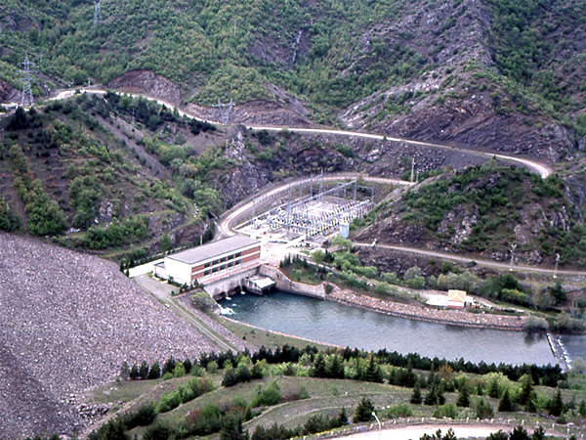
ALTINKAYA
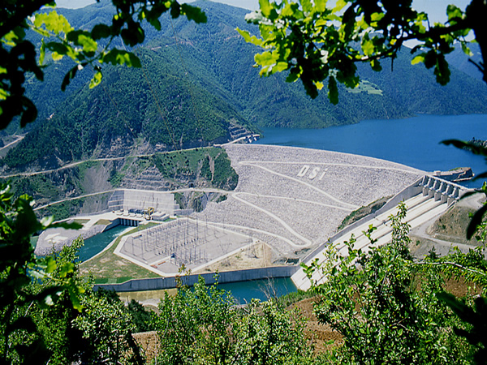
YASSIÇAL
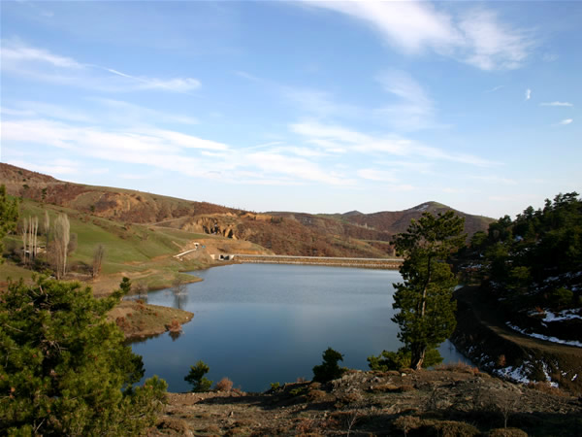
DOYRAN
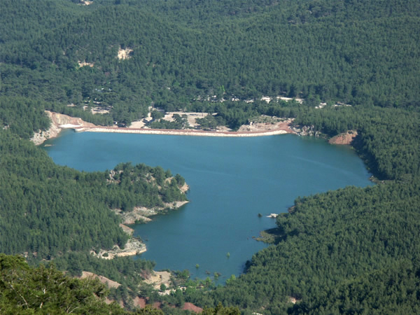
HATİPLER
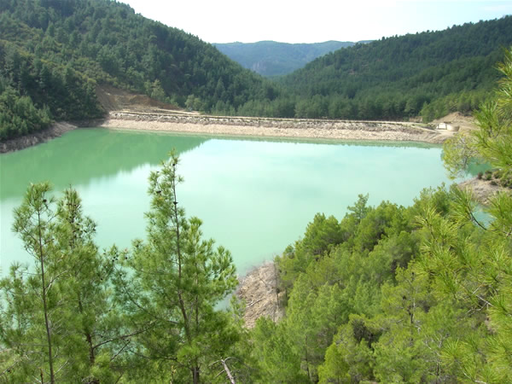

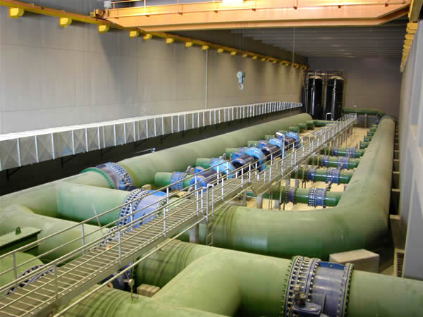
ASLANTAŞ
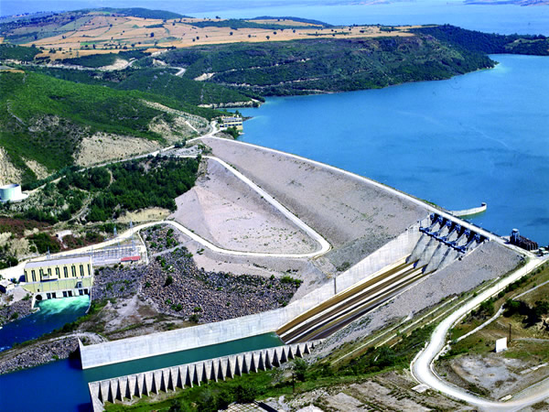
MARDİN
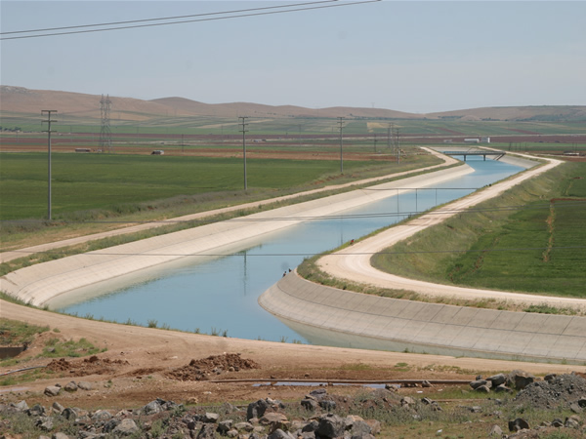
BAKLAN
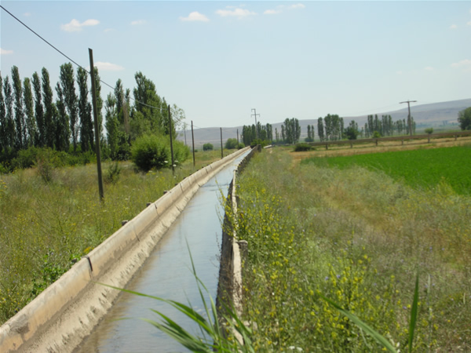

KARAKAYA
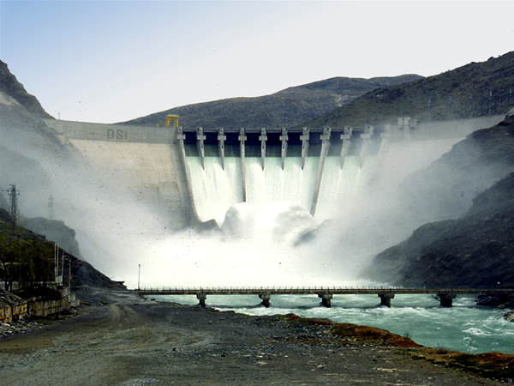
SARIYAR
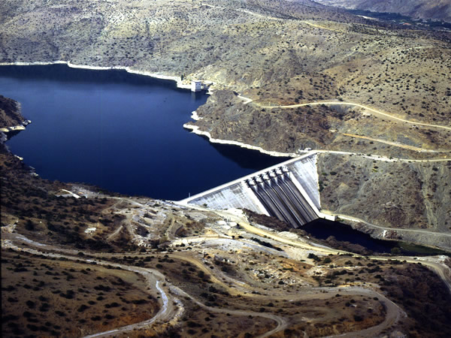

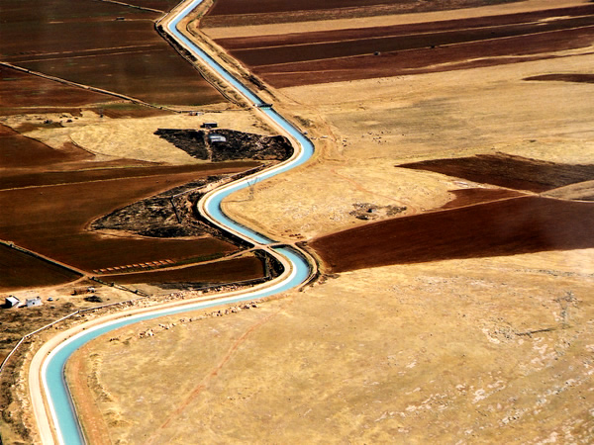

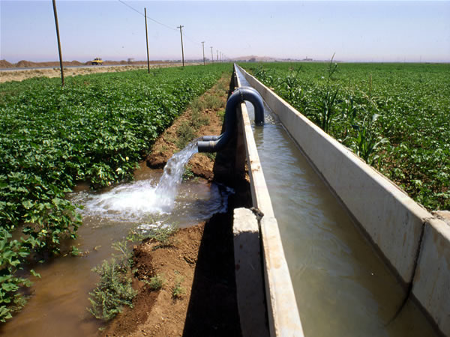

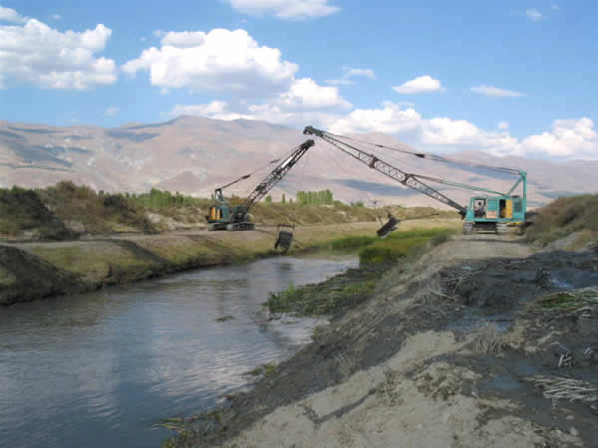

KOZVİRAN
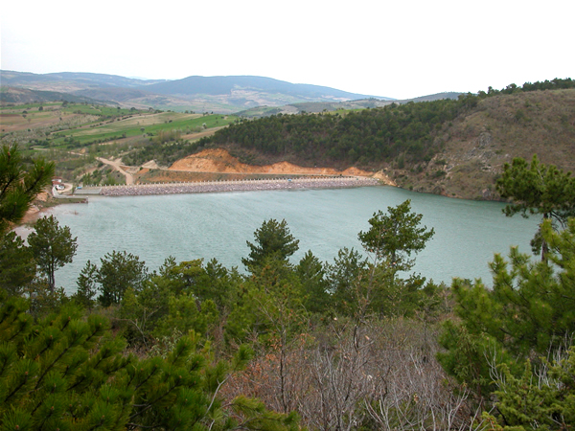
YENİCE
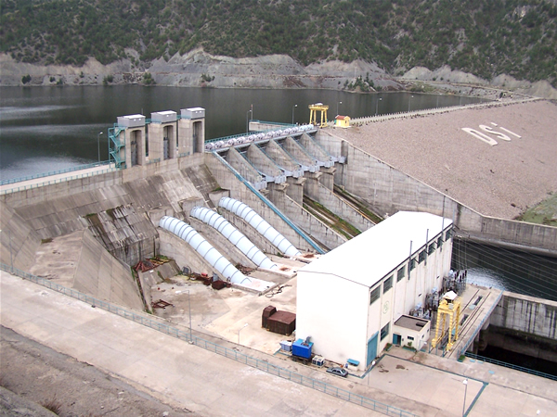
YEŞİLÇAY
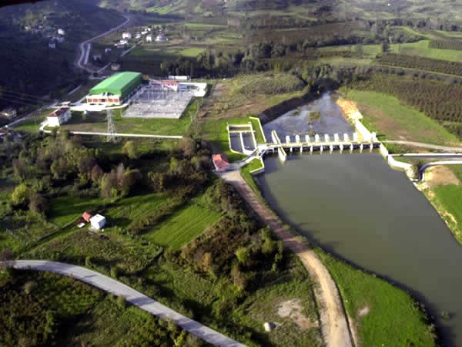

DAMS & HEPPs CONSTRUCTED AS LARGE-SCALE WATER PROJECTS BY DSI
1. Çubuk I  2. Gölbaşı  3. Gebere  4. Elmalı II (*)  5. Sarıyar (*)  6. Seyhan  7. Ayrancı  8. Kemer  9. Hirfanlı  10. Demirköprü  11. Sille  12. May  13. Mamasın  14. Apa  15. Seyitler  16. Çubuk II  17. Selevir  18. Bayındır  19. Cip  20. Kızılsu  21. Almus  22. Kesikköprü  23. Gülüç (*)  24. Tatların  25. Buldan  26. Altınapa  27. Kurtboğazı  28. Akkaya  29. Gümüşler  30. Onaç I  31. Altınyazı  32. Akköy  33. Sarımsaklı  34. Sürgü  35. Musaözü  36. Gölköy  37. Çaygören  38. Damsa  39. Kesiksuyu  40. Alakır  41. Kadıköy  42. Kozan  43. Kartalkaya  44. Porsuk  45. Enne  46. Ömerli  47. Devegeçidi  48. Hasanlar  49. Gökçekaya  50. Atıkhisar  51. Yalvaç  52. Karamanlı  53. Karaçomak  54. K. Kalecik  55. Tahtaköprü | 56. Medik  57. Çoğun  58. Keban  59. Korkuteli  60. Dodurga  61. Çorum  62. Yapıaltın  63. Maksutlu  64. Kaymaz  65. Afşar  66. Ataköy  67. Balçova  68. Süloğlu  69. Asartepe  70. Karaidemir  71. Hasanuğurlu  72. Bozkır  73. Sevişler  74. Güzelhisar  75. Suatuğurlu  76. Kunduzlar  77. Uluköy  78. Alibey  79. Doğancı  80. Kültepe  81. Demirtaş  82. Gökçeada  83. Arpaçay  84. Boztepe  85. Söğüt  86. Topçam  87. Aslantaş  88. Berdan  89. Alaca  90. Belpınar  91. Oymapınar  92. Uluborlu  93. Hasanağa  94. Çamlıdere  95. İvriz  96. Yedikır  97. Germeçtepe  98. Kalecik  99. Kozağacı  100. Sarıbeyler  101. Tayfur  102. Kayalıköy  103. Kozlu  104. Ağcaşar  105. Kayaboğazı  106. Çatören  107. B. Çekmece  108. Karakaya  109. Manavgat (*)  110. Çakmak | 111. Gödet  112. Güldürecek  113. Gölova  114. Ketsel  115. Kovalı  116. Hancağız  117. Zernek  118. Altınkaya  119. Geyik  120. Gökçe  121. Darlık (*)  122. Tercan  123. Altınhisar  124. Kapulukaya  125. Sarayözü  126. Karacaören I  127. Yarseli  128. Hacıhıdır  129. Ürkmez  130. Uzunlu  131. Mumcular  132. Polat  133. Kılıçkaya  134. Menzelet  135. Adıgüzel  136. İkizcetepeler  137. Yahyasaray  138. Gezende  139. Çavdarhisar  140. Derbent  141. Yapraklı  142. Koçköprü  143. Patnos  144. Dumluca  145. Gayt  146. Mursal  147. Çamköy  148. Göksu  149. Sarımehmet  150. Sır (*)  151. Atatürk  152. Büyükorhan  153. Eğrekkaya  154. Sultansuyu  155. Murtaza  156. Beyler  157. Gazibey  158. Örenler  159. Küre-Çatak  160. Gelingüllü  161. Seferihisar  162. Sultanköy  163. Kızılcapınar  164. Karacaören II (*)  165. Nergizlik | 166. Kuzgun  167. Demirdöven  168. Kırklareli  169. Yaylakavak  170. Tahtalı  171. Gönen  172. Bayramiç  173. Çavdır  174. Çatalan  175. Sazlıdere  176. Alaçatı (*)  177. Madra  178. Çat  179. Kralkızı  180. Armağan  181. Dicle  182. Çamlıgöze  183. Yenihayat  184. Karaova  185. Erzincan  186. Bademl  187. Özlüce  188. Yayladağ  189. Sıddıklı  190. Bakacak  191. Batman  192. Çamgazi  193. Akyar  194. Yenice  195. Karkamış  196. Kirazdere (*)  197. Çayboğazı  198. Sorgun  199. Birecik (*)  200. Kızıldamlar  201. Gökpınar  202. Palandöken  203. Berke (*)  204. Derinöz  205. Kürtün  206. İmranlı  207. Küçükler  208. Ayhanlar  209. Dört Eylül  210. Bahçelik  211. Suğla Dep  212. Koruluk

HYDROELECTRIC POWER PLANT PROJECTS TO BE HELD FOR TENDER
 | NAME | PROJECT OWNER | POWER (MW) | AVERAGE (GWh) | ACCREDITED  (GWh) | CITY | DISTRICT | REGION | AIM | TENDERS | DATE  (FROM-TO)
1 | KIZILÇAĞIL REG. VE HES | EİE | 1,33 | 5,85 | 0,78 | DENİZLİ | KIZILÇAĞIL DERE | AYDIN | ELECTRICITY | BOYUT GRUP ENERJİ VE İNŞAAT SAN. TİC. LTD. ŞTİ. | 07.05.2009 | 06.06.2009
2 | KESKİN BARAJI VE HES | EİE | 164,00 | 740,00 | 359,00 | SİİRT | BOTAN ÇAYI | VAN | ELECTRICITY | BİTLİS ENERJİ ÜRETİM İÇ VE DIŞ TİCARET A. Ş. | 25.05.2009 | 24.06.2009
3 | KÖPRÜLER-GEM | DSİ | 2,16 | 14 | 9 | VAN | GÜRPINAR | VAN | ELECTRICITY | ON THE AGENDA
4 | GÖKÇEKISIK HES | DSİ | 2,00 | 9 | 2 | ESKİŞEHİR | MERKEZ | ESKİŞEHİR | ELECTRICITY | ON THE AGENDA
5 | BAŞKALE | EİE | 5,70 | 19 | 15 | HAKKARİ | DİCLE | VAN | ELECTRICITY | ON THE AGENDA
6 | DOĞUBEYAZIT | DSİ | 4,50 | 30 | 27 | AĞRI | D.BEYAZIT | ERZURUM | ELECTRICITY | ON THE AGENDA
7 | YAHYAKÖY REG. VE HES | DSİ | 3,75 | 11,49 | 0,95 | BALIKESİR | MERKEZ | BALIKESİR | ELECTRICITY+IRRIGATION | ON THE AGENDA
8 | CÜRÜMÖREN | DSİ | 6,00 | 13 | 11 | KASTAMONU | DEVREKANİ | KASTAMONU | ELECTRICITY | ON THE AGENDA
9 | FINDIKLI BARAJI VE HES | EİE | 30,00 | 87 | 78 | ERZİNCAN |  | ERZURUM | ELECTRICITY | ON THE AGENDA
10 | ESENYAMAÇ | EİE | 9,00 | 25,00 | 14,00 | HAKKARİ | MERKEZ | VAN | ELECTRICITY | ON THE AGENDA
11 | AŞIKLAR | EİE | 1,24 | 7,22 | 3,42 | RİZE |  | TRABZON | ELECTRICITY | ON THE AGENDA
12 | KAYNAR | EİE | 1,29 | 6,00 | 1,00 | TOKAT |  | SAMSUN | ELECTRICITY | ON THE AGENDA
13 | KAYADİBİ REG. VE HES | EİE | 1,06 | 5,58 | 0,81 | SAMSUN | YEŞİLDERE | SAMSUN | ELECTRICITY | ON THE AGENDA
14 | BEKÇAN REG. VE HES | EİE | 0,81 | 4,04 | 0,99 | AFYON | SÖĞÜTÖZÜ DERESİ | ISPARTA | ELECTRICITY | ON THE AGENDA
15 | SORGUN REG. VE HES | EİE | 1,16 | 5,46 | 1,00 | BİLECİK | SORGUN DERE | ESKİŞEHİR | ELECTRICITY | ON THE AGENDA
16 | YASSITAŞ REG. VE HES | EİE | 2,65 | 9,03 | 0,22 | MERSİN | YASSITAŞ DERE | ADANA | ELECTRICITY | ON THE AGENDA
17 | AYDIN REG. VE HES | EİE | 1,50 | 5,15 | 1,13 | ARTVİN | AYDIN DERE | ARTVİN | ELECTRICITY | ON THE AGENDA
18 | ALATA REG. VE HES | EİE | 0,97 | 3,87 | 0,49 | ANTALYA | KAYADİBİ DERE | ANTALYA | ELECTRICITY | ON THE AGENDA
19 | SİSNE REG. VE HES | EİE | 1,04 | 4,20 | 0,52 | K.MARAŞ |  | K.MARAŞ | ELECTRICITY | ON THE AGENDA
20 | TAPSUR REG. VE HES | EİE | 1,65 | 6,28 | 1,47 | ERZURUM | TAPSUR DERE | ERZURUM | ELECTRICITY | ON THE AGENDA
21 | ŞEHİR REG. VE HES | EİE | 1,24 | 6,14 | 4,10 | ERZURUM | ŞEHİR DERE | ERZURUM | ELECTRICITY | ON THE AGENDA
22 | TÜNKEŞ REG. VE HES | EİE | 1,06 | 4,38 | 1,96 | ERZURUM | TÜNKEŞ DERE | ERZURUM | ELECTRICITY | ON THE AGENDA
23 | KARASU BARAJI VE HES | EİE | 22,00 | 57,00 | 33,00 | HAKKARİ | KARASU DERE | VAN | ELECTRICITY | ON THE AGENDA
Source: DSI; MAY 2009
EIE: General Directorate of Electrical Power Resources Survey and Development Administrative (www.eie.gov.tr)
DSİ: General Directorate of State Hydraulic Works (www.dsi.gov.tr)

TURKEY
LAND AND WATER RESOURCES
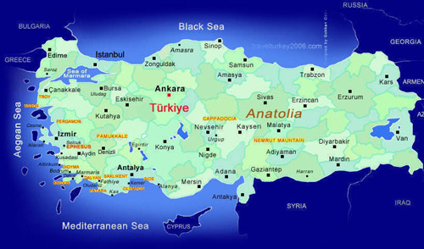
Turkey possesses a number of different characteristics in terms of its geographical location. The total length of its land borders and coastline is 10,765 km, 2,949 km of which are the land borders while 7,816 km are the coastline. Turkey has borders with Greece and Bulgaria to the west, with Georgia, Armenia, Azerbaijan and Iran to the east and with Iraq and Syria to the south.
The border with Bulgaria (269 km) extends from the mouth of the Rezve Stream in the Black Sea to the north west of Edirne. The border with Greece (203 km) extends along the Meriç River, passing around Edirne and Karaağaç and emptying into the Aegean Sea to the west of Enez. The total length of the border with Georgia (276 km), the border with Armenia (328 km) and Azerbaijan border (18 km) is 622 km, beginning from Sarp Village and extending along the Arpaçay and Aras rivers. The border with Iran (560 km) follows the summits of high mountains with extending up to the Kelsim Breach at the beginning of the Iraq border. The border with Iraq (384 km) ends at the point where the Tigris and Habur rivers meet after passing through high and mountainous territory in the vicinity of Hakkari. The border with Syria (911 km) runs immediately south of the Baghdad Railway, reaching the Mediterranean in Güvercinkaya.
The average altitude (1,132 m) of Turkey is higher than that (1,050 m) of Asia and three and a half times higher than that (330 m) of Europe. The elevation of Turkey increases from the west to the east. The altitude of Ulus, the centre of Ankara, is 875 m. The altitude of plains in the eastern region rises to 2,000 m.
Turkey’s surface area is 780,000 km², namely 78 million hectares (Mha). Excluding the total area of reservoirs and lakes, Turkey’s land area is 769,600 km². Excluding mountainous areas which cover a little more than half of the total land area, Turkey has plains, plateaux, steep and rugged land, and flat hills. Plains of different altitudes covered with alluvium amount to 19 Mha. Plateaux cover 8 Mha. The total area of plains and plateaux is equal to 27 Mha, which is 30% of Turkey’s land. Rugged terrains with flat, wide hills amount to 10 Mha. Since agricultural operations are often relatively easy in these type of rugged terrains, 10 Mha might be added to 27 Mha as flat lands. Therefore, Turkey has about 37 Mha of flat lands. However, Turkey’s total agricultural area is about 28 Mha. The General Population Census of 2000 indicates that Turkey has a population of 67.8 million in a total of 81 provinces. The average population density is 88 persons per square kilometer.
RIVERS AND LAKES
Turkey has about 120 natural lakes, including small lakes in the mountains. The largest and deepest lake is Lake Van with a surface area of 3,712 km² and an altitude of 1,646 m from sea level. The second largest lake is Lake Tuz in central Anatolia. Being relatively shallow, this lake is at an altitude of 925 m from sea level and has a surface area of 1,500 km 2. There are four main regions where lakes are intensively dispersed: The “Lakes District” (Eğirdir, Burdur, Beyşehir, and Acıgöl Lakes), Southern Marmara (Sapanca, İznik, Ulubat, and Kuş Lakes), Lake Van and its environs, and Lake Tuz and its environs. Although some of the lakes are only a few meters in depth, some of them are of a depth of more than 30 meters. The depth of Lake Van is more than 100 m.
Turkey has 555 large dam reservoirs. The names and surface areas (km²) of the large ones are Atatürk (817), Keban (675), Karakaya (268), Hirfanlı (263), Altınkaya (118), Kurtboğazı (6).
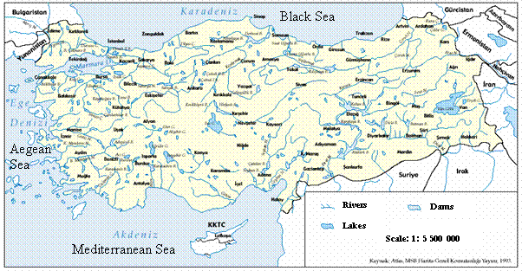
Turkey is rich in terms of streams and rivers. Many rivers rise and empty into seas within Turkey’s borders. Rivers can be classified in relation to the sea into which they empty. The rivers emptying into the Black Sea are the Sakarya, Filyos, Kızılırmak, Yeşilırmak, and Çoruh. The rivers emptying into Mediterranean Sea are the Asi, Seyhan, Ceyhan, Tarsus, and Dalaman. The rivers emptying into the Aegean Sea are the Büyük Menderes, Küçük Menderes, Gediz, and Meriç. The rivers empting into the Sea of Marmara are the Susurluk/Simav, Biga, and Gönen. The Euphrates and Tigris rivers empty into the Gulf of Basra, while the Aras and Kura rivers empty into the Caspian Sea. As far as the lengths of the some major rivers are concerned, the Kızılırmak is 1,355 km, Yeşilırmak is 519 km, Ceyhan is 509 km, Büyük Menderes is 307 km, Susurluk is 321 km, the Tigris is 523 km, the Euphrates River up to the Syrian border is 1,263 km, and the Aras River up to the Armenia border is 548 km.

CLIMATE
Turkey has a semi-arid climate with some extremities in temperature. Turkey is surrounded by seas on three sides and high mountains stretching along the Black Sea coast in the north and along the Mediterranean Sea coast in the south. Distance from sea and fluctuations in altitude result in climatic variance within short distances. Temperature, precipitation and winds vary, based on climatic features. The difference in the north to the south latitude (6 0) also plays a role in this temperature change. The southern coastal fringes enjoy the Mediterranean climate featuring hot, dry summers and mild, rainy winters. The northern coastal fringes are of the Black Sea climate, which is mild and rainy in almost all seasons. Surrounded by high mountains, Central Anatolia features a steppe climate with little precipitation and daily and yearly temperature values differing significantly. Winters are long and cold in Central and Eastern Anatolia, while mild and short in coastal regions.

PRECIPITATION VARIES BY FAR WITH RESPECT TO THE REGION AND PERIOD
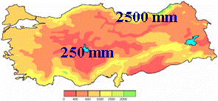
Especially the mountainous coastal regions receive abundant precipitations (1,000–2,500 mm/year). Inner parts away from coastal fringes receive relatively less precipitation. Precipitation is 500–1,000 mm/year in the Marmara and Aegean regions and in the plateaux of East Anatolia. Most parts of Central Anatolia and Southeastern Anatolia have precipitation only 350–500 mm annually, whereas the environs of Lake Tuz receive the lowest precipitation level (250–300 mm/year).
Snow falls in almost every region of Turkey, but the number of days on which it snows and the durations of snow cover vary considerably with regard to the regions. It snows less than one day a year in the Mediterranean Region while more than 40 days in Eastern Anatolia on average. The duration of snow cover is less than one day in the Mediterranean and Aegean coastal fringes, 10–20 days in the Marmara and Black Sea coastal areas, 20–40 days in Central Anatolia, and 120 days in the Erzurum and Kars provinces in Eastern Anatolia. Throughout the four seasons, higher parts of the mountains retain snow, which melts slowly, feeding rivers and ground waters.
On account of its geographical features, Turkey has four distinctive seasons. Variation in altitude up to 5,000 m causes different climatic conditions in the same season.
LAND RESOURCES
Turkey ’s total land area is 78 Mha. Almost one third of this, 28 Mha, can be classified as cultivable land. Recent studies indicate that an area of about 8.5 million ha is economically irrigable under the available technology. Until now, an area of about 2.8 million ha has been equipped with irrigation infrastructures by DSİ.

WATER RESOURCES
Geographically, there is a large variation in annual precipitation, evaporation and surface run-off parameters, in Turkey. Precipitation is not evenly distributed in time and space throughout the country. There are 25 hydrological basins in Turkey. The rivers often have irregular regimes.

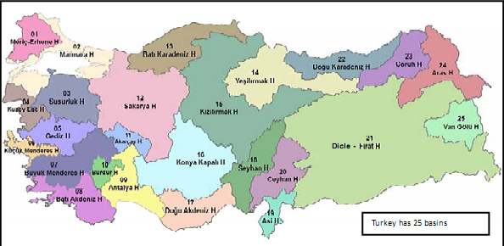

Considering the average surface water run-off which is 186 billion m³/year with the surface run-off of 7 billion m³/year coming from neighboring countries, the total surface run-off within the country reaches to the amount of 193 billion m³/year. On the other hand, the average amount of ground-water leakage is 41 billion m³/year. However, not all the renewable water resources can be utilized because of economic and technical reasons. Exploitable portions of surface run-off including inflow from bordering countries, and groundwater are 98 and 14 billion m³/year, respectively. Thus, the total of economically exploitable water resources potential amount to 112 billion m³/year.

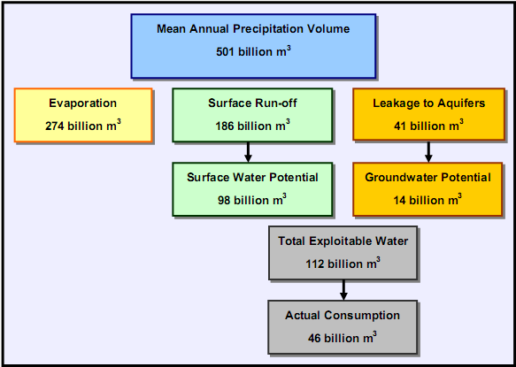
DISTRIBUTION OF PRECIPITATION
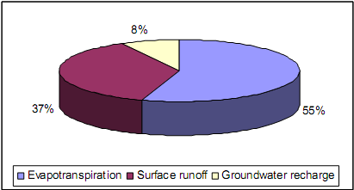
The 25 hydrological basins in Turkey have a total surface water run-off of 193 billion m³/year. 31% of the potential is constituted by the Euphrates (Fırat) and the Tigris (Dicle) Rivers both of which have their sources in the eastern part of the country.

DSİ IS A PRIMARY EXECUTIVE AGENCY RESPONSIBLE FOR ELIMINATION OF ADVERSE EFFECTS OF TURKEY’S SURFACE AND GROUND WATER AND PUTTING THEM IN PUBLIC UTULIZATION IN VARIOUS WAYS SUCH AS HYDROPOWER, IRRIGATION, DOMESTIC AND INDUSTRIAL USE

