

**CONSTRUCTION INDUSTRY IN TURKEY**

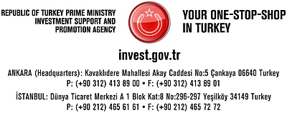

**CONSTRUCTION INDUSTRY**

Construction is one of the key sectors in Turkey, being one of the main drivers of private and public investments. As a result of economic reforms Turkey has established a large and strong construction industry in a short time. In 2007 new building permits reached 124.1 million square meter.

Apart from the Middle East and North African market in which Turkish contractors have enjoyed a great share of civil engineering and electromechanical erection work, the former USSR and some European countries have opened their construction market to Turkish Contractors. Today, they are working in four continents and 69 countries, using all the financial, managerial and technological instruments of International contraction standards.

The development of construction industry has resulted in a large and diversified production of building materials sector, a dynamic contracting and engineering services and though young, but a well established construction and mining machinery sector.

Today Turkish construction and engineering companies are able to design, erect, build and operate almost all kinds of civil and industrial projects such as: dams, hydroelectric and thermal power plants, industrial plants, airports and seaports, large scale petroleum and natural gas pipelines, fertiliser plants, petrochemical complexes and refineries, motorways, tunnels, bridges, large housing projects, hotels and all kinds of sophisticated buildings. In the period of 1972-2007 about 700 Turkish contractors have completed over 4300 projects in 69 countries. The total value of the projects undertaken by Turkish contractors abroad reached USD 105 billion in the same period.

The report entitled ‘Economical Assessment and Suggestions for the Construction Sector and the Construction Materials Sector’, prepared by the Association of Turkish Building Material Producer (IMSAD), states that the construction materials sector is among Turkey’s leading sectors. Approximately 20% of economic growth is based on the growth in the construction and construction materials sectors. According to the report, there are 85,290 contractor firms in the construction sector, with 700 contractors continuing their operations abroad. There are 308,663 engineers and architects as well as around 2,000 technical consultancy firms affiliated with 23 professional associations in the construction sector. Some 150 large companies in the sector realize 75% of all projects in the country, with a 90% share in international projects. There are approximately 6,500 producers in the construction materials sector. Their total production in 2006 was USD 27.2 billion, and 60% of production is used domestically while the other 40% is exported.

1.3 million people work in the construction sector and 225,000 people work for the 6,500 producers in the construction materials industry. The 1.5 million people working in both sectors combined constitute 6.84% of total employment.

|  |  |  |  |
| --- | --- | --- | --- |
| **BUILDING LICENSES AND USAGE PERMITS** |  |  |  |
| **Construction Licenses** | **2007** | **2006** | **Change (%)** |
| Number of buildings | 105 865 | 114 200 | -7.3 |
| Building surface area (sqm) | 124 132 360 | 122 909 886 | 1.0 |
| Value (USD) | 49 984 784 608 | 45 518 649 003 | 9.8 |
| Number of units | 581 696 | 600 387 | -3.1 |
| **Building usage permits** | **2007** | **2006** | **Change (%)** |
| Number of buildings | 67 913 | 73 383 | 7.5 |
| Building surface area (sqm) | 63 150 147 | 57 207 320 | -10.4 |
| Value (USD) | 24 540 381 028 | 20 291 058 456 | 20.9 |
| Number of units | 325 330 | 295 389 | 10.1 |

Source: CBRE

**IMPORTANT PROJECTS**

**MARMARAY CONNECTING EUROPE AND ASIA UNDER THE BOSPHORUS**

The Turkish Republic State Railroad Administration, TCDD, plans to renew its current railroad network of 10,000 km by 2011. The Marmaray project in Turkey is one of the most important transportation projects will also be connected to the Kars-Tbilisi railroad and many suburban lines. The first section of the Istanbul-Ankara fast train project is completed in March 2009, reducing travelling time between the two cities to 2.5 hours. TCDD is also working on the Ankara-Afyon-İzmir railroad project and the Ankara-Konya fast train line will be operating at full capacity in 2009. The Marmaray submarine tube crossing the Bosporus the Ankara-Istanbul and Ankara Konya fast train tracks, and Egeray projects are currently being built. New fast train projects for Ankara-Sivas, Bursa-Osmaneli, Ankara-Izmir and Istanbul Edirne will also enhance the development of cargo transportation and of new logistic centers. The Railways Act is currently being drafted to create the infrastructure enabling private companies to operate, establish a distinction between the construction of the infrastructure and the operational activities.

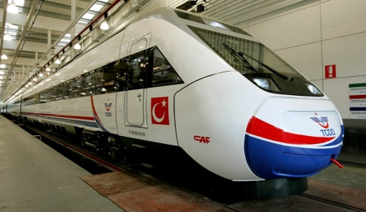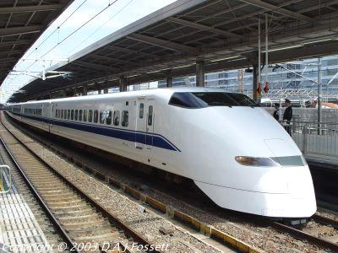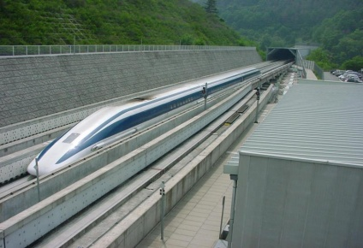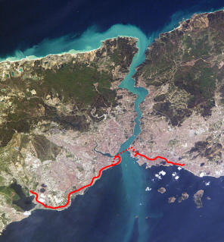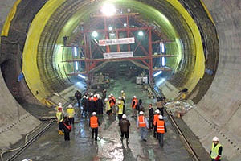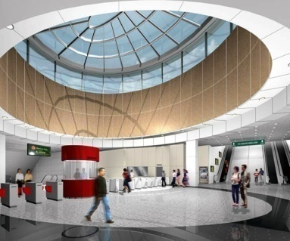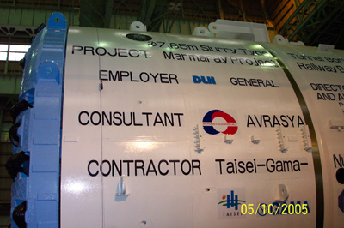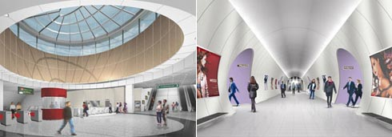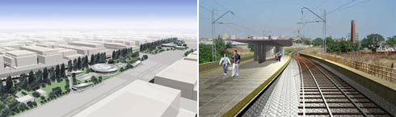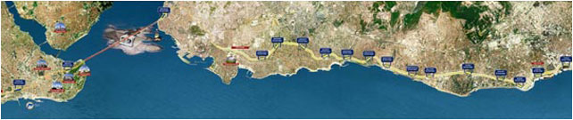

The Marmaray Project

**LOGISTIC VILLAGES**

Considered as the hearth of contemporary freight transport and improving the combined transport by integrating into all transport modes, logistic villages are being constructed in Turkey. As the first phase, the construction of 11 logistic villages are planned namely as Istanbul Halkali-İspartakule (improving), Izmit Kosekoy (first step), Kayseri-Bogazkopru (under tender), Samsun-Gelemen (in the pipe line), Hasanbey-Eskisehir (at tender), Balikesir (under project), Yenice-Mersin (under project), Palandoken-Erzurum (under project), Konya (under project), Kaklik-Denizli (under project), Usak (under project). In addition to this Tekirdag Project, located between Tekirdag and Muratli will 32 km. Its construction is in the pipe line. This project will be expanding to Tekirdag-Akport and than a ferryboat seaport will be constructed. The access to Europe will be from Derince port, Bandirma port and Tekirdag.

**THIRD BRIDGE IN ISTANBUL**

The highway project in Istanbul, including the third bridge is planned to be built at Bosphorus. The General Directorate of Turkish Highways will shape the final route once the exact location is set. The bridge, the construction of which will be completed in four years, will likely be located 500 metres south of the first bridge.

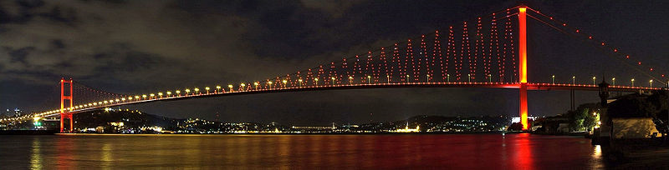

Second Bridge, Istanbul

**BRIDGE IN IZMIT**

Izmit Bay Bridge includes a **3.3 km** long suspension bridge with approach roads and a highway, which together will provide a dual, 3-lane route across Izmit Bay. On completion, it would have a main span making it the second longest in the world at **1688 metres**, with side spans of 560 metres. A Kvaerner-led Joint Venture, the Anglo-Japanese-Turkish Consortium, which includes the Turkish contractor Enka, Japanese contractors IHI, MHI and NKK, and the trading houses Itochu and Marubeni, was recommended as the preferred BOT proponent. The bridge engineer for the Government of Turkey on the project is Delcan International. The design of the Izmit Bay Bridge, with a main span of 1688 m, owes a debt of gratitude to the revolutionary Severn Bridge, which has a suspended span of 987.5 m and was constructed in 1961-66, and to succeeding steel box aerofoil structures such as the Bosphorus Bridges, and the Great Belt East Bridge in Denmark.

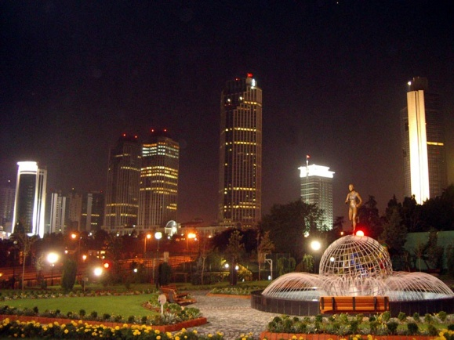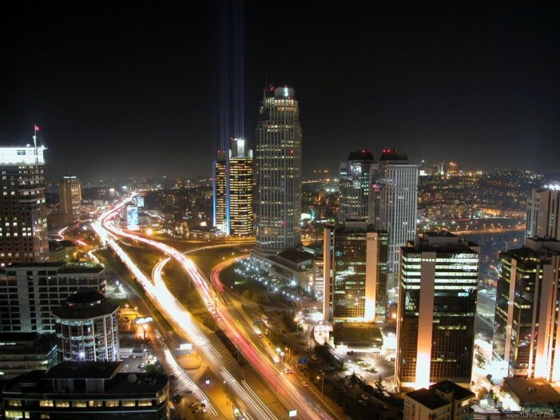

**OTHER PROJECTS IN TURKEY 2008 AND BEYOND**

The list shows projects currently in the development pipeline throughout Turkey. The information has been provided by representatives in the real estate industry. The overview covers a wider variety of projects to be realized.

|  |  |  |  |  |
| --- | --- | --- | --- | --- |
| **CITY** | **PROJECT** | **PROGRAM** | **DEVELOPMENT** | **PLANNING** |
| Adana | Adana Ancora | Shopping center 60 000 sqm | Acteeum Group | 2010 |
| Adana | Adana Shopping Center | 55 000 sqm, 2 000 parking spaces, hypermarket, 150 stores, movie theatre, 2 500 sqm entertainment area, 3 500 restaurants | Ronesans Insaat | 2009 |
| Adana | Shopping Center | Shopping center 140 000 sqm | Soyak, Tahincioglu | 2009 |
| Adana | Shopping Center | 25 999 sqm | Soyak Insaat,  Tahincioglu | 2010 |
| Adapazari | Neo AVM Adapazari | Shopping center 140 000 sqm, 12 500 sqm, hypermarket, 150 shops, 1 500 seated cinema capacity, 2 500 parking spaces, 10 000 sqm DIY | Krea Group | 2009 |
| Ankara | Akkent Konutlari | Residential 160 000 sqm, 1 263 houses | Unal Akpinar Insaat | N.A |
| Ankara | Ankara Cankaya | Residential and shopping center 10 000 sqm | Yapi Kredi Koray  Gayrimenkul | 2008 |
| Ankara | Ankara Cayyolu | Shopping center 54 000 sqm hypermarket of 5 000 sqm, electronics market 4 000 sqm, movie theatre complex with 13 halls, 160 stores | Redevco | 2009 |
| Ankara | Antares | Mixed-use, shopping center 112 100 sqm, 613 residential units | Dolunay | 2010 |
| Ankara | Besa Karina Evleri | 72 000 sqm, 620 flats, 30 000 sqm parking spaces | Besa Insaat | N.A |
| Ankara | Beysupark | Residential 560 houses | Birlik Yapi | N.A |
| Ankara | Forum Ankara | Shopping center 78 300 sqm | Multi Turkmall | 2010 |
| Ankara | Gordion Shopping Center | Shopping Center 50 000 sqm, 200 retail units, multiplex cinema, hypermarket, 2 000 parking spaces | Redevco | 2009 |
| Ankara | Guneypark | Residential 1,5 million sqm, 47 towers 6 000 residences, lower parts consist of terrace type low-rise housing, sport, shopping, health, school, recreation and social facilities | Eskogullari Group | N.A |
| Ankara | Kent Park | Mixed-use, 68 000 sqm shopping center and 465 residential units | Megaturk | 2008 |
| Ankara | Muratlikoy | Residential, total area 322 100 sqm, total residence area 36 000 sqm, total residence 200 units, open-space area 280 000 sqm total commercial area 5 000 sqm | Akem Project and Land  Development Consultancy | 2010 |
| Ankara | Nevbahar Konutlari | Residential 237 000 sqm 22 block flats, 1 244 apartments recreation area 56 000 sqm, outlet center, Nevhayat private hospital, private high school | YDA Group | 2010 |
| Ankara | Northern Ankara | Urban transformation project, 18 000 sqm residential | Ankara Metropolitan  Municipality | N.A |
| Ankara | Park Oran | Residential 17 block flats with 31 floors, 1,832 apartments | Mesa-Akturk, Emlak  Pazarlama Ortakligi | 2009 |
| Ankara | Shopping Center | Shopping center 104 408 sqm with IKEA | Maya Holding | 2008 |
| Ankara | Turkuaz Vadisi | 837 600 sqm, 4 856 houses, shopping center, day nursery, elementary school, high school, gymnasiums, social centres and landscaping | Collective Housing  Administration | N.A |
| **CITY** | **PROJECT** | **PROGRAM** | **DEVELOPMENT** | **PLANNING** |
| Antalya | Alanya-Gazinpasa Airport | International Airport | TAV | 2008 |
| Antalya | Forum Antalya | 230 000 sqm total construction area 111 000 sqm retail area, city park, aquarium, Modern Art Museum and entertainment areas | Multi Turkmall | 2009 |
| Bayrakli | Shopping Center | 44 000 sqm | Torunlar, Hayat Kimya,  Sur Yapi, Nokta Insaat | N.A |
| Bodrum | Bargylia | Holiday village, 196 residences | Regnum | N.A |
| Bodrum | Bay Peninsula | 115 000 sqm, modern villas complex | Financial Dimensions | N.A |
| Bodrum | Bodrum-Milas Project | Mixed-use 4 750 000 sqm, hotels, golf course, residences, 5 000 housing, shopping centres, sport facilities | Agaoglu | N.A |
| Bodrum | Gardens of Babylon | Residential 40 000 sqm, 74 residences, 22 duplex boutique hotel suites, 91 sqm each, 28 lake villas, indoor Spa | Cakirlar Group of Companies | 2009 |
| Bodrum | Turkuaz Koy Evleri | Residential 126 villas (1st phase), 60 villas (2nd phase), three different types of apartments built in two storey-buildings | Profilo Holding  Construction Group | 2008 |
| Bodrum | Villa select | Residential 113 000 sqm, villas complex | Semerkand Yapi | N.A |
| Bozbuyuk | Kaplankaya | Multi-purpose tourism project, 2 058 houses, 5 hotels | Capital Partners | 2012 |
| Bursa | Anatolium Shopping Center | Shopping centre 78 00 sqm, 2 400 parking spaces, number of stores approx. 200 | Maya Holding | 2009 |
| Bursa | Bursa Shopping Center | Shopping center 78 588 sqm, with IKEA | Corio, Maya Holding | 2009 |
| Bursa | Bursa Wholesale Market | Wholesale market, indoor area 40 000 sqm, 152 stores | N.A | N.A |
| Camlik | Forum Camlik | Shopping center 34 000 sqm, 2 000 parking spaces, movie theatre, restaurants, recreation area | Multi Turkmall | 2008 |
| Cerkezkoy | Dreamcenter shopping center | Shopping center 8 000 sqm 70 stores, 500 parking spaces | AA Grup | 2008 |
| Corlu | Corlupark shopping center | Shopping center 45 000 sqm 100 stores | Corlu Propa | 2009 |
| Denizli | SumerPark | Shopping center 55 000 sqm | Pera REIC | 2010 |
| Denizli | SumerPark | Mixed-use 300 000 sqm, houses, 5-star hotel shopping center, Spa, hospital, car parks | Pera GYO, Okyanus | 2008 |
| Diyarbakir | Forum Diyarbakir | Shopping center 55 000 sqm, hypermarket, DIY, eight screen cinema, 150 shops | Multi Turkmall | 2009 |
| Edirne | Redevco Edirne | Shopping center27 000 sqm | Redevco | 2010 |
| Erzurum | Erzurum Meydan | Shopping center 31 000 sqm | Redevco | 2009 |
| Erzurum | Erzurum Shopping Center | Shopping center 32 000 sqm 130 stores, 1 200 parking spaces | Redevco | 2009 |
| Gaziantep | Forum Gaziantep | Shopping center 44 000 sqm, Hypermarket 7 300 sqm, DIY 4 000, anchors 4 400 sqm, retail 19 000 sqm, restaurants 1 700 sqm, cinema and entertainment 3 700 sqm, 1 500 parking spaces | Multi Turkmall | 2008 |
| Gaziantep | Gaziantep | Shopping center 56 000 sqm | Sanko Holding,  Ronesans | 2009 |
| Gaziantep | Sanko Park | 50 000 sqm, hypermarkets, recreation center including an ice skating rink | Ronesans Group,  Sanko Holding | 2008 |
| Gebze | Logistical warehousing | Warehouse 100 000 sqm | EMG Gayrimenkul | N.A |
| Hadimkoy | Logistical warehousing | Warehouse 80 000 sqm | EMG Gayrimenkul | N.A |
| Hatay | Shopping Center | 40 000 sqm | Soyak Insaat | N.A |
| Istanbul | 212 Istanbul | Mixed-use 69 000 sqm, 148 stores, 539 residential units, 3 300 parking spaces | Edip Real Estate | 2009 |
| Istanbul | Airport Shopping center | Shopping center 50 000 sqm | Londra Dis  Ticaret Turizm | 2008 |
| Istanbul | Akkoza Shopping center | Shopping center 70 000 sqm, including 5 500 residential units and Festival Park, 3 300 sqm green areas with 5 000 seating capacity | Akis, Corio, Koza | 2010 |
| Istanbul | Anthill Residence | Residential 90 000, retail 50 000 sqm | Ant Yapi | N.A |
| **CITY** | **PROJECT** | **PROGRAM** | **DEVELOPMENT** | **PLANNING** |
| Istanbul | Buyaka Artell | Mixed-use, retail, residences and office areas | Artell, Koytur | 2009 |
| Istanbul | Buyaka Artell | Residential, three buildings with 23 floors each. Office building 22 floors | Artell, Koytur Insaat | N.A |
| Istanbul | Canan Residences | Residential, 259 flats, shopping mall in three blocks constructed on an area of 12 600 sqm | Canan Yapi | N.A |
| Istanbul | City Part (Carrefour Merter) | Shopping center 138 000 sqm including office spaces | Apollo Real Estate,  Multi Turkmall | 2009 |
| Istanbul | Deepo Outlet Center | Outlet center 78 000 sqm, 167 stores, 1 723 parking spaces | Torunlar Insaat | 2009 |
| Istanbul | Diamond of Istanbul | Mixed-use, 300-room hotel, 200-store retail and residential | Hattat Group | 2010 |
| Istanbul | Forum Bakirkoy | Shopping center, retail 70 000 sqm hypermarket 22 000 sqm, DIY 14 000 sqm, electronics store 8 000 sqm, home decoration 8 000 sqm, leisure 6 000 sqm, cinema 6 500 sqm, restaurants 6 500 sqm, offices, 19 000 sqm, 4 000 parking spaces | Multi Turkmall | N.A |
| Istanbul | Forum Istanbul | Shopping center, IKEA 30 000 sqm, DIY 10 000 sqm, retail 90 000 sqm, real hypermarket, 15 000 sqm, restaurants 4 800 sqm, leisure 10 200 sqm, residential 45 000 sqm, offices 40 000 sqm, hotel 7 000 sqm, 5 500 parking spaces | Multi Turkmall | 2009 |
| Istanbul | Forum TEM | Shopping center, hypermarket 13 200 sqm, DIY 7 000 sqm, anchors 13 800 sqm, retail 30 100 sqm, restaurants 2 3000 sqm, leisure 3 000 sqm, cinema 3 200 sqm, office 22 000 sqm, 3 550 parking spaces | Multi Turkmall | 2009 |
| Istanbul | Halkali | Shopping center, 67 stores | Migros | 2009 |
| Istanbul | Ikiz Istanbul | Residential, two buildings of 33 floors each and six buildings of 26 floors each | Eroglu Yapi | 2010 |
| Istanbul | Istanbul Ancora | Shopping center 105 000 sqm leasable area anchored by a 13 500 sqm hypermarket, 5 500 sqm electronic store, cinema, 3 500 - 4 000 parking spaces | Acteeum Group | 2011 |
| Istanbul | Istanbul Kozyatagı Optium | Shopping center 40 000 sqm | Ronesans Group | 2009 |
| Istanbul | Istanbul Sapphire | Total area 157 711 sqm, mixed-use, 35 000 sqm shopping center, spa center, golf practise range, pool/fitness center | Kiler REIT | 2009 |
| Istanbul | Mahmutbey Shopping Center | Shopping center 200 000 sqm | Torunlar Insaat | 2010 |
| Istanbul | Marka City Shopping Center | Shopping center 22 000 sqm, 120 stores | N.A | 2008 |
| Istanbul | Marmara Park | 100 000 sqm | ECE | 2010 |
| Istanbul | Mashattan | Residential, 140 000 sqm, 10 buildings each of 33 floors with a total of 1 140 apartments | Tasyapi Insaat | 2008 |
| Istanbul | Maslak Teras Project | Mixed-use, 140 000 sqm shopping center, hotel and residences | Hema Holding | 2009 |
| Istanbul | Mecidiyekoy | Residential, total area of 244,428 sqm, 2800 parking spaces | D-Yapi, Tasyapi | N.A |
| Istanbul | Merter Shopping Center | Shopping center 65 000 sqm, apartments and offices on a total land area or 187 000 sqm | Sinpas, Akkok,  Ulker, Corio | 2010 |
| Istanbul | Narcity | Residential, total size 284 822 sqm, residential 211 924 sqm, parking area 55 904 sqm | Tepe Insaat San | 2009 |
| Istanbul | Neo AVM Bahcesehir | Shopping center 64 120 sqm, 127 shops, cinema 2 000 parking spaces | Krea Group | 2009 |
| Istanbul | Neo AVM Pendik | Shopping center 31 0000 sqm, 5 500 sqm hypermarket, 120 shop mix with five anchors, 1 500 seated cinema capacity, 1 250 parking spaces | Krea Group | 2009 |
| Istanbul | Palladium Shopping Centre and Residences | Shopping center 36 713 sqm, 94 residential units, 2 000 parking spaces | Kozken Insaat | 2008 |
| Istanbul | ViaPort Outlet | Outlet area 100 000 sqm, fair space 30 000 sqm, five-star hotel with 700 rooms, convention halls, day care, 2 200 parking spaces | Bayraktar Construction | 2008 |
| Istanbul | Yenibosna Kuyumcukent Bazaar | Retail 53 000, 2 265 parking spaces | N.A | 2008 |
| Istanbul | Zeytinburnu Touristic Port Complex | Cruise port comprising 1.47 million sqm area for 8 million passengers, a 750-berth Mediterranean style showcase marina and 400 000 sqm of leasable commercial and residential space | Ronesans and Kochan  J.V. Partnership | 2010 |
| **CITY** | **PROJECT** | **PROGRAM** | **DEVELOPMENT** | **PLANNING** |
| Izmir | Multi Centrum | Multi-functional development, 18 392 sqm, housing, home-offices, shopping center | Gayrimenkul  Yatırım Ortakligi | N.A |
| Izmir | Izmit Logistic Center | Warehouse, 13 units of 10 000 sqm each | Goodman | 2008 |
| Izmir | Izmit Shopping Center | Shopping center 52 000 sqm, 160 stores, 2 000 parking spaces | Nur Insaat | 2009 |
| Kahramanmaras | Ancora Kahramanmaras | Shopping center 55 000 sqm | Acteeum Group | 2010 |
| Kayseri | Forum Kayseri | 66 100 sqm, three floors, retail 22 000 sqm, hypermarket 11 600 sqm, restaurants 2 700 sqm, cinema & entertainment 6 000 sqm, residences, hotel, 3 250 parking spaces | Multi Turkmall | 2010 |
| Kayseri | Kayseri Stadium | 33 000 people capacity | Greater Municipality  of Kayseri | 2008 |
| Kocaeli | Izmit Park | Shopping center 52 000 sqm | Nur Construction | 2009 |
| Kusadasi | KOMER | 1,1 million sqm, mixed-use, 50 000 sqm congress and exhibitions area, hotel, park | N.A | 2008 |
| Manisa | Manisa Shopping Center | Total area 90 000 sqm, shopping center 55 000 sqm, 125 stores, hypermarket 11 000 sqm, 2 500 parking spaces | Redevco | 2009 |
| Mersin | Logistic Village | Logistics center | The International  Transporters' Association | 2009 |
| Mugla | Gocek Marina Resort | Portville, Prot Gocek Marina, Swissotel Gocek Marina Resort | Anadolu Turizm Yatirim A.S.  A Group of Companies  of Turkon Holding | 2009 |
| Nevsehir | Forum Kapadokya | Hypermarket 8 500 sqm, retail 10 000 sqm, restaurants 1 500 sqm, cinema and leisure 3 400 sqm, 800 parking spaces | Multi Turkmall | 2009 |
| Palandoken | Business Center | 8 500 sqm, movie theatre, recreation area for children, hypermarket, 10 000 sqm retail park, 158 shop mix, 1 500 seated cinema capacity, 2 000 parking spaces | Redevco | N.A |
| Sakarya | Neo AVM Adapazarı | Shopping center 52 500 sqm, 12 500 sqm hypermarket, 10 000 sqm retail park, 158 shop mix, 1 500 seated cinema capacity, 2 000 parking spaces | Krea Group | 2010 |
| Salhane | Comercial center | 125 000 sqm, 35 floors | Eyilik Family | N.A |
| Samsun | Ancora Samsun | Shopping center 62 000 sqm, a five-star hotel with convention facilities | Acteeum Group | 2009 |
| Samsun | Ancora Samsun Shopping Center | 62 000 sqm, 1700 parking spaces, 8 000 sqm hypermarket, 180 small stores, restaurants, movie theatres, five-star hotel, 1 750 parking spaces | Acteeum Group | 2009 |
| Sanliurfa | Ancora Sanliurfa | Shopping center 45 000 sqm | Acteeum Group | 2010 |
| Tekira | Tekirdag | Shopping center approx. 30 000 sqm hypermarket f approx. 7 000 sqm, 1 200 parking spaces | Corio | 2009 |
| Temelli, Ankara | Temelli Yenihisar Villakent | Villa parcels, 5 000 houses, livrary, cr鐵he, cinema theatre | Turkkonut | 2009 |
| Tokat | Ancora Tokat | 25 000 sqm | Acteeum Group | 2010 |
| Trabzon | Forum Trabzon | Shopping center 45 500 sqm, retail 33 000 sqm, hypermarket 4 000 sqm, DIY 5 000 sqm, restaurants 2 200 sqm, leisure 1 000 sqm, cinema 3 000 sqm, 1 800 parking spaces | Multi Turkmall | 2008 |
| Trabzon | Novotel Hotel | Five-star hotel, 199 rooms | Akfen Holding | N.A |
| Trabzon | Trabzone Shopping Center | 45 000 sqm construction area, 60 000 sqm facilities area, hypermarkets, 7 000 sqm stores, 3 500 sqm children's center, 5 000 sqm movie theatres, 8 500 sqm home supply store, 2 500 sqm studio apartments | Sumela Insaat | 2009 |
| Zonguldak | Dedeman Hotel | 10 floors, 200 rooms, 600 beds, three pools, movie theatre | Dedeman Hotels Group /Demir Madencilik | 2008 |

**REAL ESTATE DEVELOPERS IN TURKEY**

**HOUSING DEVELOPMENT ADMINISTRATION OF TURKEY – HDA (TOKI)**

For more than 20 years TOKI maintained its activities for the production and implementation of the housing and urbanization policies in Turkey. It can be accepted as the biggest developer of Turkey working dependent on Turkish government. The projects for producing housing units for low-income groups under favorable terms and conditions have precedence among TOKI's applications. Within the framework of the housing campaign launched under the "planned urbanization and house production" program, TOKI intends to provide 5-10% of the emergency housing requirement which was estimated to be 2,5 million by the TURKSTAT and the SPO with a view to contributing to regular urbanization by:

* Imposing discipline in the housing sector by ensuring that house production follows a certain model through alternative applications,
* Producing housing units in regions where the private sector fails,
* Ensuring that low income groups acquire houses under favorable terms and conditions,
* Ensuring slums conversions in cooperation with municipalities.

# Partnerships of TOKI

## **1 - Emlak Real Estate Investment Company**

**2 - Real Estate Marketing, Project Management and Service Company**

**3 - TOBAS Company**

**4 - Real Estate Expertise Company**

**5 - Vakıf Real Estate Investment Company**

**6 - Vakıf Construction, Restoration and Trade Company**

**KIPTAS: EXAMPLE OF MUNICIPALITIES**

KIPTAS is a participation of Istanbul Metropolitan Municipality. KIPTAS builds low cost- small size housing units in order to avoid premature growth of the city and to provide secure and cozy places to people with low income.

**COOPERATIVES IN TURKEY: EXAMPLE OF BATIKENT PROJECT**

Using cooperative institutions is also a common system for developing new housing units. In this type of development cooperatives are established with their future residents. They pay monthly payments to these institutions to finance their project. This means the marketing procedure of a project is done before beginning of the construction.

The Project of Batikent has been the biggest mass housing project accomplished through cooperatives in Turkey. A whole city has been developed through the project. Having commenced in 1979, with the foundation of Kent-Koop which has been a union of housing cooperatives, the Batikent Project has sheltered 200,000 persons in 45,000 housing units since 1983, in which the first settlement had begun with only 516 housing units. For more information about “Turkish Urban Cooperatives” please refer to Central Union Of Turkish Urban Cooperatives - www.turkkent.org.tr/eng/

**REICs (GYOs)**

REICs (Real Estate Investment Companies) are the institutions that can invest on real estate, real estate development projects and establish partnership structures, in order to undertake large-scale, distinctive real estate projects. Investing to the REICs is the only investment opportunity to the sector in Turkey except for direct purchase of housing units.

REIC’s are exempt from corporate & income taxes and they are required to float at least 49% of shares to public. Turkish REIC’s are mostly affiliated to large established groups.

There are 14 REICs listed in the Istanbul Stock Exchange (ISE) with a total portfolio of US$3.2 billion as of March 2008: Akmerkez REIC, Alarko REIC, Atakule REIC, Dogus – GE REIC, EGS REIC, Is REIC, Nurol REIC, Ozderici REIC, Pera REIC, Saglam REIC, Sinpas REIC, Vakif REIC, Yapı Kredi Koray REIC, Y&Y REIC

In addition to the 14 public REICs, there are 13 more REICs that have been established and have started operations, forming their portfolios and preparing for the initial public offerings. With the quotation of **Agaoglu, Akfen, Albayrak, Buyukhanlı, Dedeman, Emlak Konut, Han Yapı, Idealist, Kiler, Marti, Maya, Torunlar** and **TSKB** REICs to the ISE, there will be 27 REICs.

The interest of foreign investors in Turkish REICs was first revealed when Dutch real estate group Corio purchased 46.9% of Akmerkez REIC. Later, foreign investment funds such as Credit Suisse, JP Morgan Chase & Co, NCH New Europe Property, East Capital Asset Management and Turkish Investment took up positions in REIC stocks, with the total shares of foreigners in REICs increasing to 30%. US-based fund manager Rudolph Younes purchased 13.35% of Y&Y (Ihlas) REIC and GE Capital Corporation purchased 25.5% of the Dogus GE (Garanti) REIC from its previous owners. Foreign investors also have shown great interest in the existing real estate portfolio of REICs, such as the Eskisehir Neo Shopping Mall of Yapi Kredi Koray REIC and the Kanyon Project of Is REIC. In the coming period, mergers and acquisitions in REICs are expected to continue. Furthermore, foreigner investors are expected to start founding their own REICs in Turkey. REICs can be classified in “Asset Management” and “Financial Servies” companies in Turkey.

**FOREIGN DEVELOPERS**

Institutional investors and real estate developers in Turkey:

Emaar Turkiye was formed in June 2006 by real estate agency Emaar Properties PJSC to make real estate investments in Turkey.

German capital investment company Union Investment Real Estate announced plans to invest 130m euros in a shopping centre in Kayseri, linking up with Multi Turkmall - the Turkish subsidiary of Multi Corporation, the Netherlands-based shopping developer and operator - for the mixed-use project.

The Bosphorus Estate Fund - a partnership between Merrill Lynch Global Principle Investors and Turkey's Krea Real Estate - has committed $1bn for investment in Turkey's real estate sector over the next three years, with residential real estate, shopping malls and hotel projects on the cards. In keeping with its investment aims, the fund bought the Neo Shopping Mall in Eskisehir for approximately $94m this year.

The founder of UK-based homebuilding company Redrow, Steve Morgan, announced plans for $1.5bn worth of development in Turkey. Morgan and UK-based international real estate investments group Salamanca are providing financing for local developer Yesil Insaat for the construction of a mixed-use urban development in Istanbul with 12,000 homes and 500,000 sq feet for offices and shops.

One of the biggest deals was the complete acquisition of Istanbul's Cevahir shopping mall by UK-based St Martins Property Group back in March 2007. In November 2006 St Martins acquired a 50% stake of the mall from Istanbul's Metropolitan Municipality for $421m, following which it acquired the remaining stake from Cevahir Holding, a construction heavyweight in Turkey.

**PROJECT FINANCE COMPANIES IN TURKEY**

**Aareal Bank AG** **- Istanbul Representative Office**

Ebulula Mardin Caddesi, Maya Meridyen Is Merkezi D:2 Blok, Kat 11 Akatlar / Istanbul / Turkey

Tel:  +90 212 349 02 00

Fax: +90 212 349 02 99

[www.aareal-bank.com](http://www.aareal-bank.com)

**EUROHYPO AG** - **Istanbul Representative Office**

Kanyon Ofis Blogu Kat:3 Buyukdere Caddesi No:185 34394 Levent-Istanbul / TURKEY

Tel: +90 212 317 22 00

Fax: +90 212 317 22 10

[www.eurohypo.com](http://www.eurohypo.com)

**CONSULTING SERVICE COMPANIES IN TURKEY**

At present, various foreign origin real estate companies including Jones Lang LaSalle, Colliers Resco, CB Richard Ellis, DTZ provide both consulting and brokerage services in Turkey, like their local counterparts Kuzeybati, NAI Pega, Turel & Turel. The extent of their consulting services include market research, feasibility and investment analysis, property valuation, real estate development consulting and real estate portfolio management.

**CONSTRUCTION COMPANIES**

Finally construction companies are the other players of the sector. They can sign contracts as contractors or sub-contractors, realize new development projects, construct companionships with other developers or construct cooperative institutions. In addition to innumerable small construction companies, there are dozens of larger firms capable of undertaking major contracts and/or specialist work. Some large and well-known construction companies are included in partnership structures with banks establishing REIC.

Some large construction companies are listed below:

Acarlar, Agaoglu, Akfen, Alarko, Dogus, Eczacibasi, Enka, Eston, Gama, Guris, IC Ictas,Is Koray, KKG, Limak, Maya, Mesa, Nurol, Oyak, Sinpaş, Soyak, Tepe, Tekfen, Yuksel, etc. Please contact with “the Association of Real Estate Investment Companies – GYODER” for additional company information - [www.gyoder.org.tr/en/](http://www.gyoder.org.tr/en/)

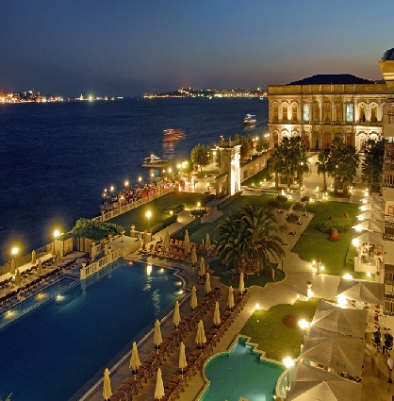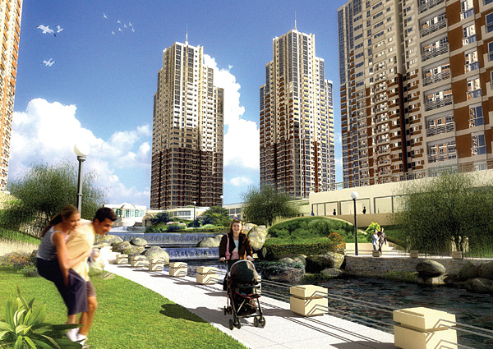

**TURKEY RETAIL MARKET OVERVIEW**

**SUMMARY[1]**

A large amount of new supply had been delivered to Turkish retail market over the past few years. As end of October 2008, retail centre supply reached to 4.4 million sq m in 189 retail centres.

It is estimated that retail supply will reach 7 million sq m by 2012, with completion of new developments. However, some pipeline and planning schemes will be postponed due to lack of finance in line with global crisis.

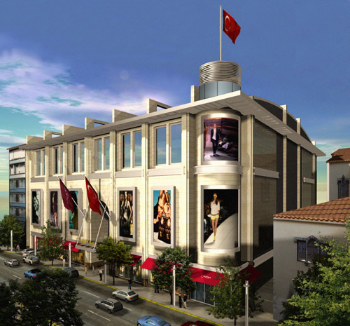

Istanbul and Ankara still dominate the market with their existing retail inventory and also large development schemes. Considering their lower GLA per capita, some metropolitan cities having population over 1 million, offer opportunities for potential developments, like Izmir, Adana, Gaziantep and Konya.

A few provinces having no existing retail centers yet, like Erzurum, Kutahya, Nevsehir, Sanliurfa and Tokat will be also added to retail inventory. Currently, 31 provinces have retail centres and it is expected to reach 45 with under construction and planning schemes, by the year 2012.

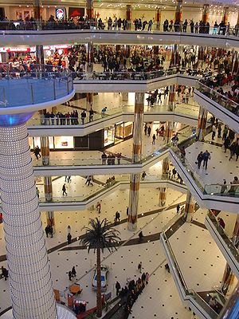

The transaction volume in Turkish commercial property market investments is still quite low, due to liquidity, transparency and lack of available investment grade products. However, transaction volume has accelerated with the interest of international developers and investors. By the end of October 2008, total annual transaction volume has exceeded US$ 800 million.

Due to economic slowdown and increase in exchange rate, investors have offered some concession to retailers, including reduction in rents, restructuring the lease agreements from fixed to turnover rent or applying fixed-exchange rate.

Turkish retail market witnessed yield compression driven by the expectation of rental growth over the last couple of years. However, in the short term, an increase in yields is expected regarding perception of risk - free rate and risk premium increase in line with global crisis.

According to data provided by Planet Retail, revenues of the Turkish retail sector (food and non-food) equaled USD 136.9 billion in 2006. This figure is expected to reach USD 199 billion by 2010.

Approximately 65% of the Turkish retail sector is constituted by traditional retail while 35% consists of modern (organized) retail. Therefore, the retail sector still has a long way to go. Given these ratios, the size of the modern retail sector is calculated to be USD 47,9 billion.

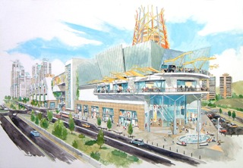

**SUPPLY**

Total retail supply reached to 4.4 million sqm in 189 retail centres by the end of October 2008. It reflected an increase of 26%, since January 2008.

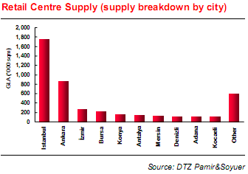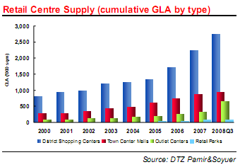

District shopping centres continue to dominate the market representing 62% of total supply, follow by town centre malls with a share of 23%. Outlet centres recorded significant increase with delivery of new supply. Besides, conversion of some district centres to outlet centres has contributed to increase of its share in total supply up to 15%.

The largest metropolitan cities, Istanbul and Ankara still lead supply having 60% of country’s GLA. Izmir and Bursa follow with a share of 19% and 6%, respectively. On the other hand, retail supply in the developing metropolitan cities like Antalya, Denizli and Mersin, has remarkably increased with the new openings in 2008.

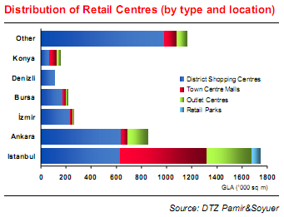

As end of October 2008, the average GLA per 1,000 inhabitants reached to 62 sq m in Turkey. This number still stays behind compared to European countries where the average is 205 sqm per 1,000 inhabitants. Ankara ranked first place with 190 sq m/1,000 inhabitants, followed by Istanbul with 139 sq m/1,000 inhabitants.

**RETAIL CENTRE SUPPLY (Breakdown by retail centre floorspace GLA by 1,000 inhabitants)**

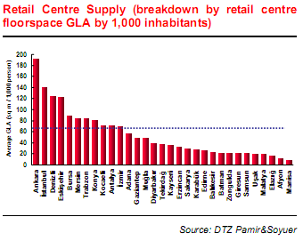

Developing metropolitan cities, Denizli, Eskisehir, Trabzon and Mersin rose with delivery of new supply and ranked third, fourth and fifth place, respectively. Other metropolises, having population over 1 million, also ranked in the upper range of the country average.

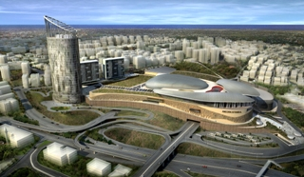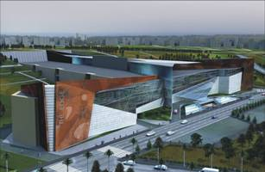

Istanbul and Ankara remain the primary markets due to their market size and population. Large Metropolitan cities with lower GLA per capita, like Izmir, Adana, Gaziantep and Konya look promising for potential developments. On the other hand, the oversupply may be crucial concern for some markets where GLA per capita above country’s average. For example, Eskisehir and Denizli seem to oversupply compared to other markets, considering their market size and population.

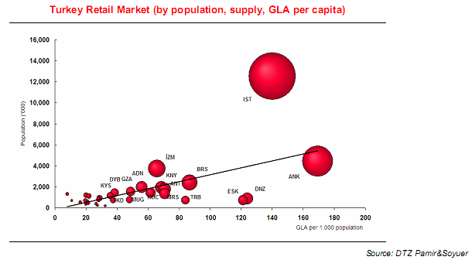

**NEW SUPPLY**

Retail market has continued to grow significantly over the past few years. Since the beginning of the year, a large amont of new space (app.9000,000 sqm) delivered to market reflecting an increase of 26%. Significant amount of outlet centre, approximately 300,000 sqm entered to market during 2008. Via Port, Deposite and Airport in Istanbul, Forum Ankara and Acity Outlet in Ankara have started to operate in this year.

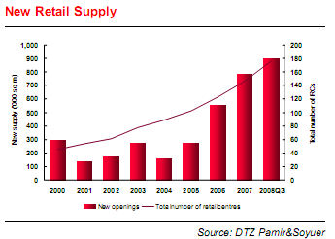

The major openings in 2008 include *City’s Nişantaşı, Astoria, Metroport, Palladium* in İstanbul; *Antares* and *365* in Ankara. In addition, *Kent Meydanı* (Bursa), *Shemall* (Antalya), *Şirehan* (Gaziantep), *Forum Çamlık* (Denizli), *Forum Trabzon* and *Forum Aydın* are other major openings in other provinces.

**PIPLINE**

Total retail supply is expected to grow with under construction and planning stage developments, for the next five years. Currently, total retail centre supply in the pipeline is calculated as 3 million sq m, while total retail supply is estimated to reach 7 million sq m by the end of 2010.

Over the next three years, approximately 85 new centres are scheduled to open in Turkey. Istanbul has the largest development scheme in the pipeline with 1.4 million sq m GLA representing 45% of total supply. Ankara follows with a share of 10%.

Other major metropolitan cities, Antalya, Gaziantep, Diyarbakir and Bursa have large development schemes in the pipeline, their attractiveness is still continue due to their large population size.

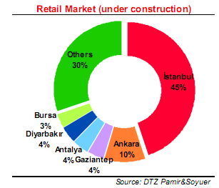

In addition, provinces have no retail centres yet, will be added to retail inventory in the next years. Currently, 31 provinces have retail centres and it is expected to reach 45 with under construction or planning schemes, by the year 2012.

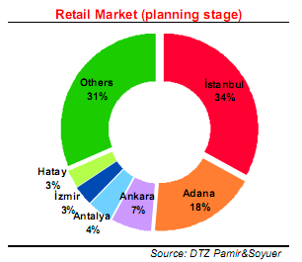

Approximately 1.5 million sq m additional supply in the planning stage is expected to deliver to market by 2012, including Adana, Canakkale and Corum by Multi Turkmall, Kahramanmaras Sanlıurfa and Tokat by Meinl (with Acteeum Group).

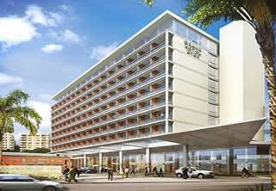

**TURKEY: RETAIL CENTRES (Current and Pipeline, by cities, 2012)**

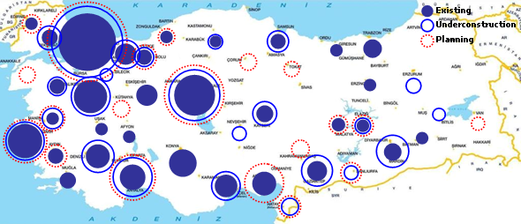

MAJOR RETAIL CENTERS IN PIPELINE (Under construction, over 30,000 sqm GLA)

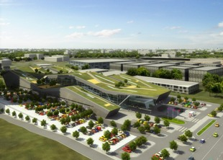

|  |  |  |  |
| --- | --- | --- | --- |
| **Retail Centre** | **Location** | **Opening** | **GLA** |
| Kentpark | Ankara | 2009 | 75,17 |
| Anse | Ankara | 2009 | 68 |
| Gordion | Ankara | 2009 | 55 |
| Optimum İzmir | İzmir | 2009 | 58,526 |
| Adana AVM | Adana | 2009 | 55 |
| Forum Antalya | Antalya | 2010 | 119,086 |
| Anatolia | Bursa | 2010 | 78,588 |
| Sümer Park | Denizli | 2009 | 55 |
| Forum Diyarbakır | Diyarbakır | 2009 | 55 |
| Ceylan | Diyarbakır | 2009 | 60 |
| Erzurum Meydan | Erzurum | 2009 | 31 |
| Gaziantep AVM | Gaziantep | 2009 | 57,56 |
| Forum Gaziantep | Gaziantep | 2010 | 38,604 |
| Lapis | Gaziantep | 2009 | 30,326 |
| Soyak | Hatay | 2009 | 40 |
| Forum Kayseri | Kayseri | 2010 | 66,5 |
| İzmit Park | Kocaeli | 2009 | 52 |
| Malatya | Malatya | 2009 | 48,13 |
| Redevco | Manisa | 2009 | 55 |
| Samsun | Samsun | 2009 | 62 |
| Çorlu Park | Tekirdağ | 2009 | 45 |
| Tekira | Tekirdağ | 2009 | 30,6 |
| **Total (Turkey)** | **3,106,508** |  |  |

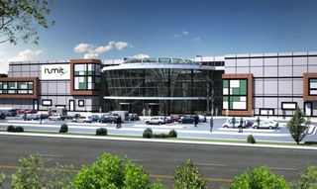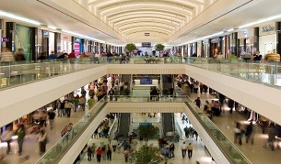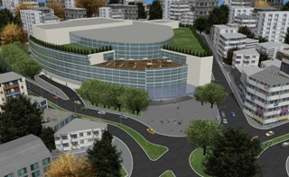

**FORECAST**

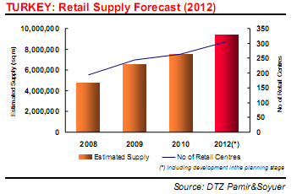

Total retail supply is estimated to reach 9 million sq m with 300 retail centres in the next five years including planning stage developments. In parallel with the supply growth, GLA per 1,000 inhabitants in Turkey is expected to reach 130 sq m by 2010.

However, some pipeline and planning schemes will be postponed due to lack of financial in line with global crisis. It is also expected that a few retail schemes may be converted to alternative uses or mix-use developments.

Although Istanbul and Ankara still dominate the market medium sized provinces having population over 1 million (Adana, Bursa, Denizli, Diyarbakir, Gaziantep, Izmir, Kocaeli, Samsun, Manisa) have large developments schemes in the pipeline.

A few provinces having no existing retail centres yet, like Erzurum, Kütahya, Manisa, Nevşehir, Şanliurfa and Tokat will be also added to retail inventory by the year 2012.

**RENTS**

After introduction of smoking-ban in the closed areas in May 2008, food vendors have encountered a significant decrease in turnovers.

Although no significant decrease has started to be observed a decline trend is expected in retail sales for the next year, due to economic slowdown. Besides, increase in Exchange rate puts additional pressure on retailers regarding rental values.

Investors have offered some concessions to retailers to overcome these problems. Proposed concessions include reduction in rents, restructuring the lease agreements from fixed to turnover rent or applying fixed-exchange rate.

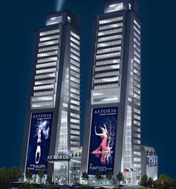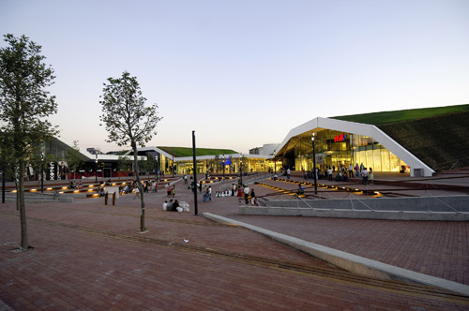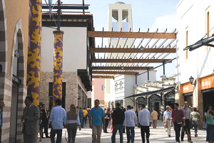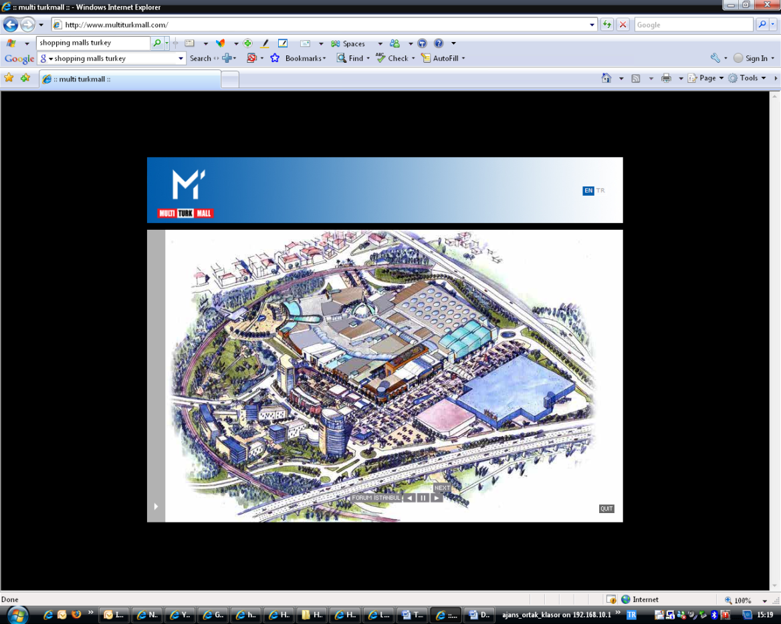

**INVESTMENT**

The transaction volume in Turkish commercial property market investments is still quite low, due to liquidity, transparency and lack of available investment grade products. However, transaction volume has accelerated with the interest of international developers and investors.

The number of transactions and value has increased since 2005. Total value of retail centre transactions was US$ 1.2 billion and US$ 800 million in 2006 and 2007, respectively. By the end of October 2008, total annual transaction volume has exceeded US$ 800 million.

In the beginning of 2008, Apollo Real Estate and Multi Turkmall have acquired the prime development site of the *City Park (Carrefour Merter Shopping Centre)* in Istanbul. The retail development opportunity was purchased for EUR268 million from Carrefour.

Corio remained the most active investor in the market acquiring eleven retail centres. Corio’s first İnvestment was 46.92% share in *Akmerkez* (Istanbul) in 2005. Other acquisitions, *Adacenter* (Sakarya) opened in 2007, while *Teras Park* (Denizli) and *365* (Ankara) have started to operate in 2008. Other centres are *Tekira* (Tekirdağ,2009), *Anatolium* (Bursa,2010), *Malatya* (Malatya, 2010) and *Acibadem* (Istanbul, 2011), are either under development or in the planning stage. Transactions can be partial acquisition (*Akmerkez*, *Teras Park, Acıbadem*) or total acquisitions.

In May 2008, Corio acquired a plot of land of 33,400 sq m in the city of Malatya to develop a retail centre with 50,000 sq m GLA in cooperation with Acteeum Group. *Malatya Project* will be developed by Acteeum Group and it will be acquired by Corio. After four operational years, Acteeum will share in the medium term performance above a predefined internal rate of return for Corio.

*Tarsus Project*, another JV with Acteeum, was acquired by Corio for EUR 50 million. Project with 25,000 sq m GLA is located in Mersin and it is expected to open in 2011.

Another acquisition by Corio was Iskenderun Shopping Centre having 55,000 sqm GLA in city of Hatay. It is Planned to open in 2010. The total investment is expected to be around EUR 116 million at a predefined net initial yield of at least

8%, in line with Corio’s other investments in Turkey.

Foreign developers have continued to seek opportunities for new retail developments in Anatolia. Redevco acquired land in Erzurum, Manisa and Edirne. Gordion Retail Centre in Ankara and Manisa Shopping Centre are being constructed.

After acquisition of Forum Trabzon in 2006, Meinl European Land Limited (with Acteeum Group) entered to Turkey as a developer and purchased land in Samsun, Tokat, Kahramanmaraş, İstanbul (Göztepe), Sanlıurfa and Adana. Acteeum Group will develop retail centres under the name of “*Ancora*”. The construction of the first project namely “*Ancora Samsun*” has started recently.

Turkish retail market witnessed yield compression driven by the expectation of rental growth over the last couple of years. The initial yields remained between 7% and 8% in the metropolitan cities while 10% – 11% for new development schemes in Anatolian cities.

However, an increase in yields is expected in line with economic slowdown. The perception of increase in risk-free rate and risk premium can cause an increase on yields in the short term.

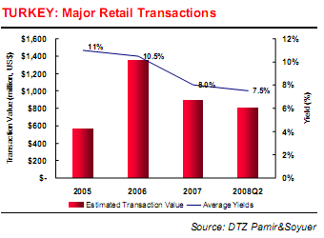

**ISTANBUL RETAIL MARKET**

Total retail supply Istanbul reached to 1.7 million sqm in 65 centres, by the end of October 2008. Istanbul retail market accounts for 40% of total retail supply in Turkey.

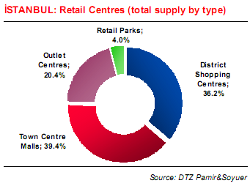

Town centre malls continue to dominate retail supply with a share of 40%. District shopping centres constitute 36% of total supply. However, the share of outlet centres increased from 10% to 20% since the beginning of 2008, due to new openings and conversion of district shopping centres to outlet centres.

As end of October 2008, approximately 410,000 sq m additional supply was delivered to Istanbul retail market, representing an increase of 30%. *City’s Nisantası, Astoria and Palladium* ve started to operate in 2008. In addition, *Viaport*, *Airport*, *Armoni Park Outlet* and *Deposite Outlet* are other major openings as outlet centres.

**PIPELINE**

Currently, 1.4 million sq m new retail schemes are under construction in Istanbul, representing 45% of total supply in Turkey. In addition, approximately 600,000 sq m additional supply is in the planning stage. By the year 2012, total supply is expected to reach 3.7 million sq m with under construction and planning developments.

Another retail centres developed by Multi Turkmall, Forum TEM having 72,000 sqm GLA is located in Gaziosmanpaşa. The project is planned to be completed in 2010.

City Park Istanbul (formely Carrefour Merter) will have 140,212 sqm GLA ant it is expected to open in 2010. Apollo Real Estate and Multi Turkmall.

212 Istanbul (old land of Edip Iplik) is being developed in Ikitelli. It has 68,000 sqm GLA and targeted to open by the end of 2009.

MAJOR RETAIL CENTERS (Pipeline, over 30,000 GLA)

|  |  |  |  |
| --- | --- | --- | --- |
| **PROJECT** | **YEAR** | **LOCATION** | **GLA (SQM)** |
| Forum Istanbul | 2009 | Bayrampaşa | 172,286 |
| City Park Istanbul | 2010 | Merter | 140,212 |
| Forum TEM | 2010 | G.osmanpaşa | 72 |
| 212 İstanbul | 2009 | İkitelli | 68 |
| Ginza | 2009 | Beylikdüzü | 60 |
| Maslak Teras | N/A | Maslak | 57,5 |
| Kozzy | 2009 | Kozyatağı | 48,13 |
| Kozyatağı Optimum | 2008 | Kozyatağı | 43,5 |
| Trump Tower | 2010 | Mecidiyeköy | 40,333 |
| Pelican Mall | 2009 | Beylikdüzü | 36,5 |
| Neomarin Pendik | 2009 | Pendik | 36 |
| Sapphire İstanbul | 2009 | Levent | 34 |
| Perla Vista | 2009 | Beylikdüzü | 32 |
| İstanbul Fashion Mall | 2008 | Kozyatağı | 30 |
| Buyaka Artell | 2009 | Ümraniye | 31 |
| Merter M1 | 2009 | Merter | 30,39 |
| Modezz | 2010 | Kozyatağı | 30 |
| Pendorya | 2009 | Pendik | 30 |
| **Total - İstanbul** |  |  | **1,391,305** |

Forum Istanbul, is being developed by MultiTurkmall in Bayrampasa, has approximately 172,000 sqm GLA including retail, DIY, hypermarket and entertainment areas and it is expected to be completed by the end of 2009.

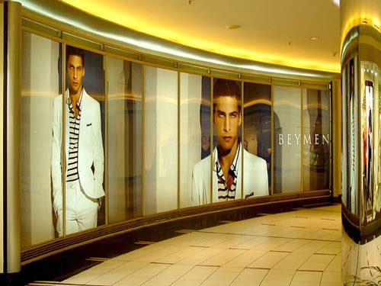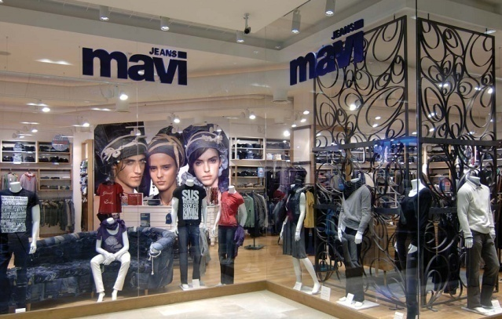

**OUTLOOK**

Retail market has seen a significant supply over the past few years. As end of October 2008, retail centre supply reached to 4.4 million sq m in 189 retail centres.

It is estimated that retail supply will reach 7 million sqm by 2012, with delivery of new supply. However, some pipeline and planning schemes will be postponed due to lack of finance in line with global crisis.

Istanbul and Ankara remain the primary market due to their existing retail inventory and large development schemes. Considering their lower GLA per capita, some metropolitan cities having population over 1 million, offer opportunities for potential developments, like Izmir, Adana, Gaziantep and Konya. On the other hand, oversupply can be crucial for a few markets where GLA per capita higher country’s average.

Retail market is becoming more competitive and challenging. Retail trends are moving new forms of lifestyle and entertainment centres emphasizing open – air design. Incorporation of sustainable technology into retail centres is another emerging design trend due to environmental concerns.

Open –air design, such as outside restaurants, cafés, is becoming more important component in the retail centres, especially after smoking - ban in the closed areas. However, tenants can face with additional operating expenses, such as ventilation, heating, etc.

Turkish retail market witnessed yield compression driven by the expectation of rental growth over the last couple of years. However, in the short term, an increase in yields is expected regarding perception of risk - free rate and risk premium increase in line with global crisis.

**THE CONSTRUCTION COST**

According to shopping mall developers the construction cost for shopping malls are approximately USD 500-600 m2.

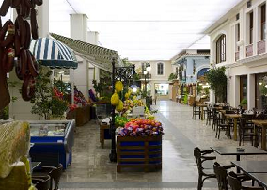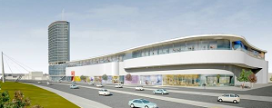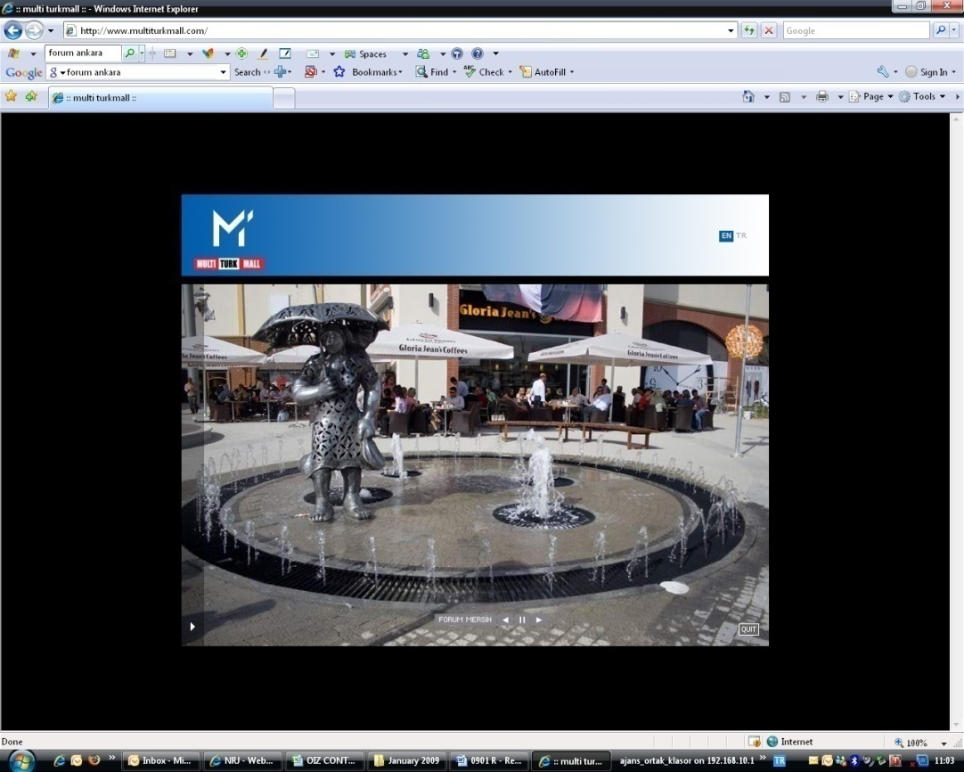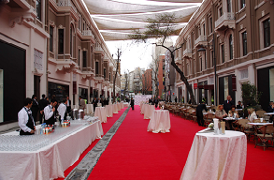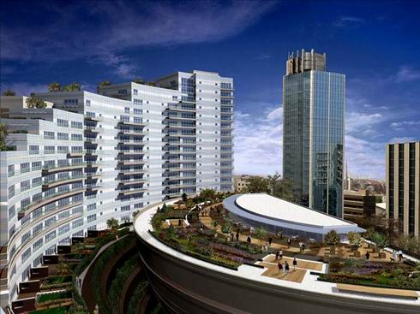

**CURRENT AND PLANNED SHOPPING CENTERS IN TURKEY**

|  |  |
| --- | --- |
| **SHOPPING CENTERS (OPENING & PLANNED OPENING DATES)** | |
| GALLERIA ALIŞVERIŞ MERKEZİ | 1988 |
| ATAKULE ALIŞVERIŞ MERKEZİ | 1989 |
| ATRİUM ALIŞVERIŞ MERKEZİ | 1989 |
| NETSEL ALIŞVERIŞ MERKEZİ | 1990 |
| KARUM İŞ VE ALIŞVERIŞ MERKEZİ | 1991 |
| YAYLADA SÜREYYAPAŞA ALIŞVERIŞ MERKEZİ | 1992 |
| AKMERKEZ | 1993 |
| CAPITOL ALIŞVERIŞ VE YAŞAM MERKEZİ | 1993 |
| GALLERIA-ADANA | 1994 |
| KİPA ALIŞVERİŞ MERKEZİ-BORNOVA | 1994 |
| CAROUSEL ALIŞVERİŞ VE YAŞAM MERKEZİ | 1995 |
| GALLERIA ANKARA ALIŞVERIŞ MERKEZİ | 1995 |
| AFRA ALIŞVERIŞ MERKEZİ-KONYA | 1996 |
| CARREFOUR İÇERENKÖY ALIŞVERIŞ MERKEZİ | 1996 |
| ANKUVA ALIŞVERIŞ MERKEZİ | 1997 |
| AVANTAJ FACTORY OUTLETS | 1997 |
| MİGROS ALIŞVERIŞ MERKEZİ-BEKLİKDÜZÜ | 1997 |
| OUTLET CENTER-İZMİR | 1997 |
| BİLKENT CENTER | 1998 |
| CARREFOURSA ADANA ALIŞVERİŞ | 1998 |
| EGS PARK ALIŞVERIŞ VE EĞLENCE MERKEZİ-DENİZLİ | 1998 |
| MAXI SHOPPING CITY-SİLİVRİ | 1998 |
| MAYADROM AKATLAR | 1998 |
| OASİS ALIŞVERIŞ KÜLTÜR VE EĞLENCE MERKEZİ | 1998 |
| PROFILO ALIŞVERIŞ MERKEZİ | 1998 |
| AFRA ALIŞVERIŞ MERKEZİ-MALATYA | 1999 |
| ANKAMALL ALIŞVERIŞ MERKEZİ | 1999 |
| DİYARGALLERIA | 1999 |
| EGE PARK MAVİŞEHİR MODA VE ALIŞVERIŞ MERKEZİ | 1999 |
| KİPA ALIŞVERIŞ MERKEZİ-ÇİĞLİ | 1999 |
| M1 MERKEZ GAZİANTEP ALIŞVERIŞ MERKEZİ | 1999 |
| MESA PLAZA ALIŞVERIŞ MERKEZİ | 1999 |
| MİLTA BODRUM MARİNA | 1999 |
| ORION ALIŞVERIŞ MERKEZİ | 1999 |
| ZAFER PLAZ ALIŞVERIŞ MERKEZİ | 1999 |
| AS MERKEZ | 2000 |
| CARREFOUR İZMİT ALIŞVERIŞ MERKEZİ | 2000 |
| CARREFOUR KARŞİYAKA ALIŞVERIŞ MERKEZİ | 2000 |
| CARREFOURSA ÜMRANİYE ALIŞVERIŞ MERKEZİ | 2000 |
| KİPA ALIŞVERIŞ MERKEZİ-GAZİEMİR | 2000 |
| M1 MERKEZ ADANA ALIŞVERIŞ MERKEZİ | 2000 |
| M1 MERKEZ KARTAL ALIŞVERIŞ MERKEZİ | 2000 |
| MERİDYEN ALIŞVERIŞ MERKEZİ | 2000 |
| OLIVIUM OUTLET CENTER | 2000 |
| REAL BURSA ALIŞVERIŞ MERKEZİ | 2000 |
| REAL İZMİT ALIŞVERIŞ MERKEZİ | 2000 |
| AFRA ALIŞVERIŞ MERKEZİ-KARAMAN | 2001 |
| CARREFOUR ANKARA ALIŞVERIŞ MERKEZİ | 2001 |
| CARREFOUR BURSA ALIŞVERIŞ MERKEZİ | 2001 |
| CARREFOUR HARAMİDERE ALIŞVERIŞ MERKEZİ | 2001 |
| KULE ÇARŞI ALIŞVERIŞ MERKEZİ | 2001 |
| MİGROS ALIŞVERIŞ MERKEZİ-ANTALYA | 2001 |
| ODC CENTER ALIŞVERIŞ MERKEZİ | 2001 |
| AFRA ALIŞVERIŞ MERKEZİ-AKSARAY | 2002 |
| ARMADA ALIŞVERİŞ VE İŞ MERKEZİ | 2002 |
| MEGA CENTER ALIŞVERİŞ MERKEZİ | 2002 |
| MİGROS BEDESTEN ALIŞVERİŞ MERKEZİ-GAZİANTEP | 2002 |
| SABAH CENTER ALIŞVERIŞ MERKEZİ | 2002 |
| TEPE NAUTİLUS | 2002 |
| TRUVA OUTLET VE EĞLENCE MERKEZİ | 2002 |
| AGORA | 2003 |
| ARCADIUM ALIŞVERIŞ MERKEZİ | 2003 |
| AYMERKEZ ALIŞVERIŞ MERKEZİ | 2003 |
| BEŞYILDIZ ALIŞVERIŞ MERKEZİ | 2003 |
| BİNA DEKORASYON MERKEZİ | 2003 |
| CARREFOUR MERSİN ALIŞVERIŞ MERKEZİ | 2003 |
| CARREFOUR BAYRAMPAŞA ALIŞVERIŞ MERKEZİ | 2003 |
| ERMERKEZ | 2003 |
| FLYINN ALIŞVERİZ VE YAŞAM MERKEZİ | 2003 |
| FTZ ALIŞVERIŞ MERKEZİ | 2003 |
| G-MALL KÜLTÜR SANAT VE ALIŞVERIŞ MERKEZİ | 2003 |
| KADİR HAS ÇOCUK DÜNYASI | 2003 |
| KARUN ALIŞVERİŞ MERKEZİ | 2003 |
| M1 MERKEZ KONYA ALIŞVERİŞ MERKEZİ | 2003 |
| MAXI CENTER-İSTİNYE | 2003 |
| MAXI CITY-ÇENGELKÖY | 2003 |
| METROCITY ALIŞVERİŞ MERKEZİ | 2003 |
| PALMİYE ALIŞVERİŞ MERKEZİ | 2003 |
| PORT BODRUM YALIKAVAK MARİNA ALIŞVERİŞ KÖYÜ VE BALIKÇIKÖY ÇARŞILARI | 2003 |
| TOWN CENTER | 2003 |
| UPTOWN ETİLER ALIŞVERIŞ MERKEZİ | 2003 |
| AKGÜN ALIŞVERIŞ MERKEZİ | 2004 |
| DEEPO OUTLET ALIŞVERİŞ MERKEZİ | 2004 |
| DOLPHIN CENTER-İZMİR | 2004 |
| G-MALL ANTALYA | 2004 |
| KARACAN POINT CENTER | 2004 |
| KONAK PIER | 2004 |
| KULESİTE ALIŞVERİŞ VE EĞLENCE MERKEZİ | 2004 |
| LAURA ALIŞVERIŞ MERKEZİ | 2004 |
| MESA STUDIO PLAZA ALIŞVERIŞ MERKEZİ | 2004 |
| MİGROS ALIŞVERIŞ MERKEZİ-ORDU | 2004 |
| OPTİUM OUTLET CENTER | 2004 |
| PARK BONOVA OUTLET CENTER | 2004 |
| ADDRESİSTANBUL EV VE YAŞAM KARMASI | 2005 |
| AQUARIUM ALIŞVERİŞ MERKEZİ | 2005 |
| ATİRUS ALIŞVERİŞ VE İŞ MERKEZİ | 2005 |
| CARREFOUR MALTEPE PARK | 2005 |
| COLONY OUTLET VE YAŞAM MERKEZİ | 2005 |
| İSTANBUL CEVAHİR ALIŞVERİŞ VE EĞLENCE MERKEZİ | 2005 |
| KANYON | 2005 |
| KİPA ALIŞVERİŞ MERKEZİ-BODRUM | 2005 |
| MILLENIUM OUTLET PARK | 2005 |
| MİRAPARK ALIŞVERIŞ MERKEZİ | 2005 |
| MKM ALIŞVERIŞ MERKEZİ | 2005 |
| PARADISE ALIŞVERİŞ VE EĞLENCE MERKEZİ | 2005 |
| PLANET ALIŞVERİŞ VE YAŞAM MERKEZİ | 2005 |
| STARS ÇOCOK DÜNYASI | 2005 |
| SUNFLOWER LIFE CENTER | 2005 |
| WHITE WORLD CENTER | 2005 |
| AFRA ALILVERİŞ MERKEZİ-SAMSUN | 2006 |
| AKKAPARK ALIŞVERIŞ MERKEZİ | 2006 |
| BEYLICIUM ALIŞVERİŞ VE YAŞAM MERKEZİ | 2006 |
| DOĞUŞ POWER CENTER | 2006 |
| EREYLİN ALIŞVERIŞ MERKEZİ | 2006 |
| FORUM BORNOVA | 2006 |
| G-CITY ALIŞVERIŞ MERKEZİ | 2006 |
| İPEKSARAY ALIŞVERIŞ MERKEZİ | 2006 |
| İSTANBUL OUTLET PARK | 2006 |
| KAYA MILLNIUM İŞ VE ALIŞVERIŞ MERKEZİ | 2006 |
| KAYSERİ PARK ALIŞVERİŞ VE YAŞAM MERKEZİ | 2006 |
| KC GÖKCU ALIŞVERIŞ MERKEZİ | 2006 |
| KİPA ALIŞVERIŞ MERKEZİ-ANTALYA | 2006 |
| KİPA ALIŞVERIŞ MERKEZİ-AYDIN | 2006 |
| KİPA ALIŞVERIŞ MERKEZİ-ÇANAKKALE | 2006 |
| KİPA ALIŞVERIŞ MERKEZİ-ÇORLU | 2006 |
| KİPA ALIŞVERIŞ MERKEZİ-KONYA | 2006 |
| KİPA ALIŞVERIŞ MERKEZİ-LÜLEBURGAZ | 2006 |
| MAGAZİN OUTLET ALIŞVERIŞ MERKEZİ | 2006 |
| MOLİDA ALIŞVERIŞ MERKEZİ | 2006 |
| NCITY ALIŞVERIŞ MERKEZİ | 2006 |
| ONEL ALIŞVERIŞ MERKEZİ | 2006 |
| PEKDEMİR ALIŞVERİŞ VE YAŞAM MERKEZİ-KINIKLI | 2006 |
| REAL ANTALYA ALIŞVERIŞ MERKEZİ | 2006 |
| SELWAY OUTLET PARK | 2006 |
| SİNASOS ALIŞVERIŞ MERKEZİ | 2006 |
| AIRPORT | 2006 |
| ANTARES ALIŞVERIŞ MERKEZİ | 2007 |
| ASTORIA ALIŞVERIŞ MERKEZİ/KEMPINSKI RESIDENCES | 2007 |
| ASYAPARK ALIŞVERİŞ MERKEZİ | 2007 |
| CAPACITY | 2007 |
| CARIUM | 2007 |
| CCEPA ALIŞVERIŞ MERKEZİ | 2007 |
| CITY´S NİŞANTAŞI | 2007 |
| DEPOSİTE OUTLET ALIŞVERIŞ MERKEZİ | 2007 |
| D´SİLVA ALIŞVERİŞ VE YAŞAM MERKEZİ | 2007 |
| ESPARK | 2007 |
| FATİH KÜLTÜR VE TİCARET MERKEZİ | 2007 |
| FORUM MERSİN | 2007 |
| İSTİNYA PARK | 2007 |
| KALE CENTER | 2007 |
| KANATLI ALIŞVERIŞ MERKEZİ | 2007 |
| KC ŞEHR-İ BAZAAR | 2007 |
| KEMERMALL | 2007 |
| KİPA ALIŞVERIŞ MERKEZİ-BALÇOVA | 2007 |
| KİPA ALIŞVERIŞ MERKEZİ-BURHANİYE | 2007 |
| KIPA ALIŞVERIŞ MERKEZİ-UŞAK | 2008 |
| KORUMAX ALIŞVERİŞ VE EĞLENCE MERKEZİ | 2008 |
| M1 MEYDAN ALIŞVERIŞ MERKEZİ | 2008 |
| MAKSİMUM ALIŞVERIŞ MERKEZİ | 2008 |
| MALTEPE KATLI OTOPARK VE ALIŞVERİŞ MERKEZİ | 2008 |
| MARİNAVİSTA ALIŞVERIŞ MERKEZİ | 2008 |
| METROKENT ALIŞVERIŞ MERKEZİ | 2008 |
| METROPORT | 2008 |
| NEO ESKİŞEHİR ALIŞVERİŞ VE YAŞAM MERKEZİ | 2008 |
| OLIVE CITY | 2008 |
| PANORA ALIŞVERİŞ VE YAŞAM MERKEZİ | 2008 |
| PARKWAY ALIŞVERIŞ MERKEZİ | 2008 |
| PRESTIGE MALL | 2008 |
| TAKSİT CENTER İHTİSAS ÇARŞILARI | 2008 |
| TERASPARK | 2008 |
| VERDE MOLİNA ALIŞVERİŞ VE YAŞAM MERKEZİ | 2008 |
| YAYLADA BALIKESİR ALIŞVERIŞ MERKEZİ | 2008 |
| YEŞİLYURT ALIŞVERİŞ VE YAŞAM MERKEZİ | 2008 |
| ZEYLAND ALIŞVERİŞ VE EĞLENCE MERKEZİ | 2008 |
| EKİNOKS BEYLİKDÜZÜ ALIŞVERIŞ MERKEZİ | 2008 |
| FORUM ANKARA | 2008 |
| FORUM AYDIN | 2008 |
| FORUM ÇAMLIK | 2008 |
| FORUM İSTANBUL | 2008 |
| FORUM TRABZON | 2008 |
| GAZİANTEP ALIŞVERİŞ MERKEZİ VE OFİS KULESİ | 2008 |
| GAZİANTEP ŞİREHAN VE YEMİŞHAN KÜLTÜR MERKEZİ | 2008 |
| HARMONY PARK | 2008 |
| İSTANBUL KOZYATAĞI FASHION CENTER | 2008 |
| İSTANBUL KOZYATAĞI OPTIMUM ALIŞVERİŞ MERKEZİ | 2008 |
| İSTANBUL OUTLET CENTER-PENDİK | 2008 |
| KENTMEYDANI ALIŞVERİŞ MERKEZİ | 2008 |
| KENTPARK | 2008 |
| KÜTAHYA ALIŞVERİŞ VE EĞLENCE MERKEZİ | 2008 |
| PALLADIUM REZİDANS VE ALIŞVERİŞ MERKEZİ | 2008 |
| PERLA VİSTA | 2008 |
| WORLD ATLANTIS | 2008 |
| 212 İSTANBUL | 2009 |
| DEEPO CENTER İSTANBUL | 2009 |
| ERZURUM ALIŞVERİŞ MERKEZİ | 2009 |
| FORUM ANTALYA | 2009 |
| FORUM DİYARBAKIR | 2009 |
| FORUM KAYSERİ | 2009 |
| FORUM TEM | 2009 |
| GORDION ALIŞVERIŞ MERKEZİ | 2009 |
| İSTANBUL SAPPHIRE | 2009 |
| MALATYA ALIŞVERIŞ MERKEZİ | 2009 |
| ACTEEUM GÖZTEPE ALIŞVERIŞ MERKEZİ PROJESİ | 2010 |
| ACTEEUM GÖZTEPE ALIŞVERIŞ MERKEZİ PROJESİ | 2010 |

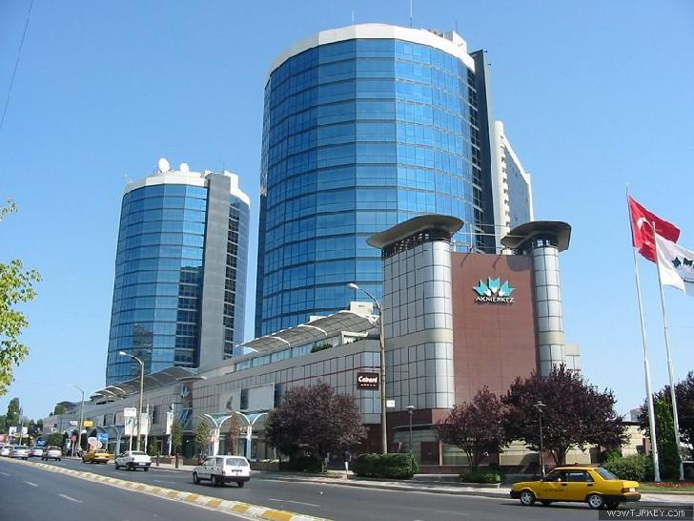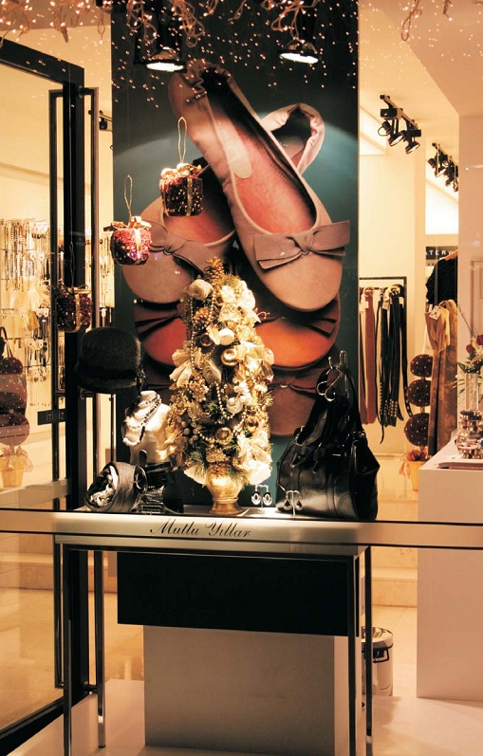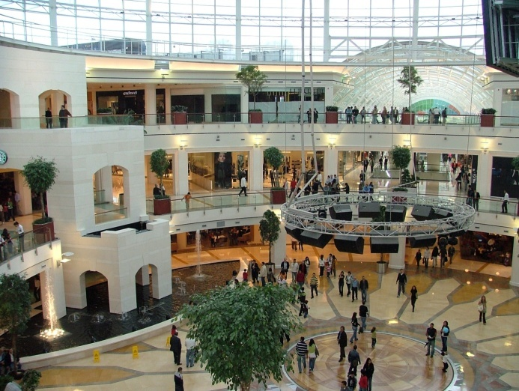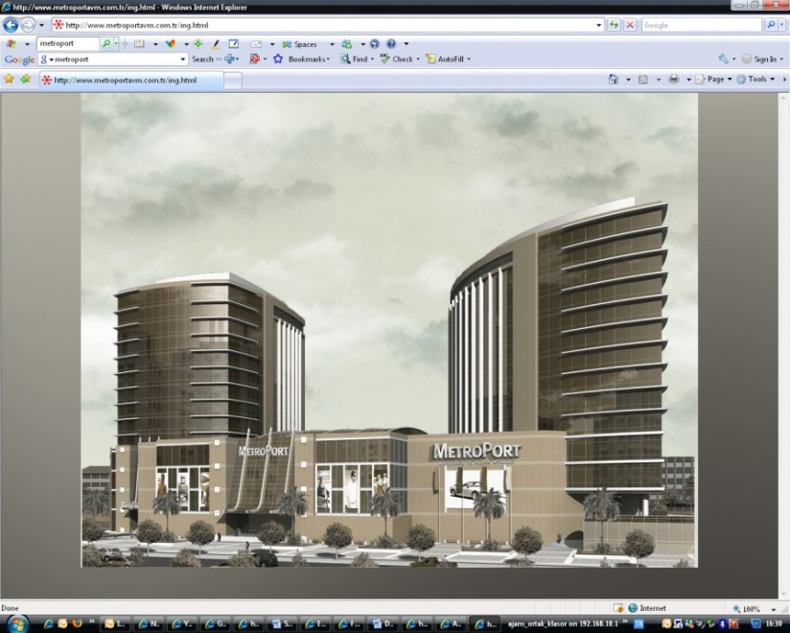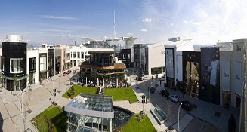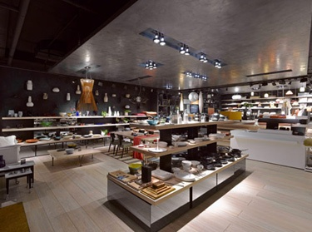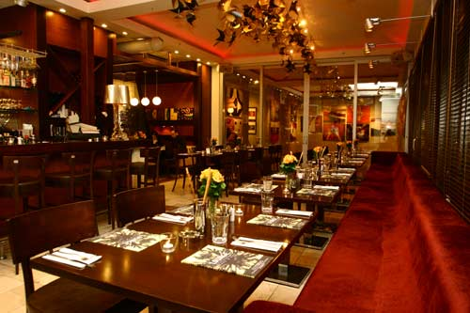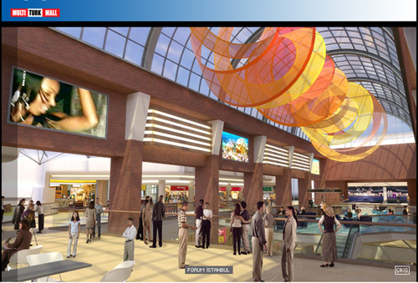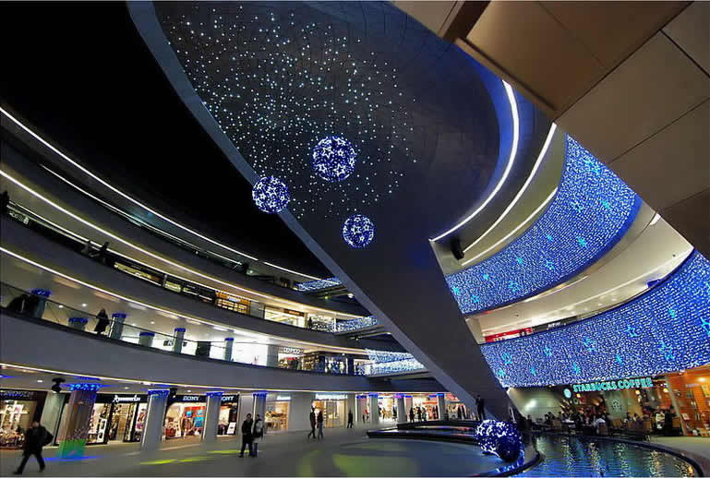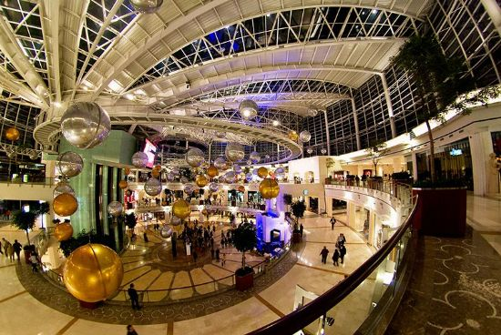

1. Pamir & Soyuer, Retail Market Research, Turkey, 2008